­­

2022/2023

Sami Sued

2022/2023

Clothing E-store

Table of Contents

Analysis 4

Problem Identification 4

Stakeholders 4

Why This Problem is Best Suited for a Computational Approach 5

Computational Aspects 5

Interview 7

Client Interview 7

Userbase Interview 8

Nick and Peter Interview 8

User 1 Interview 9

User 2 Interview 9

Research 10

Case Study of Similar Solutions 10

Urban Male Clothing 10

Amazon 12

Arne 14

Requirements 15

Hardware 15

Software 16

Essential Features 16

Limitations 18

Success Criteria 18

Design 21

Decomposition 21

User Interface Design 25

Database Design 30

Statistics 31

Income 31

Quantity Sold 31

Top 5 Items 31

Current Users 31

IPSO Table 31

Algorithms 33

Logging Algorithm 33

Verification link Algorithm 34

Account Creation Algorithm 35

Authenticate Algorithm 36

Reset request Algorithm 37

Password reset Algorithm 37

Order placement Algorithm 38

Has bought item once Algorithm 40

Review placement Algorithm 40

Manager actions Algorithm 41

Asynchronous thread Algorithm 43

Recommendation System 44

Featuring System 44

Key Variables 46

Test Plans 47

Prototype 1 47

Prototype 3 53

Post Developmental 55

Development 56

Prototype 1 56

Stage 1: Setup 56

Stage 2: The Hashing Algorithm and first response 68

Stage 3: Registration, Verification and Authentication 72

Stage 4: Reviews and Emails 110

Prototype 1 Review 122

Prototype 2 122

Stage 5: The Featuring Algorithm 122

Stage 6: The Recommendation System 126

Prototype 2 Review 140

Prototype 3 140

Stage 7: Implementing Bootstrap 5 140

Stage 8: Order Processing 155

Stage 9: Management Section 160

Prototype 3 Review 162

Evaluation 163

Post Development Testing 163

Criteria Met 164

Usability 169

Limitations 170

Maintenance 171

Conclusion 172

Final Code 172

urls.py 172

models.py 173

forms.py 176

views.py 177

accountActions.py 183

admin.py 186

Referencing 186

References (Analysis) 186

References (Design) 187

References (Development) 187

# Analysis

## Problem Identification

As the world turns away from physical shops, malls etc, and transitions towards the trend of online shopping, more and more merchants are trying to also establish an online presence to cement their brand name in the minds of shoppers. Such is this case, my client, the co-owner of the shop Nick&Zayne wants to expand his brand’s reach, to sell clothing. The current issue is that he wants to expand his sales to an untapped market, other than just his current store.  After previous failed attempts to make a website to use for e-commerce, he reached out to me asking for assistance. Thus, I took the task of developing it from the ground up. After discussing it with him, I got his full approval to present it as my A-level computer science project.  
  
The website itself is heavily inspired by the conventional online marketplaces like Amazon, Arne, and Primark (the website). It will have a Best-Selling section, featured section, new releases, and even a recommendation system that will take input data from the users' previous purchases, to recommend them clothing tailored to them. As any other e-commerce website, it will have a working transaction processing system, along with a client authentication system, via user accounts which the clients will register.

### Stakeholders

The stakeholders, in essence the people who have interest in my solution to the problem tackled, will be referred to as the **userbase** and the **clients**.

The userbase is the collection of all the current visitors of the shop, as well as all potential buyers via the developed website. The clients’ main needs are an easy to use, robust marketplace, where they can order clothes. Furthermore, if the website’s recommendation system and offered items are more well fitted to them, they can confide in the convenience, and likely stay within the ecosystem due to a recommendation system that knows what they want.

The clients are the owners of the shop Nick&Zayne, who originally contacted me to develop the website, and all its concurrent solutions. As the owners, their utmost need is to profit and expand. They want traffic and sales, so a successful website is their goal out of this. They want to branch into the internet to have another source of sales for their clothing. Therefore, they also need a way of interacting with the website further than the frontend. That means being able to see where demand is high, what items are developing a surplus (which can allow for prediction of what items to put on sale) and being able to query and modify the database of items (add, delete edit).

### Why This Problem is Best Suited for a Computational Approach

There is a plethora of reasons to explain why this issue can be best solved with a computational approach. Hence, why should the client choose to expand their sales on the internet, instead of branching out in the form of a second store? One major reason is the monetary setback. Making a second store is expensive, in many ways. Renting the location, acquiring more product to make it as capable as the current store, training and paying staff for the second store, and the difficulty of ensuring the staff are working well would also require regular drop-ins. It is time consuming and is not even guaranteed to succeed. Instead, expanding via a website is much simpler, and cheaper. The person(s) developing and upkeeping the website are the only new employees needed, and server costs usually scale with the amount of traffic, so the website can slowly expand at a much lower initial cost, with room to grow. The quality of the website can simply be checked by visiting it, and in general, it is a low-risk potentially high-reward endeavour, especially with the boom of e-commerce over the last 10 years.

### Computational Aspects

*Decomposition*

The development of the proposed website is a huge and complex task which can be easily decomposed to much simpler, smaller tasks. First, a functional backend is necessary for interactions with the users. This means that it must be *hosted* on a server that can safely handle traffic, have a *well-designed database*, that is storage efficient to reduce unnecessary costs, *data validation, a login system*, among others. In addition, a frontend is equally important to allow for a common user to interact with it. This means the webpage’s *style*, *layout*, and more *data validation*, to lighten the backends’ load. Furthermore, the website will need a recommendation system and a way to pick “featured” items. Both of those tasks are well suited to AI, of different types. Lastly, a logging system for statistics and their visualisation must be added to allow for quantitative feedback that can help the owners know their demographic better. This decomposed structure allows for an easier distinction of success criteria, features, modularisation, and completion, due to a ***divide and conquer*** *approach*.

*Abstraction*

A problem of a clothing website with a recommendation system is quite complex, having multiple sources of unnecessary details. There are an infinite number of ways to measure a user’s interests and keep trying to understand them better as a person, in order to give them the most personalised recommendations. However, for every little statistic and quirk measured, the user profile / model will increase in size. That, in of itself isn’t a problem, but if done on a large scale per user, the increase in size would be linear with the number of users, which would result in a bloated database. Furthermore, the recommendation system having to go through more data per user would make it substantially harder to go through all users as the website grows, and a MB increment can result in GBs worth of net increase. AI is already technologically challenging, so any optimisations can save time and money.

*Thinking Ahead*

Thinking ahead is a major computational method that I will use a lot throughout my project. When working with a publicly available website, you have to think about the casual users who may not be as technologically inept, as well as the malicious users who might try to use a plethora of techniques to exploit the website. Thus, you have to think of the users’ experience, the information they have to input, mistakes they might make, and commonly used exploits in advance. That way, the website is user-friendly, and safe to meet standards of different regulation boards.

*Thinking Procedurally*

A solution for such a problem requires many intricate parts that work in tandem, thus thinking procedurally allows for the splitting of this problem into the procedures that result in a meaningful solution. For a customer to buy a piece of clothing they have to decide what clothing they buy, then purchase it on their end. Then, the website’s backend must handle that payment in multiple commands that check if they have enough balance, if the bank accepts the payment etc. This can all be simplified into a simple procedure processPayment() to make code easier to read and reusable.

*Thinking Logically*

Thinking Logically is the application of logical statements to validate if certain thresholds are met. In the previously mentioned example, the moments where the system was validating if all the preconditions for a purchase are met, logical thinking was applied to process all the arguments given and return a final true or false on whether the transaction has gone through.

*Concurrence*

While the server is sending the necessary data to one user, dozens of other users could and probably will make other requests. If the server was working on a sequential basis, some users would be served slower than others. For that reason, a concurrent solution is required, to send data in a parallel fashion, allowing for users to experience equal delay. No users will be prioritised. Moreover, the recommendation system will be continuously picking items, and tweak values to better know the users. This also links back to concurrency, as the server and AI will have to be working simultaneously in order to provide quick results.

*Data Mining*

The previous statements tie into the computational method of data mining. In the current way the shop is set up, the customers come in, have a look at the stock depending on what they want, then they buy or leave. Frequent buyers have to go through the same process of searching for things they like. If someone asks for recommendations from the staff, the two approaches are either recommending best-selling items that sell often, or ask them what they are searching for, or what they like. The second process is a long and arduous one, and automating it can save on time, and allow for an indefinite number of users to get recommendations. The nature of the convenient online shopping landscape can be further amplified with such recommendations, as it can remove the searching for items. Frequent buyers are rewarded not only with conventional rewards, but with a system that knows what they want better than they do.

*Heuristics*

Likewise, what about the first process of “recommending what sells well”? A computer can try to calculate based on an infinite number of metrics. Such recommendations would be put on a daily “featured” section. But computing usage and time can be reduced if heuristics are used instead. Such a method is that of trial and error. The computer picks a random set of items to show on the featured section, measures their performance of how well they sold, if they sold better than usual, and how much is gained in total by having these on the front page. Then it slowly separates the items into items that should be on featured, and items that shouldn’t. This results in quick generation of a featured section, as all it does is randomly pick from a list of items that do well.

*Visualisation*

In the end, with all this data to go around, the store owners need a way to see it represented in a common format. They need a quick way to see if they’re doing well, what is selling well, their current income, among other stats. Visualisation can make it easier to get an understanding of what to do next, even for people with a weak understanding of computers.

## Interview

Interviews are a vital part of ensuring your views and goals of the solution are useful to the stakeholders, as well as clearing up any misconceptions on either side. I first interviewed the clients, before picking representatives of the userbase demographic, who I interviewed after.

### Client Interview

For the interview of the clients, I prepared 8 questions, which were:

1. Do you record orders in the physical store? If so, what system do you use?
2. How do you identify different items in the store?
3. How do you handle refunds and returns?
4. Did you have a previous e-commerce website?
5. If so, why does it need to be replaced?
6. What are some websites that fit your views of what the website should be like?
7. Apart from basic functionality, what are the biggest priorities for the website?
8. What are the main statistics you want recorded?

Question 1 was chosen in order to learn if there is a current system of records /logs, because I’d likely have to adhere to the same standard for the convenience of my clients. If they use a certain layout of information, or don’t ask for full names, I’d need to adapt to that.

Question 2 was chosen because different shops identify their items in unique ways. Some shops might use barcodes, some might refer to a separate serial code, some might even refer to them by name. In the last case, I’d have to enforce my own solution to identification to act as a primary key for the database.

Question 3 was briefly asked to get an idea if there would be any incompatibilities when converting from refunds in-store to refunds online.

Question 4 and 5 were a combination of queries that notified me if I was the first person porting their shop to the internet, or if there were other attempts. That would allow me to then learn of any shortcomings that I should look out for.

Question 6 and 7 were a good way to gauge what websites they had in mind for the finished project to appear like and focus on. That would assist me during the further research of the existing solutions. Consequentially, question 8 was asked to make the job of picking statistics to be logged easier.

### Userbase Interview

For the Interview of the userbase, I prepared 6 questions. Sometimes I added more as I went along. Those questions were:

1. If any, how much experience do you have with online shopping?
2. What do you prefer about Nick&Zayne over other shops?
3. What is one thing that you dislike about the current online shops?
4. If any, what devices do you own at home?
5. What do you buy most in Nick&Zayne?
6. Do you have anything else to add?

Question 1 was asked to get an idea if most of the demographic would expect the online shop to look like the existent websites, or if they had no preconception of how it was supposed to be.

Question 2 was necessary to see what aesthetics or features drew them to Nick&Zayne over the competitors. That way I’d know if there was a feature or aesthetic that was a tiebreaker that I’d need to preserve. Question 3 was to expand on that by trying to appeal to an untapped feature or market. Something the other shops didn’t have. It would also allow me to avoid any mistakes that I could’ve otherwise not noticed in the websites.

Question 4 was necessary to see what percentages of the demographic owned what devices in a *domestic* environment. They might have a work phone, but that wouldn’t necessarily count.

Lastly, question 5 allowed me to get a sense of the best-selling items. This would help with the development of the default settings for the recommendation system.

### Nick and Peter Interview

1. **Do you record orders in the physical store? If so, what system do you use?**

“Yes, we log everything manually, literally by book. The description of the state, size description of the garment, date of sale, price and form of payment.”

1. **How do you identify different items in the store?**

“It’d be the title of the item. For example, Blue ICON jacket with black stripes.”

1. **How do you handle refunds and returns?**

“We don’t do want to do refunds once an item is sent, to save the hassle of postage. But if an item isn’t sent, we will obviously refund it.”

1. **Did you have a previous e-commerce website?**

“No, we haven’t had one that’s stayed up for long.”

1. **If so, why did it fail/need a replacement?**

“There was no traction, it wasn’t advertised anywhere. Lack of volume, people. It was only word of mouth. The only thing that pushed it was Instagram, so people who couldn’t reach the shop used the site.”

1. **What are some websites that fit your views of what the website should be like?**

“*Arne*, arneclo.”

1. **Apart from basic functionality, what are the biggest priorities for the website?**

“Availability and the ability to handle traffic.”

1. **What are the main statistics you want recorded?**

“What products get the most sales, weekly sales reports, such as income and quantity of items sold.”

### User 1 Interview

1. **If any, how much experience do you have with online shopping?**

“*None, but I sometimes browse Amazon.”*

1. **What do you prefer about Nick&Zayne over other shops?**

“*The prices are better than anywhere else.*”

1. **What is one thing that you dislike about the current online shops**

“They’re too slow, it can take like 6 seconds to load a page.”

1. **If any, what devices do you own at home?**

“*A laptop and a phone.*”

1. **What do you buy most in Nick&Zayne?**

“*Hoodies.*”

1. **Do you have anything else to add?**

“*No.*”

### User 2 Interview

1. **If any, how much experience do you have with online shopping?**

“A lot. I mostly shop on Amazon.”

1. **What do you prefer about Nick&Zayne over other shops?**

“*I personally enjoy the selection of clothes they have*.”

1. **What is one thing that you dislike about the current online shops?**

“*Sometimes they have a really bad recommendations, which is annoying.*”

1. **If any, what devices do you own at home?**

“*A computer, a laptop, a phone.*”

1. **What do you buy most in Nick&Zayne?**

“*Hoodies, jackets and tops.*”

1. **Do you have anything else to add?**

“Yeah, I hate it when websites don’t have dark mode.”

## Research

### Case Study of Similar Solutions

### Urban Male Clothing

**Overview:**

Urban Male Clothing is a website as the name says, sells male clothing. They have a variety of different outfits and follow a structure alike to what I am building towards. Starting off the main page has a navigation bar that is structured in two. The top has a search bar on the left with a phone number above it. A logo which links back to the main page is in the centre. The right has account, currency, wishlist, and “bag” buttons. Then the bottom segment allows you to shop by different categories, such as departments, brands sales etc.

Figure 1a. Urban Male Clothing Navigation Bar

After thoroughly studying the navigation bar, I tried browsing for items to see their interface for that part of the website. Items are shown three at a time, with pricing, colour, type of item, and any attributes of importance also being shown. When on sale, items show their previous price, and price difference in black, while showing the current price in blazing red. Although not shown in the screenshots, when the mouse hovers over an item, a different angle is shown.

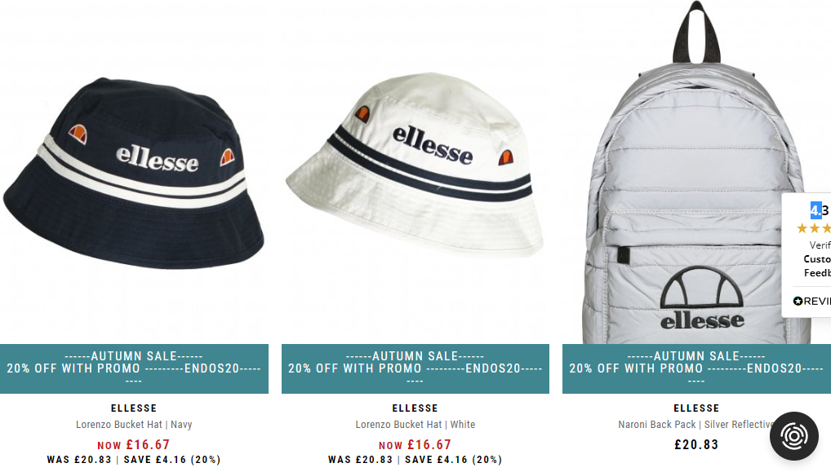

Figure 1b. Browsing on Urban Male Clothing

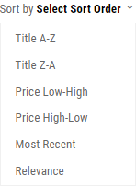

Looking over to the top right of the screen, I can see a multitude of options on how to sort the results from the query given. First are the two ways of sorting it alphabetically, ascending and descending, dependent on the item name shown. Then the options of sorting it by price, from low to high, and vice versa. Most recent is essentially sorting by date of addition, and relevance is a vague statistic, likely measured by an in-house algorithm of some sort. Possibly “Sales per Week”, or some similar statistic

Figure 1c. Options of sorting in Urban Male Clothing.

Thus, I had seen most of the website. The only thing left to analyse was the footer, although briefly. The footer is split into a tab about the brand (containing an about us, FAQ, Contacts, Discounts and loyalty points section), a tab for customer service (delivery and returns info, privacy policy, terms and conditions, security information, and a map that shows the real-life location), and a tab for brands represented.

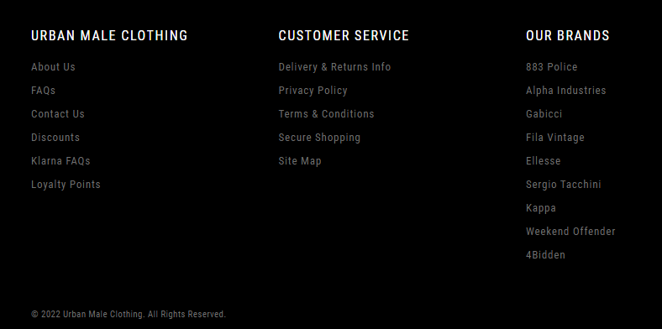

Figure 1d. Urban Male Clothing Footer

*Parts that I can apply to my solution:*

Urban Male Clothing is a prime example of what clothing seller websites look like. From what I can interpret, a navbar is near necessary when it comes to websites such as these, as the large demographic is casual users. Accounts and wishlists get further cemented, as they are also present here. Having a logo that links back to the index page is also something that I will likely do, because it’s simple and intuitive. A search bar must be included for custom queries. One feature that I didn’t originally think of is loyalty points. Adding those would promote settling into the ecosystem, thus I will likely be adding some sort of reward system. Lastly, a footer is necessary to show important information and “smoothen” the end of a webpage. One feature that I really didn’t like was that when browsing, only 3 items were shown, and when they were shown, the item took up too much space on the screen, which made it harder to go through items. Although a mobile phone might be better suited to this style of UI, the desktop shopping experience isn’t.

### Amazon

**Overview:**

Although I believe Amazon needs no introduction, in brief, Amazon is the largest e-commerce marketplace. Anything and everything that can be bought is sold there. Clothes, video games, books are some notable examples. Amazon navbar is similar to the previous one covered. It has different categories, an ability to change country, a tab that shows returns and orders. On the right edge there is a basket that shows the number of items in it. One thing that is noticeably different is that due to amazon’s nature of selling a multitude of products, there are boundless categories (aka departments).

Figure 2a. Amazon’s Navigation Bar

Then, to analyse the browsing, due to a single item being able to be multiple colours, they are shown below the image of the item. Unlike in the other two examples, hovering the mouse over the item doesn’t show a different angle, likely because Amazon sells a lot of products that don’t benefit or are actively impaired by such a feature. When on sale, items show the current price, and the old price with a line through it. Lastly, the reviews are shown under the image.

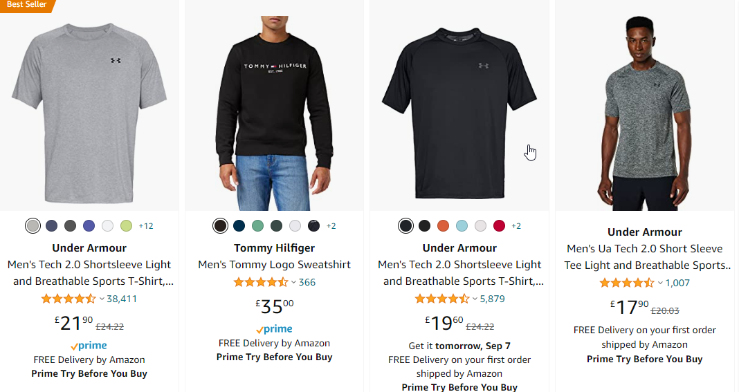

Figure 2b. Browsing on Amazon

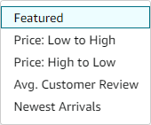After analysing the way browsing is viewed, I moved over to the “Sort By” box. There is the option of sorting by featured, sorting by price from high to low and low to high, sorting by average reviews, and sorting by “Newest Arrivals”, which is more or less sorting by date. Amazon’s footer is not worth covering, as it doesn’t contribute to any use for this analysis.

Figure 2c. Options of sorting in Amazon

*Parts that I can apply to my solution:*

Although less specialised to the cause, Amazon also has a lot of features to get inspired by. First, the navbar has an “All” tab that allows to pick categories in a more efficient way than a drop-down menu. Amazon’s browsing is better executed than Urban Male Clothing’s. 4 items are shown at a time, which is a good balance. The vertical overhead can easily be reduced as well, in order to perfect it further. Something I dislike about Amazon’s design is how generalised it is. This is unfit for a website that specialises in selling clothing, so a lot of tweaks would be needed.

### Arne

**Overview:**

Arne is the last example of an existing solution. It is similar to Urban Male Clothing, although it presents the items in a more massive scale, most likely due to a multitude of stock. To begin, a quick look at the navbar makes it clear that Arne’s website is excellently designed. The navbar is not too cramped with content and takes up about the right amount of screen space. In the centre lies the logo, with the categories to the left of it, and account, wishlist, bag and a search button on the right. It’s a discrete solution which I will take inspiration from.



Figure 3a. Arne’s Navigation Bar

Browsing in Arne shows a lot of similarities to Urban Male Clothing. When hovering over an item, a different angle shows. A simple display of colour, title and price is a good representation of the item shown. It’s also pretty easy to wishlist an item, with an accessible button on the side. Something I disliked about the design is how tightly packed the items are within a row, which makes the items less notable, and more likely to be ignored.

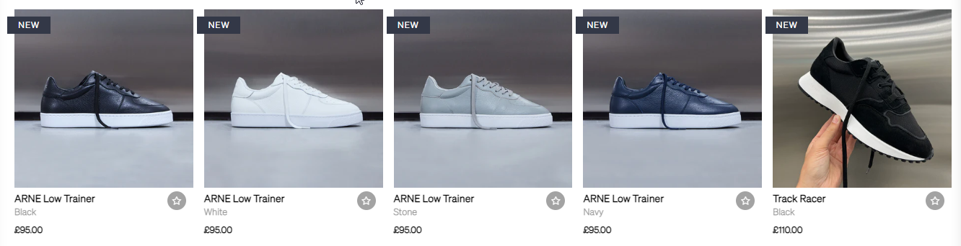

Figure 3b. Browsing on Arne

Then, there are the sorting options. Just like Urban Male Clothing, Arne has a vague statistic which I would have to infer, in this case, “Featured”. Everything else is the basic sorting settings. Descending and ascending alphabetical order, and sorting by price from low to high and vice versa.

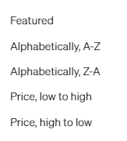

Figure 3c. Options of sorting in Arne

Lastly comes the footer for Arne. In this case, it is split in between an information column, a social media column, an “about us” column, and 2 irrelevant columns. In general, it contains mostly the same hyperlinks as Urban Male Clothing’s footer.

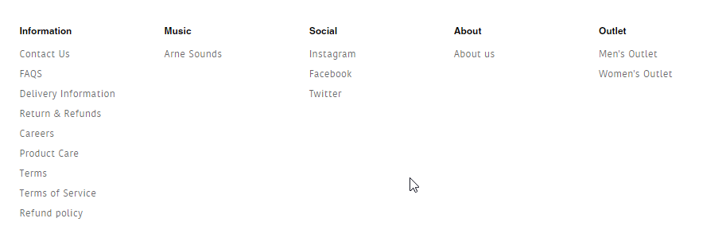

Figure 3d. Arne Footer

*Parts that I can apply to my solution:*

Arne’s website is greatly designed, and user friendly. It is very similar to Urban Male Clothing in some sense, so a lot of the criticisms for Urban Male Clothing apply. First, the sorting options for Arne seem to be a good balance between too much and too little. Their navigation bar is also well done, more efficient than the other two examples. However, their browsing shows too many items, which makes it harder to pay attention to a certain item. Furthermore, their footer is overcrowded with hyperlinks and pages that are not relevant to my solution, as I would only need up to 3 columns. Overall, a great design, with some amendments needed.

## Requirements

### Hardware

|  |  |
| --- | --- |
| Any Multi Core CPU with 1.6 GHz clock speed that supports AVX instructions | The CPU will be needed to run the software and the support for AVX instructions will be required by the machine learning package. |
| RAM 4 GB | This will be the minimum required RAM to run the code editor, browser, and server. |
| A GPU | To train the AI recommender model. |
| Minimum Disk Space of 20 GB | This will be needed to store all the dependencies and code. |
| Monitor of 16:9 (minimum 1280 x 720) aspect ratio | This will be needed to display the webpage to the user. |

### Software

|  |  |
| --- | --- |
| Windows 8 – 64-bit, or any 64-bit Linux distribution with Debian 10 or above | The operating system is needed to run the software, in particular the VS Code the internet browser, python, and git. |
| VS Code | This will be the code editor used for the development of the program. |
| Python (3.7 or newer, preferably 3.9) with Django, Stripe, Bootstrap for Django, sci-kit learn and all their dependencies. | This will be the programming language used for the main segments of the solution, such as the backend and AI. |
| Any modern web browser that supports HTML, CSS and JavaScript (Google Chrome, Mozilla Firefox, Microsoft Edge) | This will be needed to open the webpages being developed and browse them as a user would. |
| Git | This will be needed to set up a version control system (git) where the code of the project will be stored in a repository. |

## Essential Features

After all this analysis, and a meeting with the stakeholders, we had decided to finally comprise the essential features of the system so that the project could move forward. Overall, the priorities of the stakeholders lied in a simple UI, with quick response times. The rest of the essential backend features are my proposals and ideas to aid in the usability of the system.

* **Database that stores transactions, user information and items**

Anything that needs to be stored in the long term should be stored in a database. All the If a user orders something in any of the websites analysed, their order is always logged, and they can view their past orders at any time. This makes it a conventional and expected feature, which makes is essential. Furthermore, the logging of what a user orders is needed for a working collaborative filtering AI, so that they can see what other users “also ordered”.

* **Hashing algorithm for passwords**

As mentioned, passwords need to be stored somehow into the database. However, it’d be a massive data safety hazard if those passwords were stored in plaintext. Thus, a hashing algorithm is required to make the project viable. The algorithm should be irreversible, and consistent. This means that if the database is compromised, the user’s credentials will be safe.

* **A login and registration system for User Accounts**

How do you know who orders what? Technically, you can use the MAC / IP address to identify a user, but due to multiple users being able to share one device (e.g., A family computer), it would be a faulty solution. Thus, a user should instead log in to access their account and be able to also create one. Usernames must be atomic, passwords will need to be a minimum of 8 characters, with numbers ***and*** letters. This should be stored securely and easily in the database.

* **Reviewing System**

This is another requirement not only for the users to show their feedback of an item, but subsequently in the AI as well. If a user has bought an item, they should be able to review it. This review allows the Recommender AI to assess what a user likes and doesn’t like.

* **An email automation system**

If a user registers a new account or forgets their password, they must be sent an email from the server automatically to verify that it is A) Their email address, B) Them in particular. This means that I will have to add an email automation system.

* **“Featured” Heuristic Algorithm and Recommender AI**

Lastly, there is the two recommendation systems. The Featured Heuristic system will allow for increased exposure of items that sell well whenever shown on the front page, which can get rid of excess stock, and increase the overall rate of purchase. This is a request from my clients, which made it essential. The Recommender AI is also essential, as it allows for an ecosystem to be created within the website such that users will *want* to come back.

* **A payment processing system**

One of the most important features of this implementation is the payment system. If the user purchases an item, the website must charge them before processing the order and shipping, for obvious reasons. This functionality will most likely be implemented with an API that allows for interfacing with banks.

* **Management Sector**

The Clients need a way to see if the website is doing well and have objective statistics to keep track of when monitoring the progress of the website weekly. They also need to occasionally make manual changes to the database, if they sell an item in the real store etc. This justifies and requires a separate sector of the website that is only accessible to “Management Accounts”. They can perform CRUD (Create, Read, Update, Delete) operations on items and view the statistics.

* **Visualisation of Statistics**

These statistics should be shown in an easily accessible format such that the client will understand what they are looking at. This will be directly assessed by the client, and mostly involves the use of plotting libraries and tweaking the settings to a comfortable configuration on different types of measurements (deviation, frequency etc.).

* **Appealing Front End User Interface**

As per all the stakeholders’ requirements, it is one of the essential steps at the end to make an appealing front end that is easily accessible. Although during most of the development the frontend will be in its barebones form that allows for me to focus on the backend development, and interfacing with any APIs needed, I eventually have to fully migrate the user interface to be more appealing in order to make it

## Limitations

One limitation of my solution is that the quick loading times might be limited by the user’s computer or network. If a person has a less capable internet connection, this might result in slower loading times. Thus, testing the loading times on one machine might not hold a global result. There is no easy way to further assess how fast the website is loading without possibly inaccurate test data sent by actual users, which falls beyond the scope of the A level project.

Another limitation of my solution is the fact that the recommendation system is prone to review abuse, via so called “review bombing / shilling”, where reviews are done regardless of the actual opinion of the users en masse. This is done to skew the recommendation system towards recommending a certain item, or the opposite. Overall, this results in a corruptible recommendation algorithm, as there is no easy way to tell the real reviews from the fake ones.

## Success Criteria

|  |  |  |  |
| --- | --- | --- | --- |
| Requirement ID | | Requirement | Evidence |
|  |  | **Database** |  |
| 1 | 1.1 | The Database can contain user accounts. | Screenshot of the database format for user accounts with test data. |
| 1.2 | The Database can contain items. | Screenshot of the database format for items with test data. |
| 1.3 | The Database can contain manager accounts. | Screenshot of the database format for manager accounts with test data. |
| 1.4 | The Database can contain reviews. | Screenshot of the database format for reviews with test data. |
|  | 1.5 | The Database can contain order info to show past orders. | Screenshot of the database format for orders with test data. |
|  | 1.6 | The Database can handle CRUD queries. | Screenshot of code and test for each query (Create, Read, Update, Delete). |
|  |  | **Password hashing algorithm** |  |
| 2 | 2.1 | The server can convert a plain text password into a hash. | Screenshot of the code and evidence of testing hash conversion with input and output. |
| 2.2 | The hash function is consistent with a provided sample text. | The previous evidence will be repeated two more times, to show consistency. |
| 2.3 | The hash function has virtually no collision cases. | The first 10000 “rockyou.txt” passwords will be checked against the hash function. The collision frequency should be less than 1%. |
|  |  | **User account system** |  |
| 3 | 3.1 | The server can create user accounts without activating them. | Screenshot of the code and evidence of testing the creation. |
| 3.2 | The server can activate accounts. | Screenshot of the code and evidence of testing the activation. |
| 3.3 | A login can be authenticated by the server by comparing credentials (username and password hash). | Screenshot of the login authentication code and evidence of testing for normal and erroneous data. |
|  | 3.4 | The server won’t allow accounts that aren’t activated to log in. | Screenshot of the code and evidence of testing if entry is stopped. |
|  | 3.5 | The server can delete a user’s account. | Screenshot of the code and evidence of testing the deletion. |
|  | 3.6 | The server can reset a user’s account password. | Screenshot of the code and evidence of testing the method for changing. |
|  | 3.7 | The server can’t overwrite existing account when registering user. | Screenshot of evidence with proper error handling. |
|  |  | **Reviewing System** |  |
| 4 | 4.1 | A user who has bought an item can review it, and vice versa. | Screenshot of code and evidence of testing the reviewing method. |
| 4.2 | Reviews that are placed can be stored and read. | Screenshot of evidence of testing storage and reading of reviews. |
|  |  | **Email Automation System** |  |
| 5 | 5.1 | The server has its own “no reply” email address which can’t receive messages. | Screenshot of the email address and evidence of attempting to send email to it. |
| 5.2 | The email address can send mail to other addresses. | Screenshot of code and evidence of testing email function. |
|  |  | **“Featured” Algorithm and Recommender AI.** |  |
| 6 | 6.1 | The Featured Algorithm is not too slow to run. | The time complexity of the algorithm is less than O(n!). |
| 6.2 | The Featured Algorithm segregates the well performing and bad performing items. | Screenshot of code and evidence of the featured algorithm performing segregation of items. |
| 6.3 | The Featured Algorithm is implemented and works. | Screenshot of code and evidence of testing if the output is as predicted. |
| 6.4 | The Featured Algorithm is automatically called every week. | Screenshot of code and evidence of testing if the code repeats weekly. |
| 6.5 | The Recommender AI is trained and can produce expected outputs. | The predictions given by the AI should align with the test data set by at least 80%. |
| 6.6 | The Recommender AI is implemented into the server. | Screenshot of the code and evidence of the AI making recommendations to users. |
|  |  | **Order Processing** |  |
| 7 | 7.1 | The website has a checkout section. | Screenshot of the code and checkout section. |
| 7.2 | The API chosen can process credit and debit cards. | Screenshot of tests that show it processing debit and credit cards. |
| 7.3 | The website can take in payment info and make a withdrawal. | Screenshot of code and evidence of testing a money withdrawal. |
| 7.4 | The website can handle the placement of orders. | Screenshot of code and evidence of testing placement of orders. |
| 7.5 | The website can process refunds. | Screenshot of the code and evidence of testing the refund feature. |
| 7.6 | The website can process cancellation of orders. | Screenshot of code and evidence of a testing order cancellation via frontend. |
|  |  | **Management Sector** |  |
| 8 | 8.1 | The management sector can only be accessed by “managers”. | Screenshot of a 403-type error when a non-manager tries to access management sector. |
| 8.2 | The management front end only supports dropdowns for input | Screenshot of frontend input dropdowns. |
| 8.3 | The management sector can execute, and output read instructions. | Screenshot of code and evidence of testing read function on management sector |
| 8.4 | The management sector can execute deletion instructions. | Screenshot of code and evidence of testing delete instruction. |
| 8.5 | The management sector can execute update instructions. | Screenshot of code and evidence of testing update instructions. |
| 8.6 | The management sector can execute creation instructions. | Screenshot of code and evidence of testing creation instructions. |
| 8.7 | The backend must also validate if a user has the permission to execute a certain instruction. | Screenshot of code and evidence of testing if a user can execute instruction with insufficient permissions. |
|  | 8.8 | The order queue must be visible and functional. | Screenshot of code and evidence of testing the display and operations of order queue. |
|  | 8.9 | The design of the management sector must be easy to use. | Feedback from stakeholders via a 1-10 rating. |
|  |  | **Visualisation of Statistics** |  |
| 9 | 9.1 | The management sector can retrieve statistics from the backend. | Screenshot of code and evidence of testing the retrieving functionality for statistics. |
| 9.2 | The management sector has visually representations of data. | Screenshot of code and evidence of testing visual representation of data. |
| 9.3 | The visualisation result has gotten the approval of the stakeholders. | Feedback from stakeholders via a 1-10 rating. |
|  |  | **Appealing Front End User Interface with Quick Loading Time** |  |
| 10 | 10.1 | The front end represents the UI designs made in the design stage. | Comparing the UI design to the final UI. |
| 10.2 | The front end has been reviewed by the stakeholders. | Feedback from stakeholders via a 1-10 rating. |
| 10.3 | The front end can load within the given threshold. | The website loads within 5 seconds of entering the link. |
| 10.4 | The front end has a dark mode setting. | Screenshots of the dark mode UI. |

# Design

## Decomposition

The first action of importance was to begin with a decomposition of the great number of tasks that there are in a solution like this one. I began by imagining common customer actions which are required for the solution to function, and eventually made this diagram.

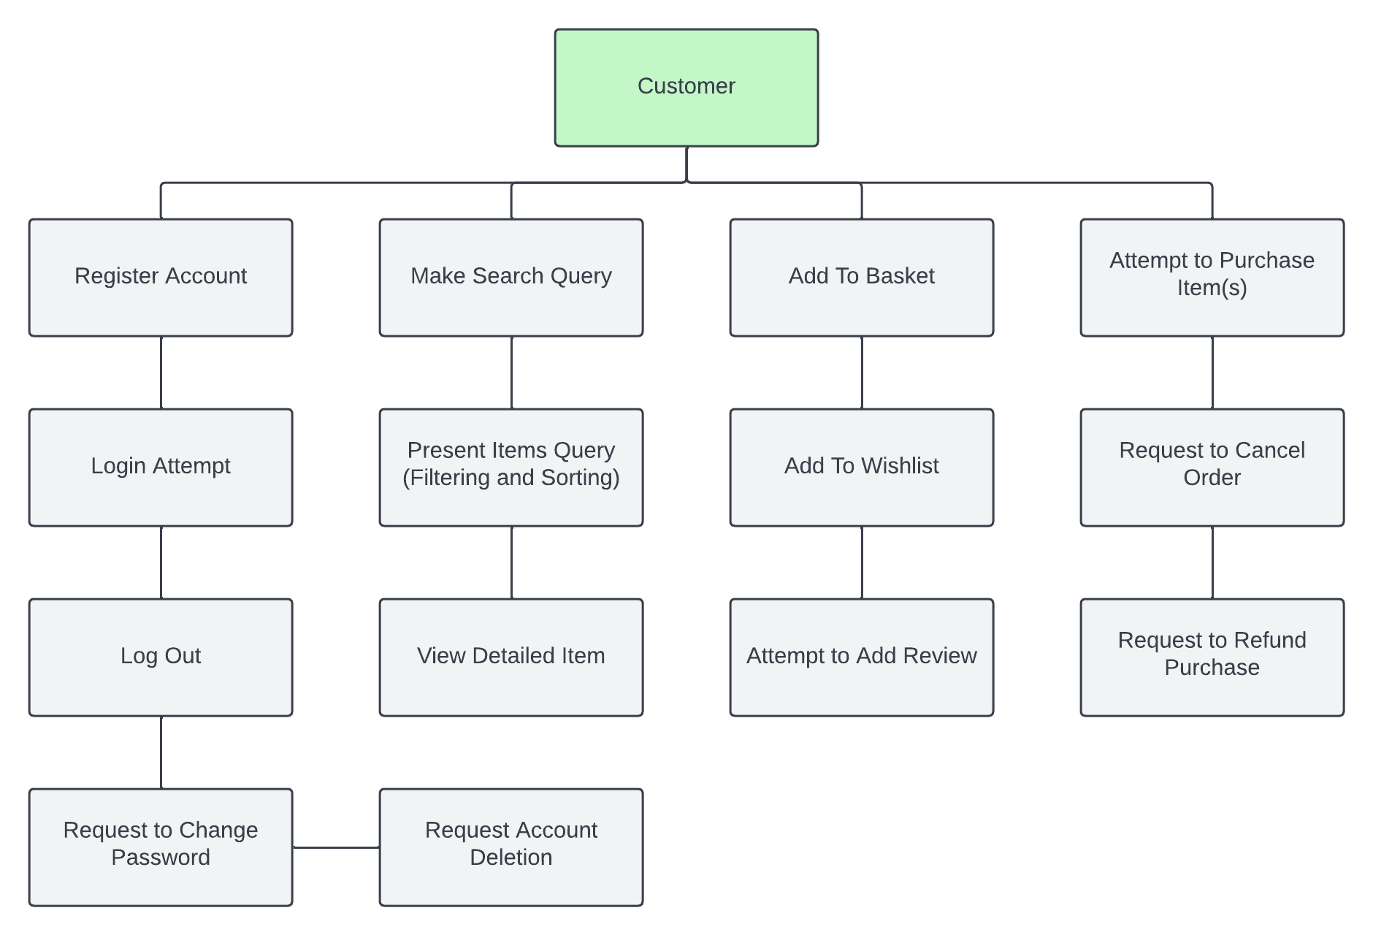

Figure 5a. Customer Decomposition Diagram

In the heart of the concept, a customer can browse and buy. This is better broken down into the account actions, query actions, usability features, and payment actions. The account actions are needed to recognise which customer is which. If someone wants to be able to get recommendations and see their order history, as well as leave reviews, they must be identifiable. Otherwise, anyone would theoretically be able to see what one orders, which is a massive privacy violation. Thus, an account system is needed. If one wishes to browse, they must query the database about the selection of items, or a particular item in detail. The usability features are there to enhance the user experience, such as convenient item storage for certain items and reviews to see the opinions of other customers. Lastly, when the decisions are made, the items are bought, which is only possible with a set of payment actions, such as buying, refunding, and cancelling. I decided that this shade of green would be associated with customers.

After that I remembered that the other type of user inside such an ecosystem would be the manager, who is interested in the business side of the website. I thought of every possible need for a manager figure and created this diagram.

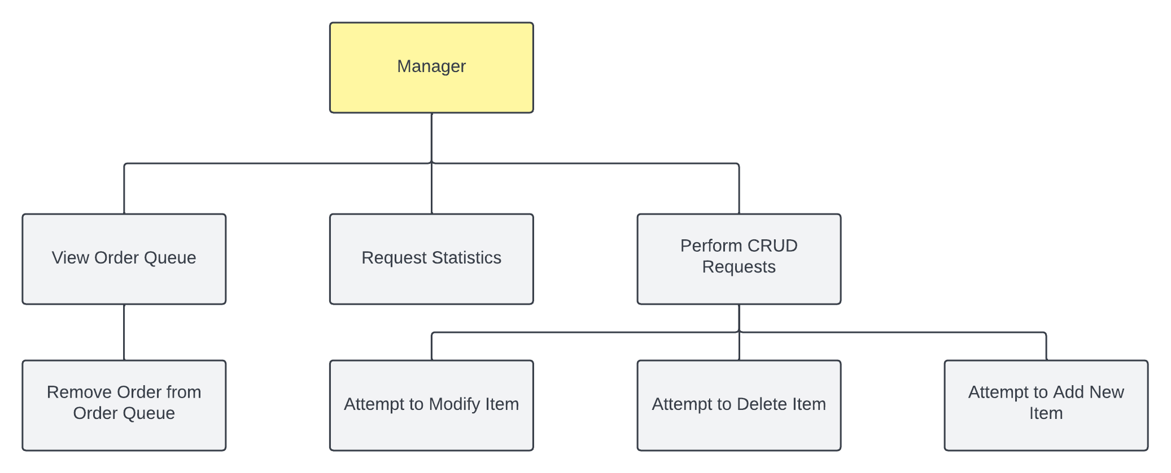

Figure 5b. Manager Decomposition Diagram

For a manager, business is key. They handle the shipping of orders, the addition and removal of stock, and are the biggest stakeholders of the website. If a managerial section misfunctions, they are losing potential profits. Therefore, the best system for orders I could think of was a system on a queue, a First In First Out data structure. This is because the person who orders first should theoretically get the order sent first. This also simplifies the workflow of packaging. Then statistic reports allow the manager to see how the website is performing, with granular control of exactly where the most profits are made, and their overall income. Lastly, when new stock becomes available, it must also appear on the online shop, so a simplified interface for CRUD (Create, Read, Update, Delete) operations is key to the managers, who are unlikely to have a technological background. All these operations are added to a management sector inaccessible to customers, akin to the back of a shop.

After plotting all the potential actions that could be taken as input to the website, the backend, the server side was the next decomposition to make. A bare minimum to meet the standards of the given input. In the case of managers, this shade of yellow seemed to fit as the associative colour.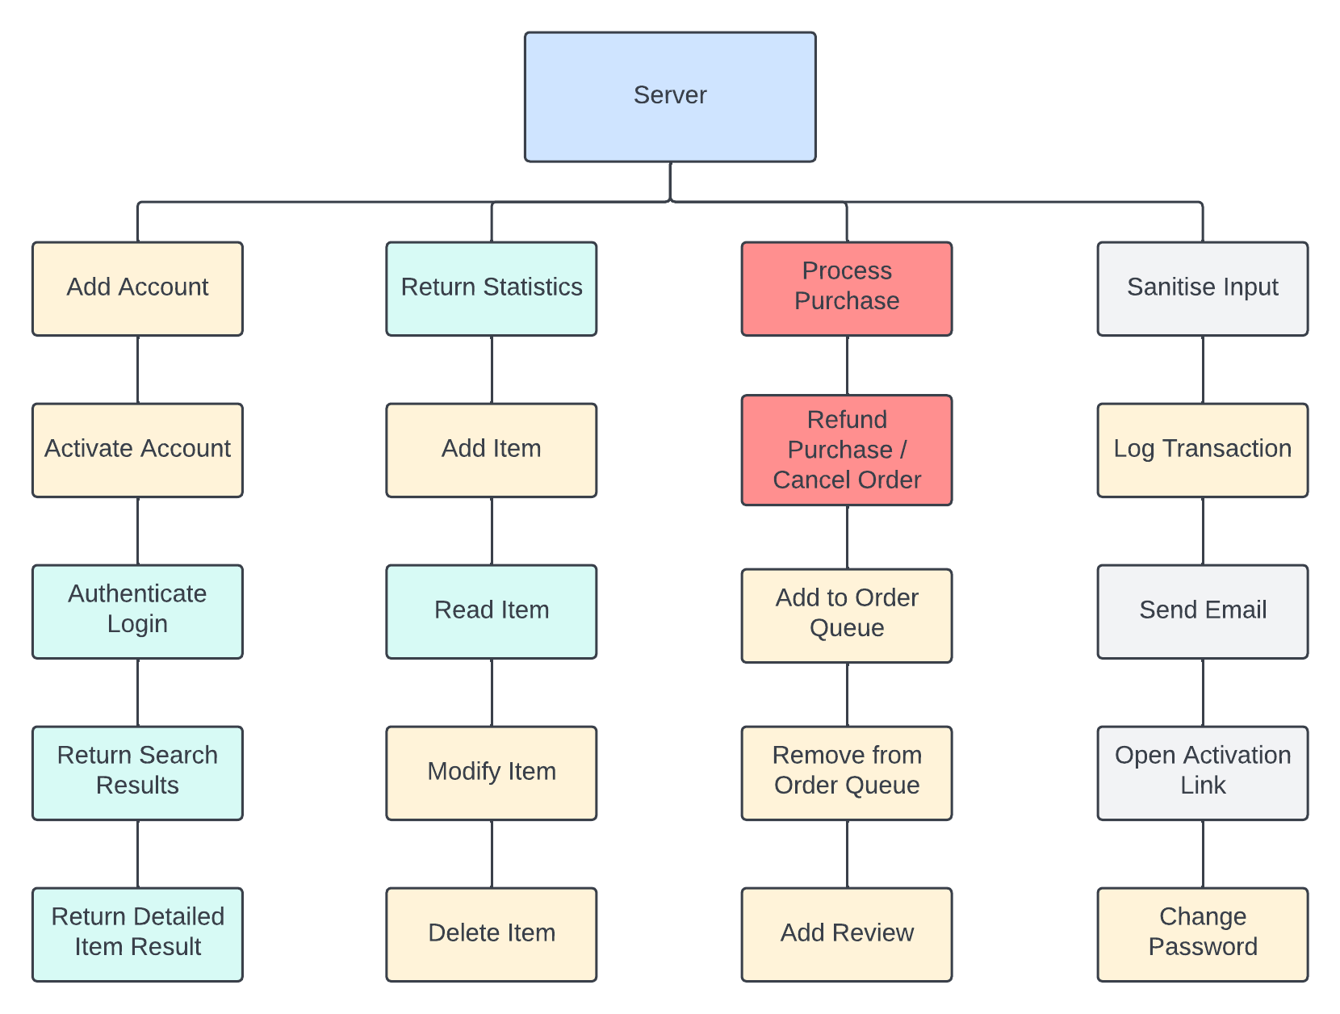

Figure 5c. Server Decomposition Diagram

What the server does is automate the job of the whole store, to handle requests from customers and managers, respond to redirections and process purchases, while keeping itself secure. Actions in transparent orange perform some type of writing action to the database, while the cyan ones are read-only actions. The red actions are associated with the payment processing in the server, and grey ones are for everything unrelated to the database. The first set of actions is that of the customer actions. These are related to the customer experience, such as account creation, authentication and browsing. The second set is the managerial actions. A CRUD operation stack, as well as the ability to return statistics upon a request. The third set are the order actions. Orders can be placed and cancelled, which innately impacts the order queue, while reviews follow an order. Lastly the fourth set is that of general utilities. As a rule of thumb, blue was set as a colour associated with the server.

Now what was the use of all this colour annotation? It makes the top-down program design much clearer in the sense of what is occurring. The final top-down design ended up as such.

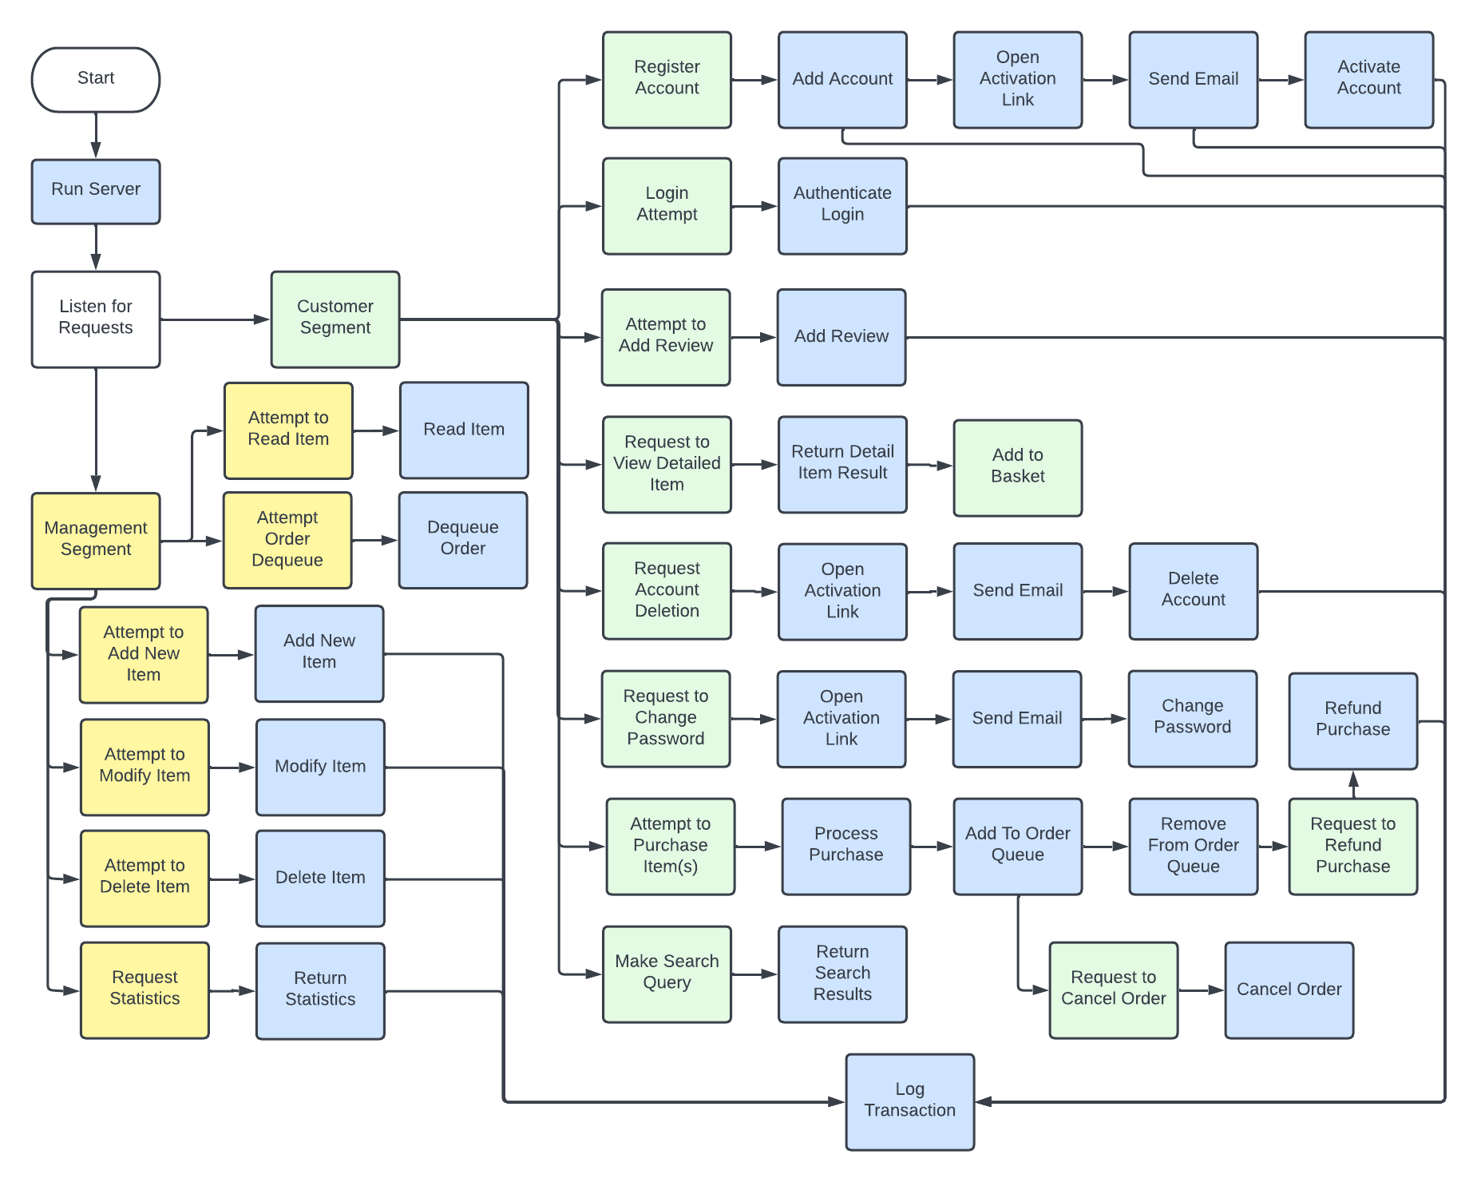Figure 5d. Top-Down Program Design

## User Interface Design

To interact with the website the users need a User Interface (UI). Thus, I need to design a usable interface that properly conveys the information from the database etc. I started off with a design for the browsing of the items, along with the navigation bar design.

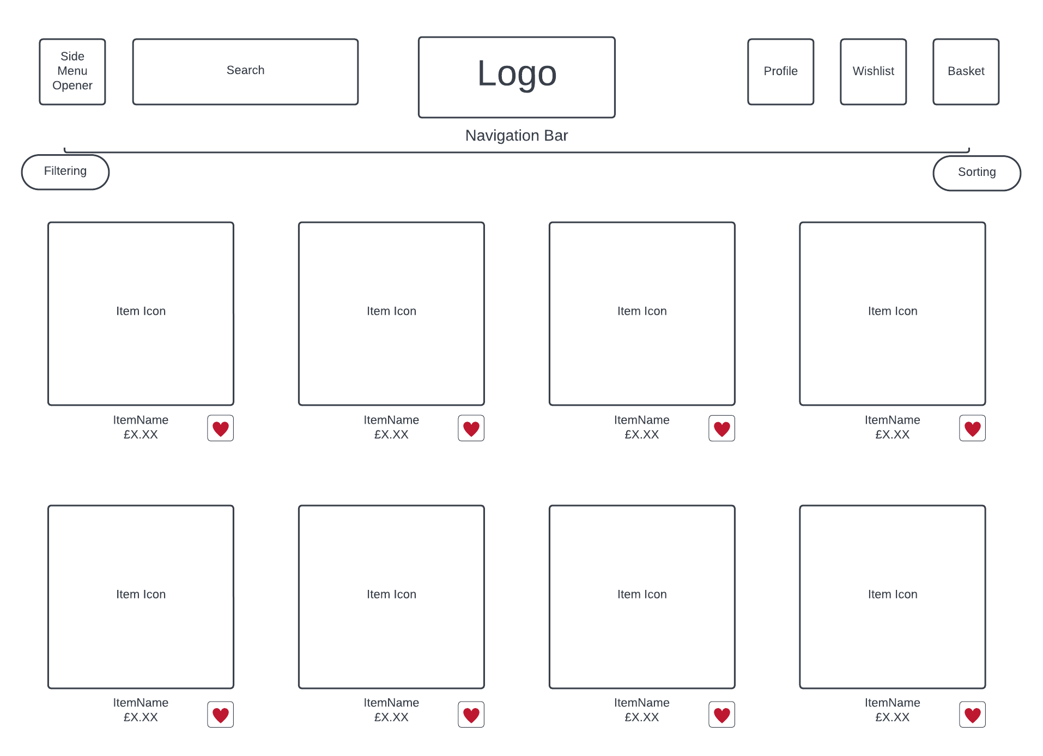

Figure 6a. Navigation Bar and Item Browsing Design

In most websites, the pattern for navigation bars was a top-centre alignment with a logo in the middle. Clicking the logo leads the user to the front page. This feels intuitive, and as such, I took that into consideration. A search bar is also necessary, so it was added alongside the logo, to be easily accessible. When on the front page, if the user is interested in certain categories of items, they would click a “categories” button to only see that category. However, I decided against having that in the nav bar for the sake of a less cluttered screen. Instead, a side menu seems like a more elegant option. If the user wishes to access their profile, wishlist or basket, they need a hyperlink to take them there, but those three tend to be often accessed, so hiding them in a slew of menus would make them harder to find, thus I decided to not use the side menu, instead putting them side by side on the navigation bar.

Then come the items, which should be represented in a desktop friendly way. As described in the analysis, 4 items seem to be the perfect amount. The item icon being shown as a big square is a design choice that makes the UI more accessible to people who have impaired eyesight or motor control. A bigger box is easier to see and easier to click. Then, only showing the essentials is important, to not overwhelm the user with information that should be omitted. The item name and cost are the two significant pieces of data that a customer cares about when they see a piece of clothing. The quantity should not be shown for two reasons. One is that the quantity is only seen as important if they’ve already taken a liking to the item, so displaying it otherwise would be redundant. The other is that if a user shows some interest in an item, but is not certain, the quantity not being show creates some sense of intrigue. A possibility of scarcity causes them to take further notice. Lastly to allow the user to pace themselves and save the items they’re interested in looking at later without having to change page, a wishlist button is also a good addition.

Then, if a user clicks an item, they should see a detailed view of an item with any other data of importance, as well as being able to add the item to their basket. So, I made this design to reflect that.

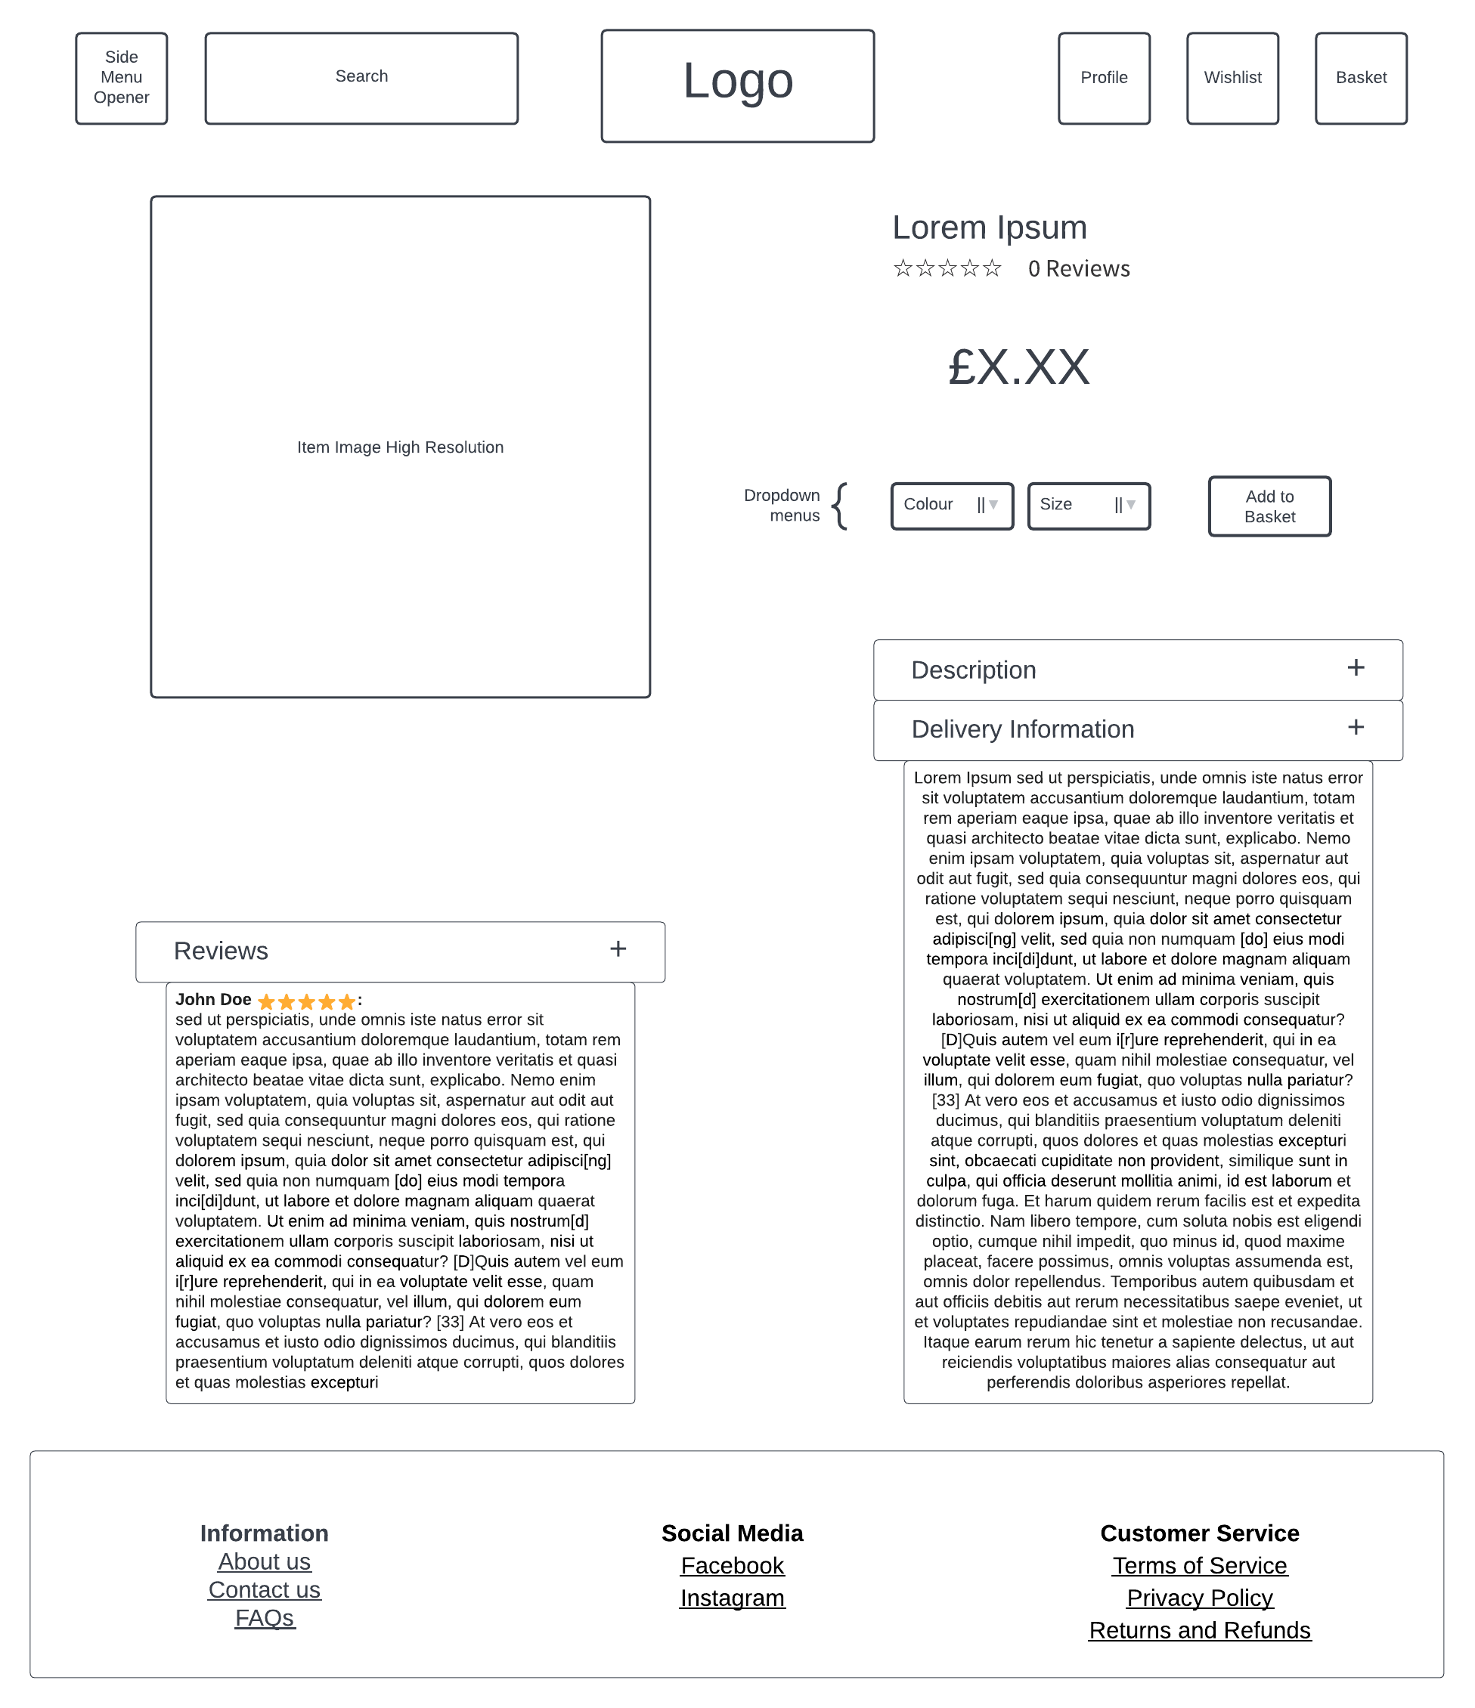

Figure 6b. Detailed Item and Footer Design

First things first, as in all websites, the navbar is inherited over all the customer side pages, not just the front page, in order to show consistency. Onto the new designs, the Item image is now in much higher resolution. This is because when only showing one item, it’s permissible to show it in higher resolution, while delivering hundreds of items makes it logical to heavily compress the file size for the sake of quicker loading times. The big “Lorem Ipsum” text is where the title of the item goes. Putting it in a large font to the right of the item allows for a design that can fit both the image and text in parallel without one being off to the side awkwardly. The reviews are shown right under the title, because that seemed to be the most convenient place to fit it. Not showing the reviews next to the title makes it unintuitive to find. The price is then shown in big text, which is done for easy readability. Colour and Size are picked via dropdowns, which is user friendly compared to any other methods, like manually typing them in. Then, Description and Delivery Information show their respective fields. However, unlike a price, title or image, those fields are less needed to decide on an order. Therefore, it makes logical sense to hide them in a drop down. The same goes for reviews, as not everyone is interested in reading reviews, so hiding them allows for someone to easily reach the footer for whatever need. Speaking of which, the footer is located at the bottom of the page, as that is the convention established during my research. I only added the information that fit in with my research and my client’s needs, thus no social media my client doesn’t have, nor any other irrelevant details.

With that done, the UI design for the management sector was left.

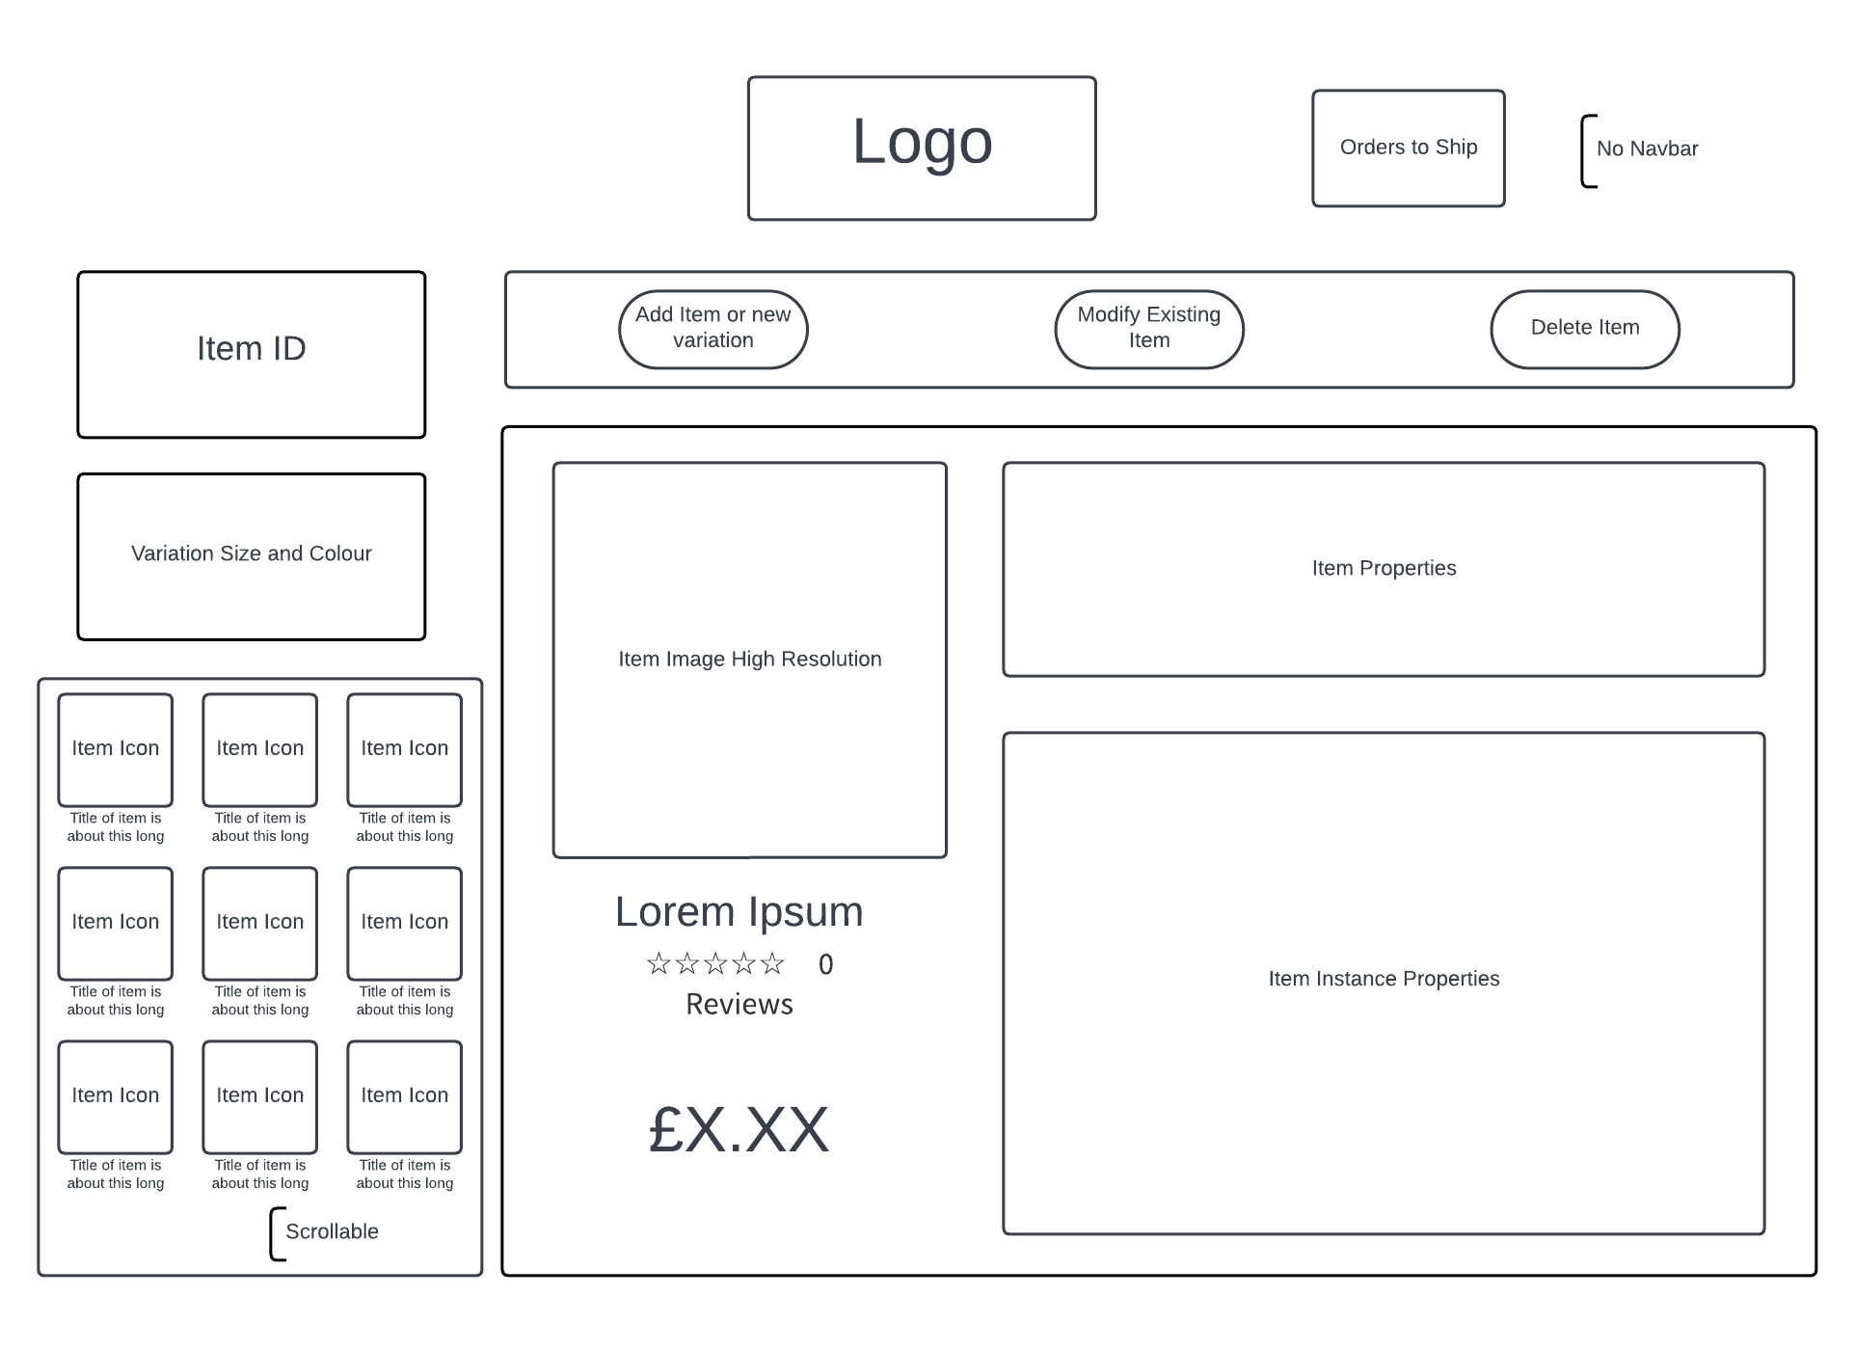

Figure 6c. Management Sector Item Modification UI

This design is only meant to be seen by a managing user, so a flashy UI is insignificant in the face of simple and easily usable UI. The navbar is no more, as there is no need for a following part of the page. The first thing to take notice of is the two input areas, one for Item ID, and another for variation and colour. This design allows for specific queries when the manager is aware of the identifier of a record, sparing them time. Below that is the scrollable collection of all items. In the case that a manager isn’t aware of the Item ID or instance they are looking for, they can find it by scrolling through the items shown there until they find their desired item. Then, the operation specifier is the collection of three buttons below the logo, and each button changes the operation that is carried out, be it a Create, Update or Delete. The high-resolution image, title, overall review, and price are shown on the left side, while the property input fields are on the right. This is all done to convey the item information in the least overwhelming way possible, so splitting the two different uses in the middle is a good design choice to make.

Lastly, if the manager wanted to start packing, shipping and marking orders as complete, they would have to have direct access to the order queue. And for that, further design is needed.

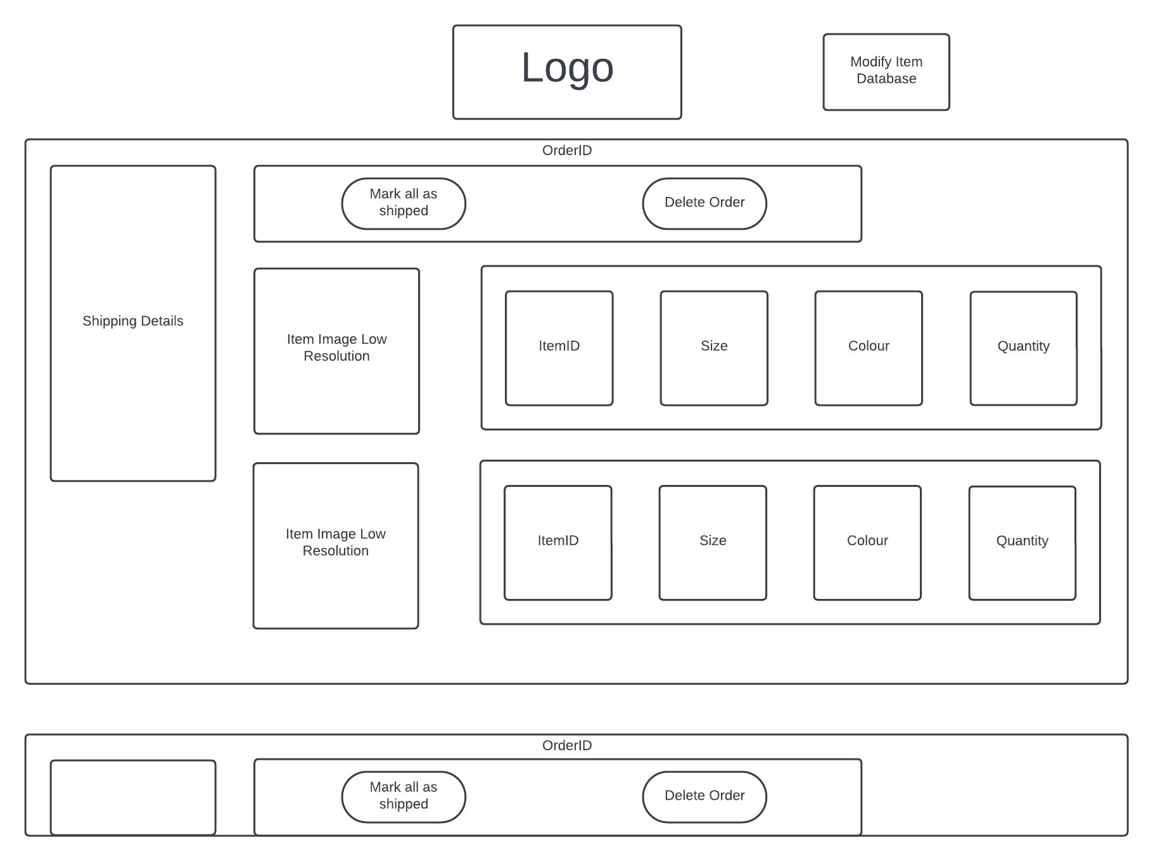

Figure 6d. Management Sector Order Queue UI

The thing that I prioritised when designing the management sector was simplicity, so the layout chosen was a pretty good balance. The scrollable page is split into big containers which are isolated as separate orders. The Order ID is shown to identify said orders. Then, the shipping details are shown on the leftmost side, with room to fit shipping details, regardless of the size. The operational buttons return, but with different operations. Mark all as shipped is the operation that conveys that an order is shipped, removing it from the order queue. If the order cannot be completed for whatever reason, the manager can delete it, which will result in its cancellation. Then, there are the order lines, displaying each item instance that was ordered in a straight sequence. This shows all identifying features of an item instance.

## Database Design

Due to the solution’s nature, there is a large amount of data to record permanently. This means that a database is necessary. As such, I began making a database design.

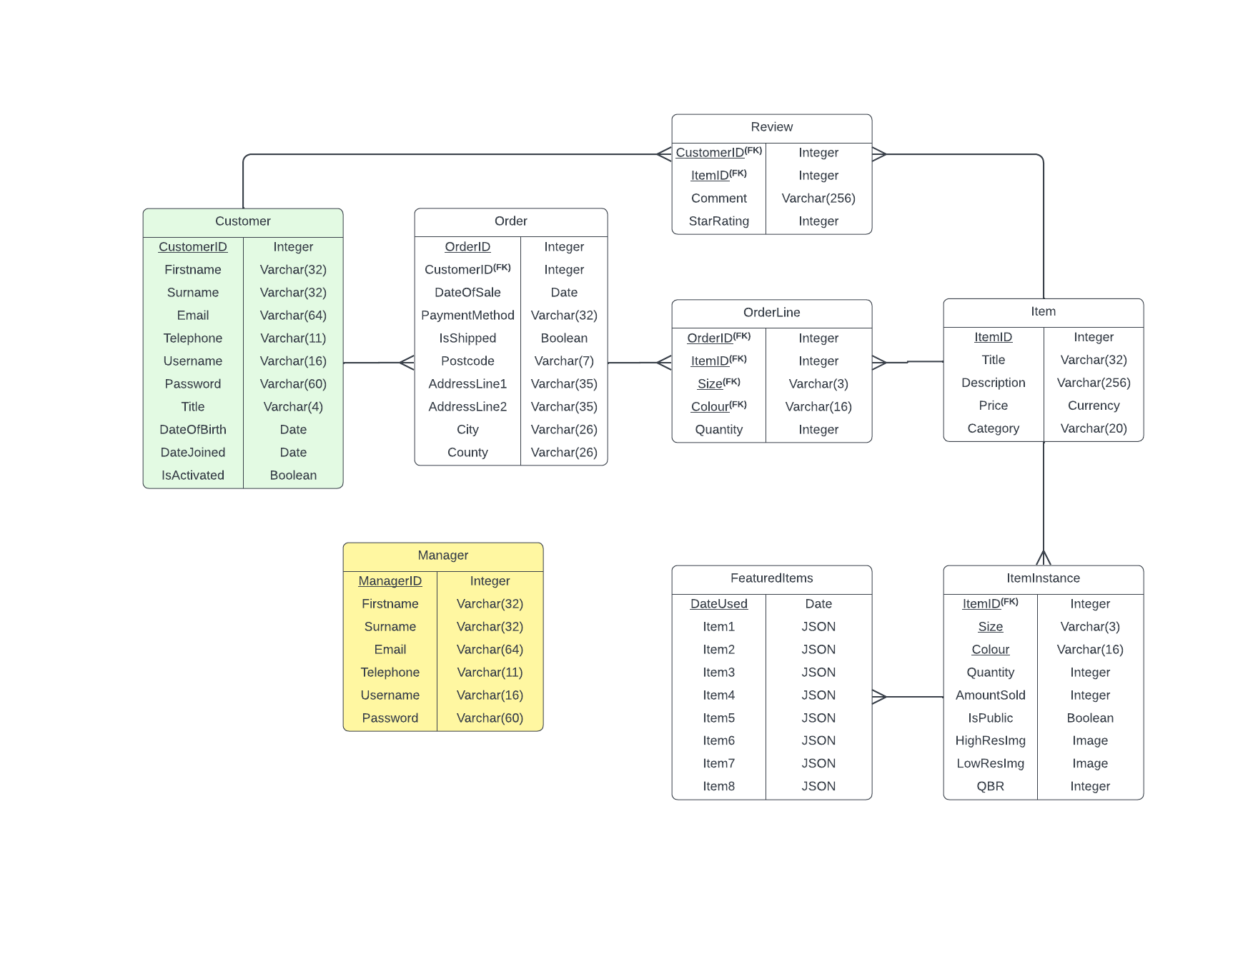

The final database design came out as so. It starts with a Customer table. The reason for the first name, surname, email, title, and telephone number fields is to know how to contact the user and how to refer to them. Username and password are used for login authentication, the two dates are used for purposes of not advertising wrongfully to minors in the future of the website. Lastly, IsActivated is needed to know if the user has proven themselves human. The same applies to the fields of the Manager table. The Order table refers to a singular order placed at a certain day. The record shows who placed the order, date of sale, for statistical purposes, and refunding purposes. The rest are shipping details. Then, there is the OrderLine table. It’s a must to not only make the database plausible, but also to maintain normalisation. An order can theoretically contain an infinite number of items of different IDs, so how are those best stored? A link table. OrderLine’s existence makes it easy to add more items to an order and maintains a one to many relationship between the Order and Item.

Speaking of which, the Item table contains the Title for the ability to search and recognise items, as IDs are not memorable. Descriptions are an opportunity to elaborate on the materials of the clothing etc. Lastly, the category field is there for the purpose of easy sorting through the side menu where the user can look at a certain category of items. So, what is an ItemInstance? One item of a certain price can have multiple variations of size and colour, which all have different quantities, images, QBRs (more on those later), and amounts sold. Storing any one of these in the Item table would make the data inaccurate, as all those fields are dependent on the size and colour. Thus, for the database to be in 3rd normal form, a separation was necessary. A composite key of three fields is used because adding an ItemInstanceID field would still leave a non-key dependency with the ItemID, Size and Colour. The LowResImage field is used to store the compressed HighResImage to avoid needless repetition of the compression process. Then, the Review table is simple. A user can only leave one review on a single item. Thus, the primary key can be the CustomerID and ItemID together. The StarRating stores the 1-10 rating of the item by a given user, instead of 1-5, in order to not use unnecessary floats. Star ratings can only have a decimal place of X.5 or X.0, which allows me to instead divide by 2 upon display and make massive savings on storage space. The comment is an opportunity to elaborate on the item’s rating, a boost in user expression. Lastly, the FeaturedItems table, which stores the featured items per week is used in the QBR calculation and featured items picking algorithm. A date of generation will never repeat, thus the date can be used as the primary key, as the featured items are generated once per week. For the sake of simplicity, the ItemInstances are stored as JSON records containing the ItemID, Size and Colour.

## Statistics

One other thing to take notice is the statistics picked and their visualisation. This was mostly picked by my client during the interview. The 4 statistics are as follows:

### Income

As per the client’s request, one of the statistics measured is that of the income between two dates. This will allow the client to see how much net income is coming in during a certain period. Since the income is a static value, the number of pounds made will be shown.

### Quantity Sold

My client also wants to know how much stock was sold over a certain period. This also being a static value, the number of items sold will be shown.

### Top 5 Items

The top 5 best-selling items are another statistic that I need to implement. This is going to be shown in the form of the 5 items’ icons next to numbers.

### Current Users

Lastly, the current users are going to be shown as a line graph, as the gradual drops and jumps in user activity are best expressed as the spikes and troughs of a line over time.

## IPSO Table

|  |  |  |  |
| --- | --- | --- | --- |
| Input | Process | Storage | Output |
| Checkout Details:   * Email * Card Number * Month of Expiry * Year of Expiry * CVC * Cardholder Name * Items Ordered * Postcode * Address Line 1 * Address Line 2 (Nullable) * Town/City * County (Nullable) | * Data is sanitised. * The payment will be attempted. * Upon success, the order is stored, along with its OrderLines. * Failure results in unsuccessful status. * The transaction is then logged. | Order Table (Delivery Details)  OrderLine Table (Items Ordered)  Stripe Database (Payment Details) | * If it succeeds the user will get an email response of success and be redirected to the success page. * If it fails, return cause to customer. |
| Registration Details:   * First Name * Surname * Email * Telephone Number * Username * Password * Title * Date of Birth | * Data is sanitised. * If all the data is valid, and no conflicts are encountered, the account is added with a hashed copy of the password. * Failure results in unsuccessful status. * The transaction is logged. | Customer Table | * If it succeeds, the user is sent an email with a verification link to activate their account. * Otherwise, the user gets a response of failure. |
| Login Details:   * Username * Password | * Data is sanitised. * The user’s hashed password is compared to the hashed input password. * Failure results in unsuccessful status. * The transaction is logged. |  | * If successful, the user is sent to their session, and redirected to the front page. * Otherwise, the user gets an error response |
| Search Query:   * String of search | * Data is sanitised. * The string is used to make an exact query of the items in the database. |  | * The resulting items are returned in a certain format (to show as in UI design) to the requesting customer |
| Manager Query:   * Username * Password * Action Type * Context (varies) | * Data is sanitised. * The Username and password are used to validate the manager. * Depending on the action type, a different subroutine runs. * The context is given as parameter. * Failure results in an unsuccessful status. * The transaction is logged. | Item Table  (If an item was subject)  Item Instance Table (if an item instance was subject) | * If successful, the database is modified as the manager requested. * Otherwise, no changes are made to the database. |
| Review Placement:   * Reviewed Item ID * Comment * Star Rating | * Data is sanitised. * The database checks if the user has bought the reviewed item before. * If so, the review is written. * If not, a failure state is automatically triggered. * Failure results in an unsuccessful status. * The transaction is logged. | Review Table |  |

## Algorithms

### Logging Algorithm

The logging algorithm will be used as a means of storing actions that occur around the server. There are certain actions which get logged. The log structure is split into subject, id, type, status and time. The subject is as the name suggests, referring to the subject of logging. The id is used to identify actors. The type is used to generate the log description, while the status and time are used to show the analytical information in case of malicious actions. When provided with correct parameters, the message is added to the LogQueue to be added to the day’s txt file.

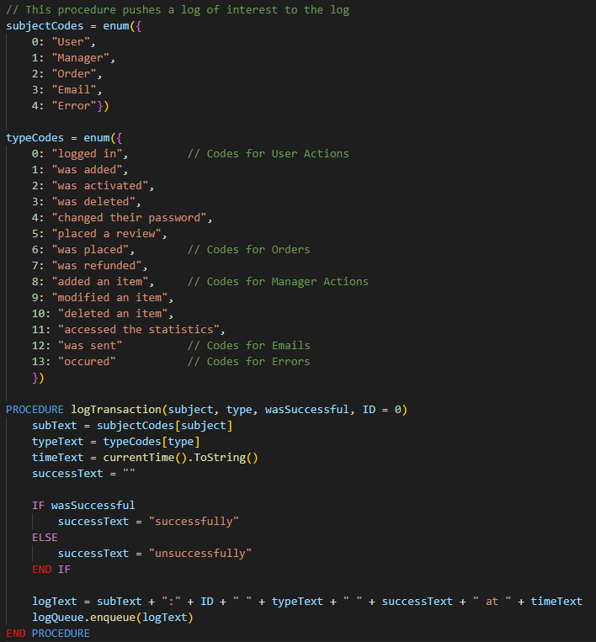

### Verification link Algorithm

This algorithm will be responsible for ­the creation of verification links with a unique token which will be used for the verification of users over email. It randomly generates tokens until a unique one is created. Depending on the reason for creation, a different action will be chosen to use as the action part of a “Token Dictionary”, which will define tokens adjacent to their actions. 24 hours after creation, the token will be removed. If any error occurs, the interaction will be logged.

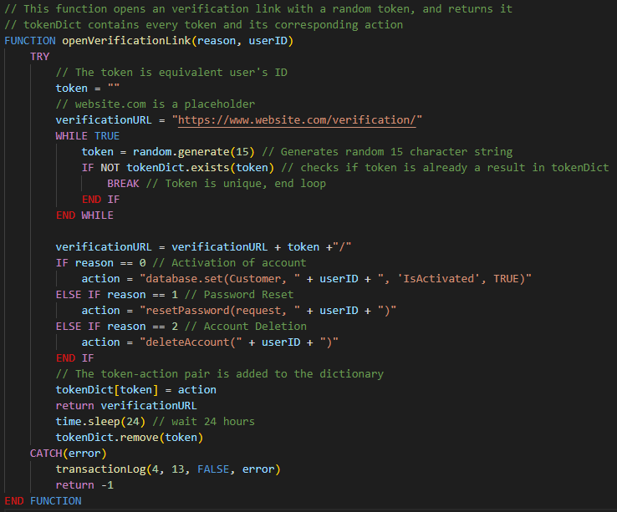

### Account Creation Algorithm

Account creation takes in registration info and creates a new instance of a user with it. This also involves hashing a password to make it scrambled. After the user is added, a link for verification is opened, and sent to the user’s email to verify that they own that email address. If anything goes wrong, the transaction will be logged as failed, as well as the normal log in the end, which will be marked as successful or unsuccessful.

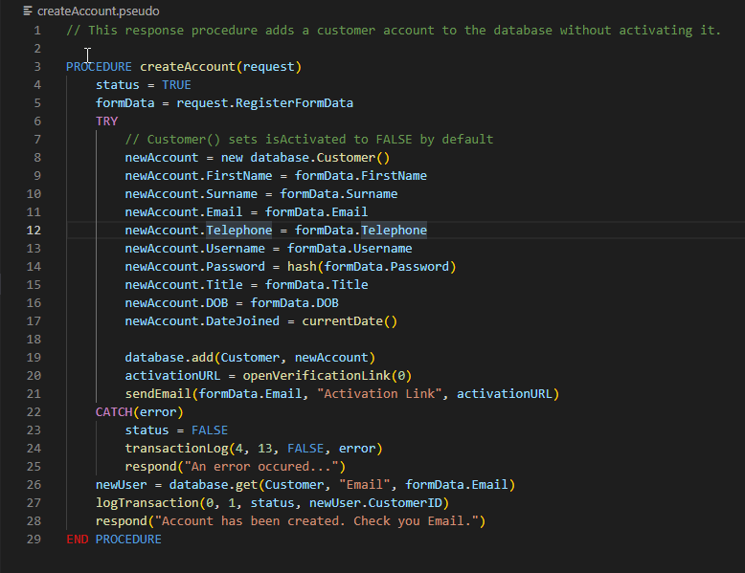

### Authenticate Algorithm

The authentication algorithm is essentially responsible for the log in of a user. Given a username and a password, it hashes the password given and then logs in the user by creating a new session if the user provided exists, is activated and has the same hash as the given passwords hash. In the case of failure, it will log it as an error. It will also log the attempt with the status.

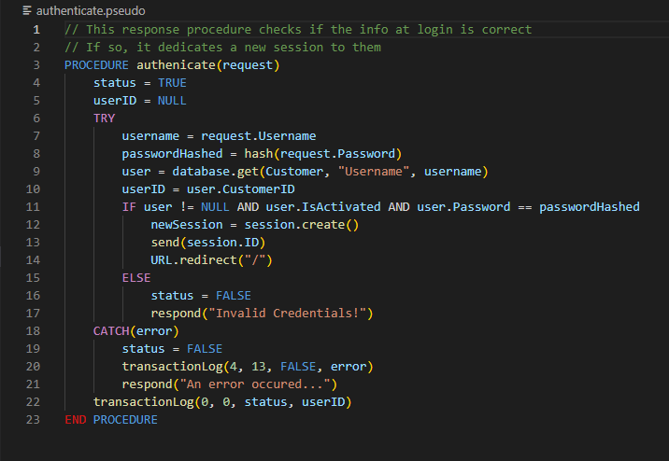

### Reset request Algorithm

The reset request algorithm is responsible for setting up the password reset token and sending it to the user. If an error occurs, it will be logged.

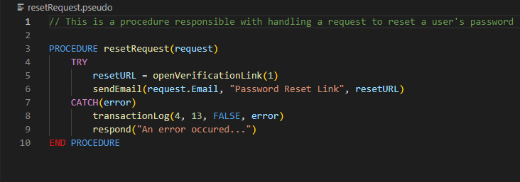

### Password reset Algorithm

The password reset algorithm is responsible for handling the previously opened up verification link. When it is triggered, the password will be changed to the new password provided by the user. Like with the previous algorithms, if anything goes wrong, the transaction will be logged with a matching status.

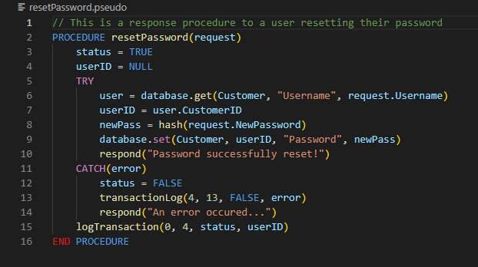

### Order placement Algorithm

The order placement algorithm handles the processing of orders from beginning to completion. The first thing that is done is the use of the basket to calculate the final charging price for all the items. If any item has no stock left, an error will occur. After the price is calculated, then the payment will be processed, and if everything goes through successfully, then the Order will be stored in the database. This involves first initialising the order and adding the shipping details. Then, getting that from the database, the OrderLines will be added to show which items have been ordered. Then, the user will be redirected to a success page, and they will be sent an order confirmation email. The transactions will be logged.

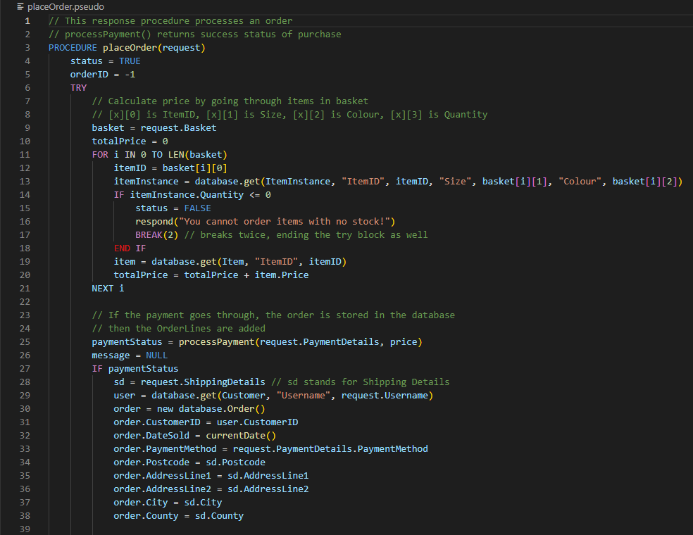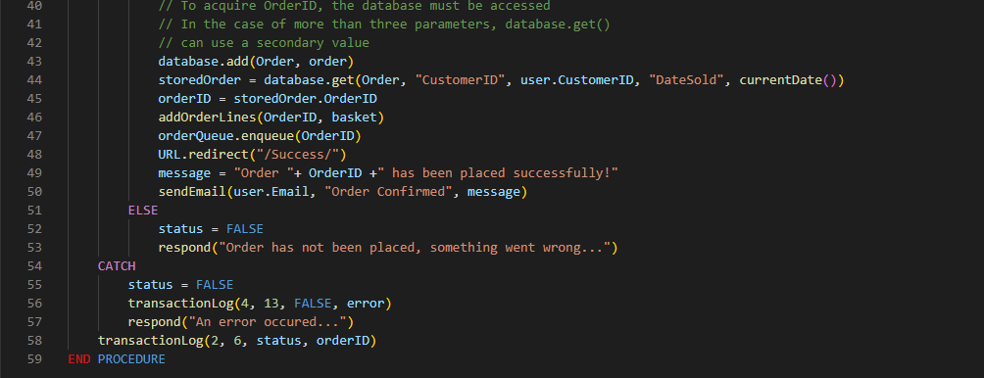

### Has bought item once Algorithm

This algorithm is used to prevent a user who hasn’t bought an item from reviewing it by returning a Boolean value based on whether or not the given user has bought the given item at least once. Results == [] will return true if there are no order lines which contain the itemID of reference, which would be a false value on the eligibility to review an item.

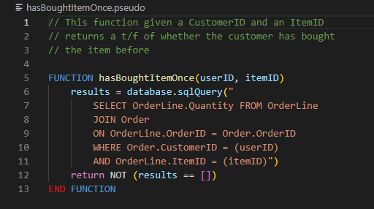

### Review placement Algorithm

The review placement algorithm processes a review. If the user has bought the item once, they are eligible to place the review, and so it will be placed. Otherwise, an error will occur. All the transactions are logged.

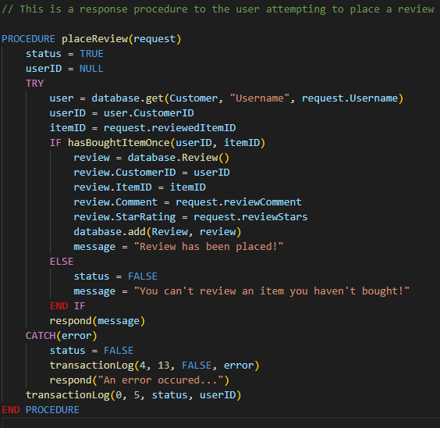

### Manager actions Algorithm

For the manager section of the website, the manager actions algorithm is responsible for handling the different actions made by a given manager. The action types are defined above, and so if a correct action type is given, it will be carried out. Otherwise, an error will occur. The transactions will all be logged.

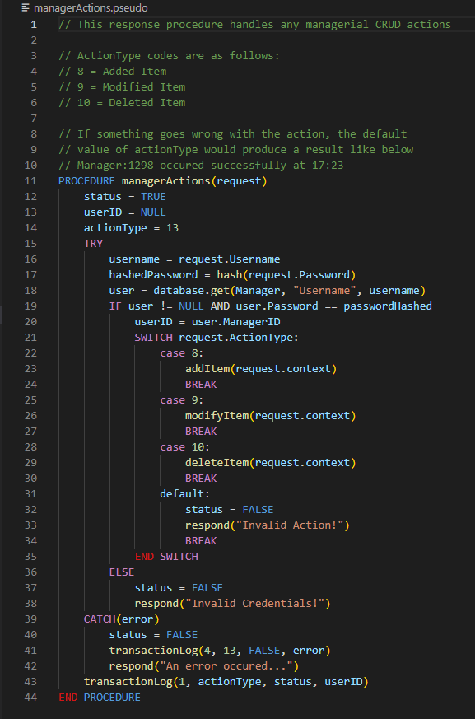

### Asynchronous thread Algorithm

There is a collection of time dependent tasks within the solution. To handle that, a single asynchronous thread exists. The first responsibility of the asynchronous thread is to log the current number of users which are browsing the website in the userActivity circular queue. Every entry in that array corresponds to a snapshot of the user count. This will be repeated every 10 minutes to give an accurate representation of the users’ activity.

The second responsibility of the thread is to write logs from the LogQueue. All logs of a single day are stored in a single “.log” file, which can only be written to once at a time. If multiple things happen simultaneously, then the program might experience bugs. To avert that, all logs are put in a queue, and whenever the queue is detected to not be empty, the logs contained within that queue will be written to the file in succession.

Lastly, the asynchronous thread is responsible for the call of the featuring algorithm every week. The reason why I chose to call it every Monday is that in the event of an outage, the pace of the featuring algorithm would forget all volatile variable values. If it triggered every week, it wouldn’t know when to call the function. Instead, the time of change is consistent, which reduces a lot of issues.

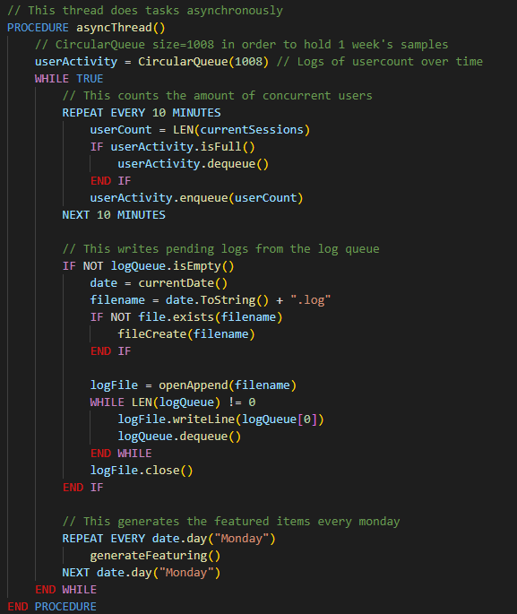

### Recommendation System

The recommendation system I will be using is SVD. It will take in a dataset and load it into the program. That dataset will be then pivoted such that a utility matrix of values is created, the columns being items, and the rows being the individual reviewers. An instance of SVD will be created, and the model will be fit around that dataset. Then, using the similarity of different items considered and multiplied by the rating, the predictions will be made as a sorted list. Then, the first choice is the prediction. If the accuracy is unsatisfactory, the algorithm will be repeated until it is. When that model is made, it will be stored permanently.

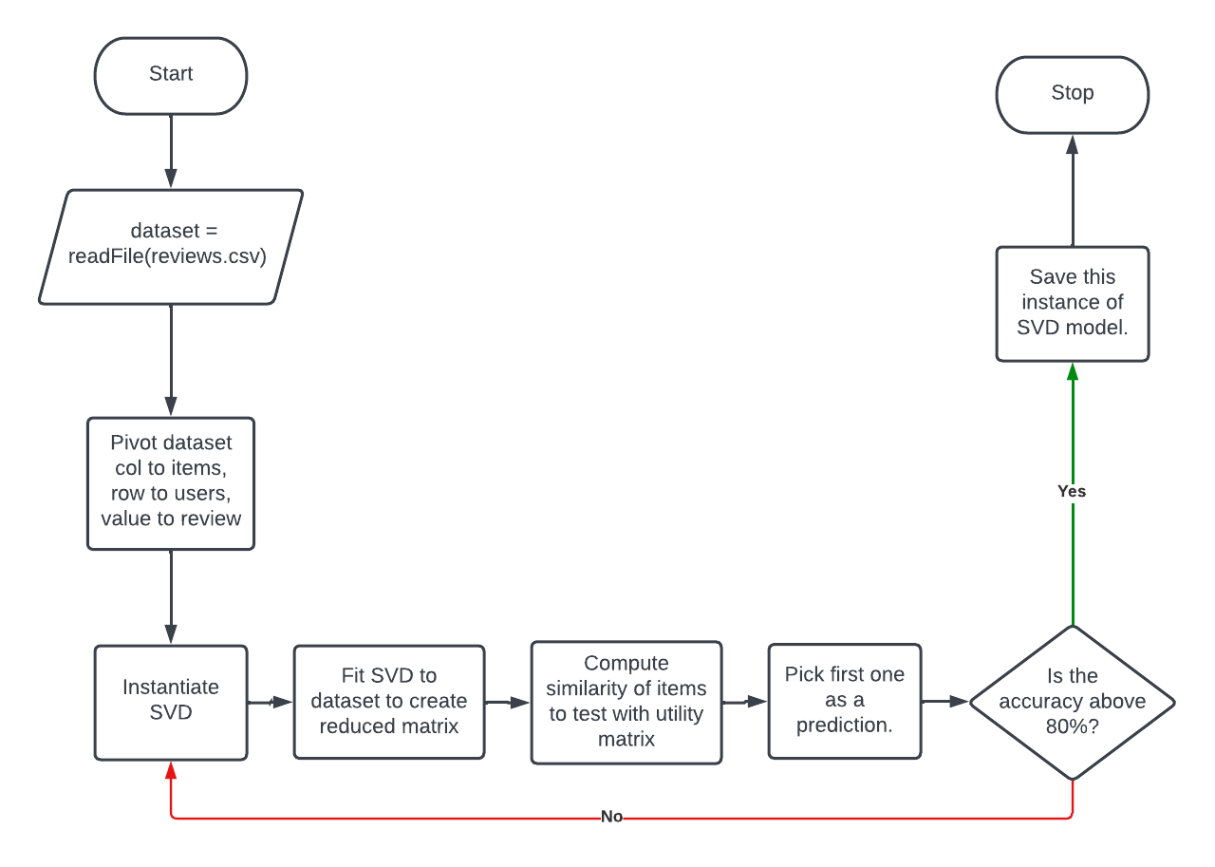

### Featuring System

The featuring system algorithm is one of the most complex parts of my solution it involves minimalization of items that perform well against ones that don’t. Some of the terminology I used in it is custom acronyms, which I will explain. QBU stands for Quantity Bought Usually, which is a measurement of the net quantity ordered during the last week when an item wasn’t featured. It is crucial that it was the **last time it wasn’t featured** and not the last week. This is in order to prevent a feedback loop where the QBR will keep getting lower as the item performs well, which would sabotage well performing items. QBF stands for Quantity Bought when Featured, which is a measurement of the number of OrderLines in which the item instance appears in. Those will all be added for the itemID’s definition, which will store the final QBF for all of its instances. QBR stands for Quantity Bought Rating, which is a rating of how well an item performs when it’s featured. It is calculated as QBF/QBU. The QBU should usually be lower, so a QBR will mostly be above the value of 1. A QBR of 1 is a very bad rating, as the featured item performed the same regardless of whether it was featured or not. This could be because it’s a bad item or because it’s already selling very well. Regardless, this is not what the algorithm is attempting. The items which perform significantly better when featured will be the ones that are selected. The result of generation is 8 items. The first 4 will always be the best QBR items that are available. Then, there’s the second row. If 4 or more items with a QBR of -1 exist, that row will be solely populated with new items. A QBR of -1 a signifier of an item which has never been featured before, which is prioritised over the bottom row of items in order to find out if an item is good for the featuring algorithm or not. In the case of 2 items with QBR of -1, the first two slots will be taken by those items, while the other two will be random items, in order to attempt to make any reintroductions. In the case of zero non-featured items, the first two slots will be the 5th and 6th “runners-up” items to be featured on the first row. One last thing 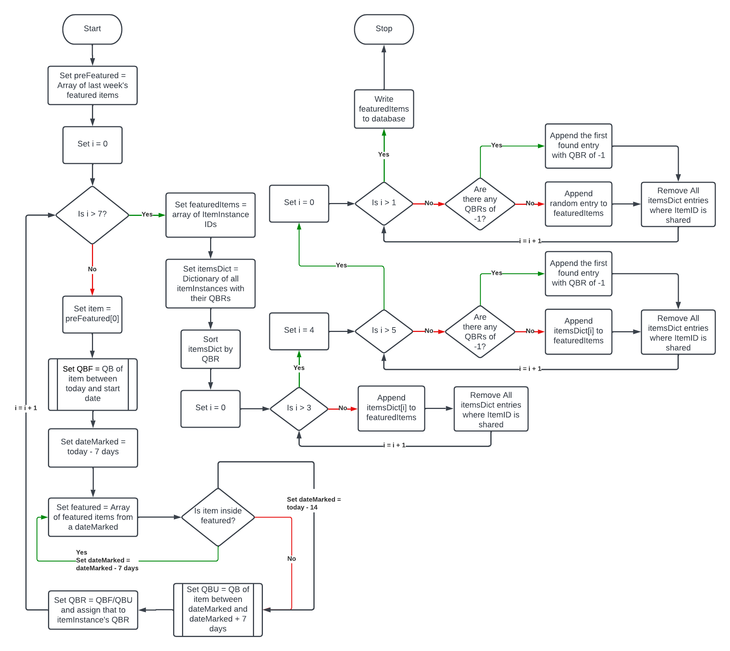to mention is its time complexity. The featured algorithm is of a linear time complexity.

## Key Variables

|  |  |
| --- | --- |
| Variable Name | Purpose |
| subjectCodes | Enumeration that stores subject code to subject string pair. |
| typeCodes | Enumeration that stores type codes to action string pairs. |
| logQueue | A queue which contains all logs that are currently in the process of being written |
| token | Random string that identifies a certain user account action to be carried out in verification. |
| tokenDict | A dictionary containing all the token – action pairs. |
| status | A variable used to note if a function is working as intended or suffered an error. |
| request | A variable that contains the HTTP request sent by a user that is being responded to. |
| formData | Purified data from the user’s submitted form. |
| username | A variable that stores the user of interest’s username. |
| passwordHashed | A variable that stores the hashed copy of a provided password. |
| userID | A variable that stores a primary key referring to any user, be it manager or customer. |
| newPass | A variable that stores the new password set by a user. |
| totalPrice | A variable that holds the total cost of all the items in the basket of the user. |
| storedOrder | A variable that references the newly placed order. |
| results | A variable that holds all the instances that an item was bought by a user, using quantity. |
| message | A variable that holds a message to be sent to the user. |
| actionType | A variable that holds the type of action being executed during the runtime of managerActions |
| userActivity | A circular queue which holds the number of users online per 10 minutes. When full, the oldest record is replaced. |
| logFile | A variable referring to an open file where logs are being written. |
| dataset | A reference to an open file that contains the dataset to train the AI on. |
| SVD | An instance of the SVD algorithm to be used when training. |
| model | The instance of the SVD model currently being trained or demonstrated. |
| preFeatured | An array which stored the last set of featured items. |
| QBF | A variable that stores the quantity bought when featured. |
| QBU | A variable that stores the quantity bought on the last week not featured. |
| dateMarked | A variable that refers to the current date of interest. |
| QBR | A variable that stores the rating of an item on the QB scale. |
| itemsDict | A dictionary that contains all the existing item IDs paired with their QBR. |

## Test Plans

Note: Any time a test value is not present in Data, assume a “valid data” value.

### Prototype 1

|  |  |  |  |  |
| --- | --- | --- | --- | --- |
| Test ID | Testing | Test Type | Data | Expected |
| 1.1.1 | Valid data given to “database.add ()” equivalent. | V | **Firstname** = “John”  **Surname** = “Doe”  **Email** = [foo.bar@doemail.org](mailto:foo.bar@doemail.org)  **Telephone** = “05555555555”  **Username** = “johnDoe.01”  **Password** = “1@2B3c4.”  **Title** = “Mr”  **DOB** = “01/01/1970”  **DateJoined** = “01/01/2022” | Success. The database adds the user without any errors or incorrectly stored data. |
| 1.1.2 | Boundary check for all values. The test will be repeated to check each boundary value individually. | B | **Firstname** = “Vila Bela da Santíssima Trindade”  **Surname** = “Fernando del Valle de Catamarcas”  **Email** = “ReallyLongEmailThat  StretchesForWayTooLong  @ButStillValid.mail.org”  **Username** = “vilaCat.01011970”  **Password** = “ThisIsARe@llyL0ng  PasswordForSome”  **Title** = “Lord” | Success. |
| 1.1.3 | This is an overflow check. The test will be repeated to check each boundary value individually. | I | **Firstname** = “Vila Bela da Santíssima Trindades”  **Surname** = “Fernando del Valles de Catamarcas”  **Email** = “ReallyLongEmailThat  StretchesForWayTooLong  @SeenAsInvalid.email.org”  **Username** = “vilaCats.01011970”  **Password** = “ThisWasARe@llyL0ng  PasswordForSome”  **Title** = “Large” | The operation should throw an error upon execution, and not add a record to the database. This should be consistent no matter which value is overflowed. |
| 1.1.4 | This is an underflow check for the date fields. The values will be tested individually. | I | **DOB** = “31/12/0”  **DateJoined** = “31/12/0” | Error thrown. |
| 1.1.5 | This is a null check. The values will be tested individually. | E | **Firstname** = NULL  **Surname** = NULL  **Email** = NULL  **Username** = NULL  **Password** = NULL  **Title** = NULL  **DOB** = NULL  **DateJoined** = NULL | Error thrown. |
| 1.1.6 | This is an erroneous data type check. The values will be tested individually. | E | **Firstname** = 1  **Surname** = 2  **Email** = 3  **Username** = 4  **Password** = 5  **Title** = 6  **DOB** = 7  **DateJoined** = 8 | Error thrown. |
| 1.5.1 | This is a null check for nullable values. The values will be tested individually. | V | **AddressLine2** = NULL  **County** = NULL | The database adds the user without any errors or incorrectly stored data. |
| 1.6.1 | This is an attempt to test the “read” operation. Known as “database.get()” in the pseudocode. | V | **table** = Customer  **queryField** = “Username”  **value** = “johnDoe.01” | The operation returns the record with the username of “johnDoe.01” |
| 1.6.2 | This is to test what happens if multiple records meet the conditions of the read operation. | V | **table** = Customer  **queryField** = “DOB”  **value** = “01/01/1970” | The operation returns the record that meets the condition with the smallest ID. |
| 1.6.3 | This is a check for a non-existent record. | I | **table** = Customer  **queryField** = “Username”  **value** = “ThisUserDoesNotExist” | This operation should throw an error upon execution. |
| 1.6.4 | This is a null check for the function. | E | **table** = NULL  **queryField** = NULL  **value** = NULL | This operation should throw an error upon execution. |
| 1.6.5 | This is a test attempt for the “update” operation, known as “database.set()” in the pseudocode. | V | **table** = Customer  **recordID** = 0001  **modField** = “IsActivated”  **value** = TRUE | The operation successfully changes the “IsActivated” field of customer:0001 to TRUE |
| 1.6.6 | Setting to non-existent user. | I | **table** = Customer  **recordID** = 9999  **modField** = “IsActivated”  **value** = TRUE | This operation should throw an error upon execution. |
| 1.6.7 | This is a null check. | E | **table** = NULL  **recordID** = NULL  **modField** = NULL  **value** = NULL | Each iteration should throw an error. |
| 1.6.8 | This is valid data for the “database.delete()” equivalent. | V | **table** = Customer  **recordID** = 0001 | Customer:0001 should be deleted. |
| 1.6.9 | Deleting a non-existent user. | I | **table** = Customer  **recordID** = 9999 | This operation should throw an error. |
| 1.6.10 | This is a null check. | E | **table** = NULL  **recordID** = NULL | Each iteration should throw an error. |
| 2.1.1 | This is a valid test attempt of the hash function to check if it works as expected. | V | **password** = b“r3allySecur3”  **salt** = b”$2b$12$Mr8cYTjur7w4  gUtGG.P7Mu” | The output should be b”$2b$12$Mr8cYTjur7w4  gUtGG.P7Mu6yHhhj7Vvc/  ticID9PZXlY4GmCwfqRe” |
| 2.2.1 | This is a valid repeat of the previous test to show consistency. It involves two repeats of test 2.1.1. | V | **password** = b“r3allySecur3”  **salt** = b”$2b$12$Mr8cYTjur7w4  gUtGG.P7Mu” | The output should be b”$2b$12$Mr8cYTjur7w4  gUtGG.P7Mu6yHhhj7Vvc/  ticID9PZXlY4GmCwfqRe” for the other 2 iterations. |
| 2.3.1 | This is a test where the first 10000 “rockyou.txt” passwords will be hashed and compared. | V | N/A | The collision cases should be less that 1%. |
| 3.1.1 | Valid data. | V | **Firstname** = “John”  **Surname** = “Doe”  **Email** = [foo.bar@doemail.org](mailto:foo.bar@doemail.org)  **Telephone** = “05555555555”  **Username** = “johnDoe.01”  **Password** = “1@2B3c4.”  **Title** = “Mr”  **DOB** = “01/01/1970”  **DateJoined** = “01/01/2022” | Success. Added user. Sent email with verification link. |
| 3.1.2 | Boundary tests for user creation. Each one of these values will be tested individually. | B | **Firstname** = “Vila Bela da Santíssima Trindade”  **Surname** = “Fernando del Valle de Catamarcas”  **Email** = “ReallyLongEmailThat  StretchesForWayTooLong  @ButStillValid.mail.org”  **Username** = “vilaCat.01011970”  **Password** = “ThisIsARe@llyL0ng  PasswordForSome”  **Title** = “Lord” | Success on each iteration. |
| 3.1.3 | Overflow test for user creation. | I | **Firstname** = “Vila Bela da Santíssima Trindades”  **Surname** = “Fernando del Valles de Catamarcas”  **Email** = “ReallyLongEmailThat  StretchesForWayTooLong  @SeenAsInvalid.email.org”  **Username** = “vilaCats.01011970”  **Password** = “ThisWasARe@llyL0ng  PasswordForSome”  **Title** = “Large” | Error thrown on each iteration. |
| 3.1.4 | Erroneous test for user creation. Each value will be tested individually. | E | **Firstname** = 1  **Surname** = 2  **Email** = 3  **Username** = 4  **Password** = 5  **Title** = 6  **DOB** = 7  **DateJoined** = 8 | Error thrown on each iteration. |
| 3.1.5 | Null check for user creation. | E | **Firstname** = NULL  **Surname** = NULL  **Email** = NULL  **Username** = NULL  **Password** = NULL  **Title** = NULL  **DOB** = NULL  **DateJoined** = NULL | Error thrown on each iteration. |
| 3.2.1 | Valid data for user activation. | V | **Username** = “johnDoe.01” | Success. The user should now be activated. |
| 3.2.2 | Trying to activate non-existent user. | I | **Username** = “doesNotExist” | Error thrown. No effect on database. |
| 3.2.3 | Erroneous data type. | E | **Username** = 1970-01-01 | Error thrown. |
| 3.2.4 | Null check. | E | **Username** = NULL | Error thrown. |
| 3.3.1 | Valid data for user authentication. | V | **username** = “johnDoe.01”  **password** = “1@2B3c4.” | Success. The user should be logged into a session. |
| 3.3.2 | Boundary data for user authentication | B | **username** = “vilaCat.01011970”  **password** = “ThisIsARe@llyL0ng  PasswordForSome” | Success. The user should be logged into a session. |
| 3.3.3 | User doesn’t exist. | I | **username** = “doesNotExist” | Error thrown. User is not logged in. |
| 3.3.4 | Passwords don’t match. | I | **username** = “johnDoe.01”  **password** = “notCorrect” | Error thrown. |
| 3.3.5 | Overflow data for user authentication. | I | **username** = “vilaCats.01011970”  **password** = “ThisWasARe@llyL0ng  PasswordForSome” | Error thrown. |
| 3.3.6 | Erroneous Data Type. | E | **username** = 1970-01-01  **password** = 1970-01-01 | Error thrown. |
| 3.3.7 | Null Check. | E | **username** = NULL  **password** = NULL | Error thrown. |
| 3.4.1 | Attempt to log in with non-activated user. | I | **username** = “notActivated”  **password** = “1234” | Error thrown. User is not logged in. |
| 3.5.1 | Valid data for account deletion. | V | **username** = “notActivated” | Success. The user is deleted. |
| 3.5.2 | Deleting non-existent user. | I | **username** = “doesNotExist” | Error thrown. No impact on the database. |
| 3.5.3 | Null check. | E | **username** = NULL | Error thrown. |
| 3.6.1 | Valid data for password reset request. | V | **Email** = “19091781@students.ncclon-  don.ac.uk” | Success. A verification link for password reset should be generated. |
| 3.6.2 | Valid data for password reset. | V | **username** = “johnDoe.01”  **newPassword** = “mor3Secur3” | Success. The password of the given user should change to the new one. |
| 3.6.3 | Erroneous data type test. | E | **username** = 1970-01-01 | Error thrown. Password isn’t changed. |
| 3.6.4 | Null check. | E | **username** = NULL  **newPassword** = NULL | Error thrown. |
| 3.7.1 | Attempt to register with already registered user. | I | **username** = “johnDoe.01” | Error thrown. The pre-existing user shouldn’t be impacted. |
| 4.1.1 | Valid data for review placement | V | **ReviewedItem** = 0001  **Comment** = “This was a lovely piece of apparel.”  **reviewStars** = 4 | Success. The Review should be now in the database. |
| 4.1.2 | Upper Boundary check for review placement. | B | **reviewStars** = 5 | Success. |
| 4.1.3 | Lower Boundary check for review placement. | B | **reviewStars** = 1 | Success. |
| 4.1.4 | Review can’t be placed twice. | I | **Username** = “johnDoe.01”  **ReviewedItem** = 0001 | Error thrown. No impact on the database. |
| 4.1.5 | Item not bought. | I | **Username** = “johnDoe.01”  **ReviewedItem** = 0002 | Error thrown. |
| 4.1.6 | Erroneous data type. | E | **Username** = 1  **ReviewedItem** = 2  **Comment** = 3  **reviewStars** = “joe” | Error thrown. |
| 4.1.7 | Null Check. | E | **Username** = NULL  **ReviewedItem** = NULL  **Comment** = NULL  **reviewStars** = NULL | Error thrown. |
| 5.1.1 | Attempt to send Email to no-reply address. | N/A | **N/A** | No impact on server. |
| 5.2.1 | Use the built-in emailing function. | V | **recipient** = “19091781@students.ncclon-  don.ac.uk”  **subject** = “Hello World”  **content** = “This is a test.”  **cc** = “19087670@students.ncclon-  don.ac.uk”  **bcc** = “19091639@students.ncclon-  don.ac.uk” | Success. The email should send successfully. |
| 5.2.2 | Null check for nullable values. | V | **cc** = NULL  **bcc** = NULL | Success. |
| 5.2.3 | Attempting to send not an invalid email. | I | **recipient** = “asdasd” | Error thrown. |
| 5.2.4 | Erroneous data type. | E | **recipient** = 1  **subject** = 2  **content** = 3  **cc** = 4  **bcc** = 5 | Error thrown. |
| 5.2.5 | Null check. | E | **recipient** = NULL  **subject** = NULL  **content** = NULL  **cc** = NULL  **bcc** =NULL | Error thrown. |

### Prototype 3

|  |  |  |  |  |
| --- | --- | --- | --- | --- |
| Test ID | Testing | Test Type | Data | Expected |
| 7.4.1 | Valid data for ordering. | V | Items = 1 , 2 , 3  User = “johnDoe.01”  Postcode = “WD22G2N”  AddressLine1 = “21 Something Ln” | Success. |
| 7.4.2 | Erroneous data type for ordering. | E | Postcode = 1970-01-01  AddressLine1 = 1970-01-01  AddressLine2 = 1970-01-01 | Error. |
| 7.4.3 | Null check. | E | Postcode = NULL  AddressLine1 = NULL  AddressLine2 = NULL | Error. |
| 7.4.4 | Attempt to force an order with empty basket. | E | Items = NULL | Error. |
| 7.5.1 | Valid Refund. | V | OrderID = 1  *Placed up to a week ago. | Success. The refund should be successful. |
| 7.5.2 | Invalid refund due to deadline passing. | I | OrderID = 2  *Placed over a week ago. | Error. |
| 7.5.3 | Erroneous Refund due to nonexistence. | E | OrderID = 21 | Error. |
| 7.5.4 | Null Check. | E | OrderID = NULL | Error. |
| 7.6.1 | Valid Cancel. | V | OrderID = 1  IsShipped = False | Success. The items should replenish their stock |
| 7.6.2 | Item has been already shipped. | I | OrderID = 1  IsShipped = True | Error. |
| 7.6.3 | Attempt to cancel non-existent order. | E | OrderID = 21  IsShipped = False | Error. |
| 8.1.1 | Attempt to enter the management as customer. | I | User = johnDoe.01 | Error. The user should not be able to enter. |
| 8.3.1 | Attempt to read an item. | V | Item = 1 | Valid. The information of the item should be shown. |
| 8.3.2 | Attempt to read a non-existent item. | I | Item = 21 | Error. |
| 8.3.3 | Null check. | E | Item = Null | Error. |
| 8.4.1 | Attempt to delete an item. | V | Item = 2 | Valid. The item should be deleted. |
| 8.4.2 | Attempt to delete a non-existent item. | I | Item = 21 | Error. |
| 8.4.3 | Null check. | E | Item = Null | Error. |
| 8.5.1 | Attempt to modify an item. | V | Item = 1  Description = “Something.” | Valid. The item should be modified. |
| 8.5.2 | Attempt to modify a non-existent item. | I | Item = 21 | Error. |
| 8.5.3 | Null check. | E | Item = Null | Error. |
| 8.6.1 | Attempt to create an item. | V | Item = 2 | Valid. The item should be created. |
| 8.6.2 | Null check. | E | Item = Null | Error. |

### Post Developmental

In the post developmental test plan, I’ve decided to go for a less strictly structured approach. These test plans will be structured in a way that is easy to follow by users. These simple instructions will also allow for the grading of useability.

**Test scenario 1**: Customer using the website.

1. Visit front page.
2. Set website to dark mode.
3. Register account.
4. Attempt to log in.
5. Activate account via email link.
6. Attempt to log in with wrong password.
7. Reset password via email link.
8. Log In with the new password.
9. Browse hoodies via categories.
10. Wishlist some hoodies.
11. Add hoodies to basket.
12. Place order through basket.
13. Review item.
14. Delete account via email link.
15. Attempt 4-11 while logged out.
16. Rate the usability of the system from 1-10

**Test scenario 2**: Manager using the website.

1. Log in via the manager log in.
2. Look at current items.
3. Create an item.
4. Make a change in that item after initialisation.
5. Delete that item.
6. Look at the order queue for current orders.
7. Remove an order from the queue.
8. Look at statistics of the previous week.
9. Rate the usability of the system from 1-10

# Development

## Prototype 1

### Stage 1: Setup

The first prototype will be focused on implementing the backend.

The first thing in this prototype is to check if Django is configured correctly to launch. A sort of hello world. This means first configuring the settings.py file which contains the server’s configurations. Although most of the settings are fit for the project, the database format must be changed from SQLite3 to MySQL, which is better for my use case, and the TIME_ZONE property must be set to “Europe/London”.

After that, I ran it with the “python manage.py runserver” command, and it initially didn’t work. But after installing mysqlclient with pip and MySQL via the installer, I opened the server on localhost port 8000. The default splash screen was a sign of the correct configuration.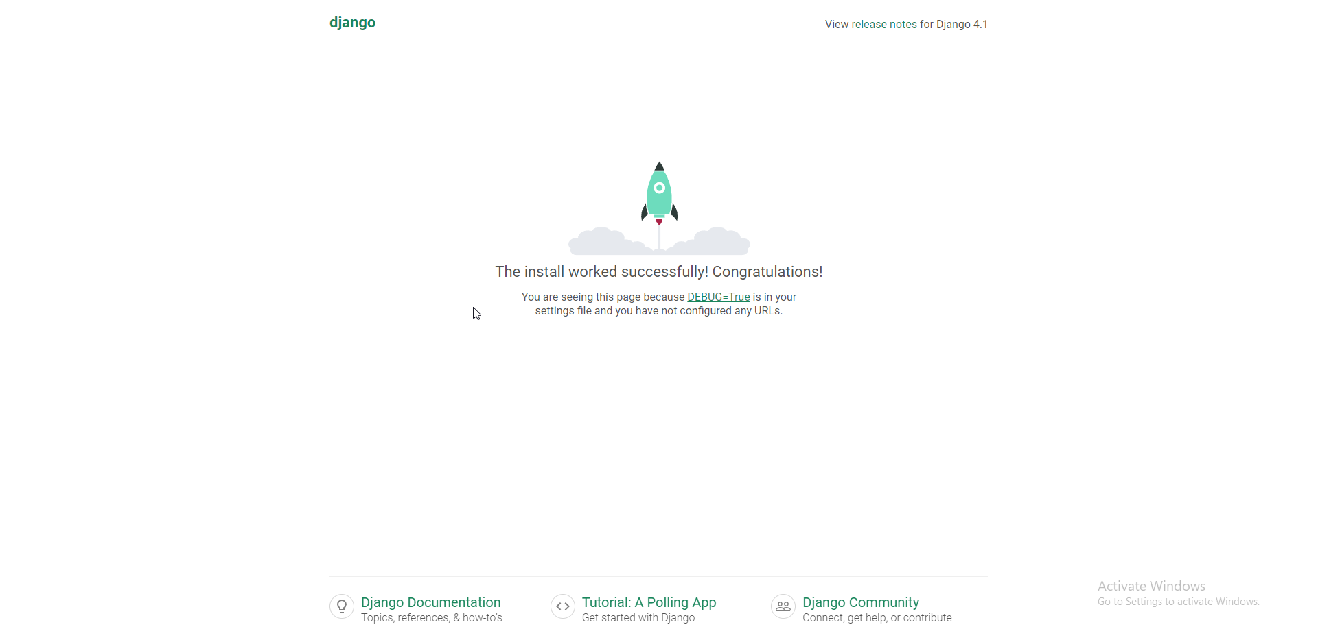

Thus, it was time to start adding the users and the rest in the database. I created two “apps”, which are just as the name says, apps. They are containers for models, which are the Django ORM way of defining tables in the database, views, which are custom http responses, and tests. Adding the two apps allowed me to begin writing the model for the customer to enact the first database test.

To make Django recognise my apps, I have to “install” them, by adding them to the “INSTALLED_APPS”.

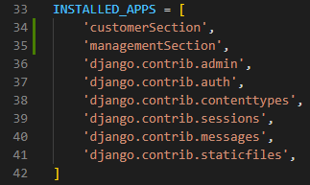

Then, I started writing the Customer model that stores the customers’ data, and this was the code I wrote.

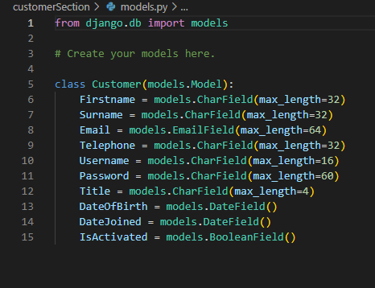

Models are defined as classes and adding fields to them is as simple as adding attributes to a class. I also found out I could use an Email field for the email, so I used that instead of a VarChar, aka CharField. All of these fields are non-nullable, which is the default in Django. After saving the changes, to change the database to include the model, I have to “make migrations” and “migrate”. These commands convert the model ORM to the proper mySQL statements to have the same effect, then migration causes the changes to take effect.



As such, when the migrations are made, it shows the changes to the model system. With the Customer model now being implemented, I can make a new customer. I can access the database in a shell environment by running “python manage.py shell”. 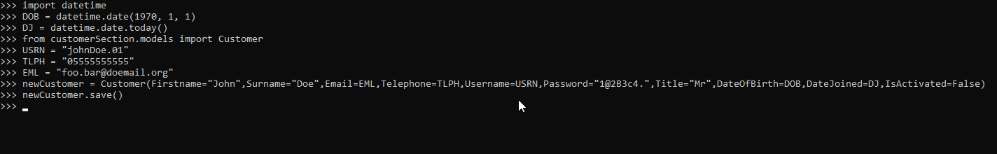

With the shell, I first imported datetime and the Customer model from the customerSection. This allowed me to use the Customer() method that creates and returns a Customer Object. I then gave the valid test values from test 1.1.1 to the constructor, and used the save() method, which is the equivalent of “database.add()”. This resulted in everything being written to the database correctly, which is a clear mark of success.

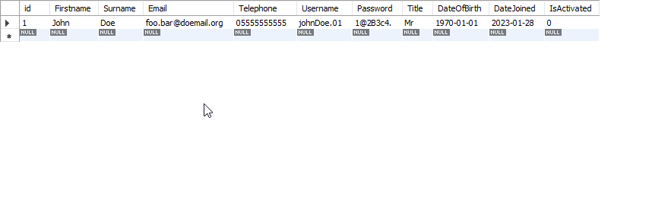

With that done, implementing the rest of the items should be easier, now knowing that the setup is working correctly. It was also at this point that I realised that Django automatically declared a primary key. Since I wanted to give custom column names to my primary keys, I had to take that into account as I started writing the other models. While writing the Review model’s definition I also learned that Django does not support the definition of composite keys, which led me to instead make a ReviewID field. Another thing that I realised Django doesn’t have support for is the Currency Abstract Data Type, so I replaced it with a decimal field. The models I wrote ended up like so.

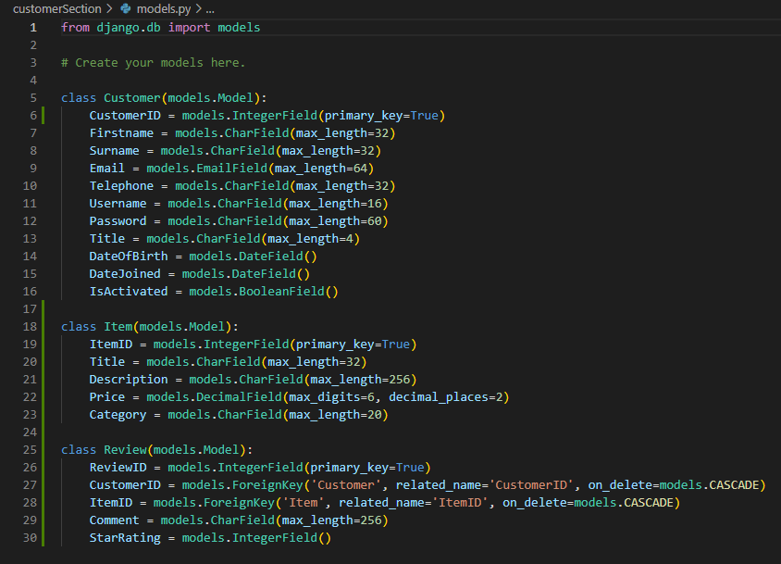

A feature to note is that of the ForeignKey in Django. Due to its ORM nature, a delete() method has to know in advance whether to be a cascade delete or not, in order to spare the use of different delete commands. If a Customer or Item referenced in a review is deleted, the review will be as well.

As I tried to run the make migrations command, I surprisingly received a plethora of errors. 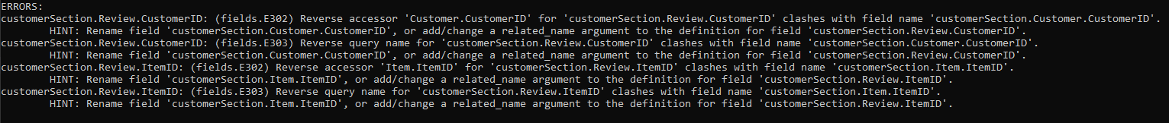

I was initially puzzled by the errors, but when I read further into them, I thought that reusing names between Django models maybe caused errors, unlike the usual convention of local variables not having any impact on each other if they didn’t share a scope. I tried renaming the variables, but that did not solve the problem either. After further reading, I realised that I was using the ForeignKeys in Django wrong. After that, the models I made looked like so.

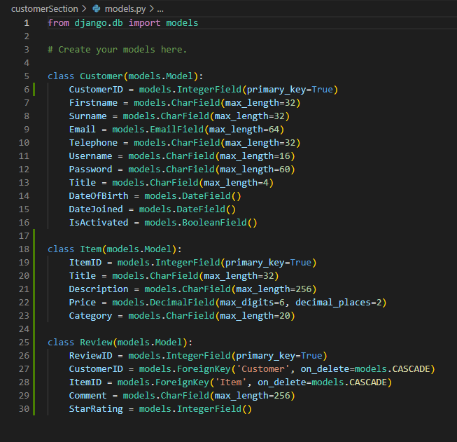

With this change, the migration ran smoothly, and I was able to move on. I started implementing some of the tests in the tests.py file. I implemented the first three tests to see if the testing worked correctly, and after some minor syntax errors, I got the unit tests working. I also found out that I had been using the wrong field type for the IDs, so I fixed that. The changes resulted in these files.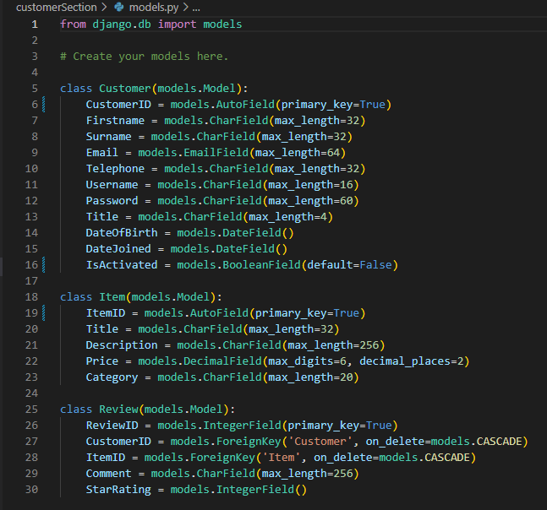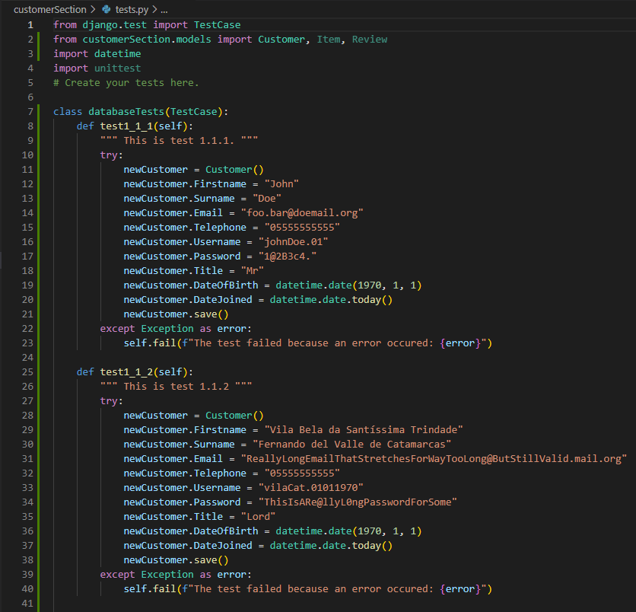

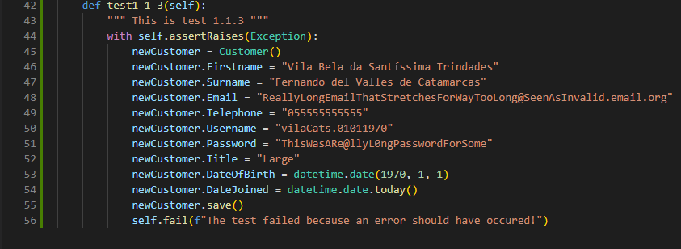

As documented in the test plan, test 1.1.1 tries a valid save() to the database for a Customer. 1.1.2 Tries the same thing with boundary data. If either one of those raise an exception, the test will fail. Test 1.1.3 has to raise an exception, or it will fail. When I ran these tests, they passed.

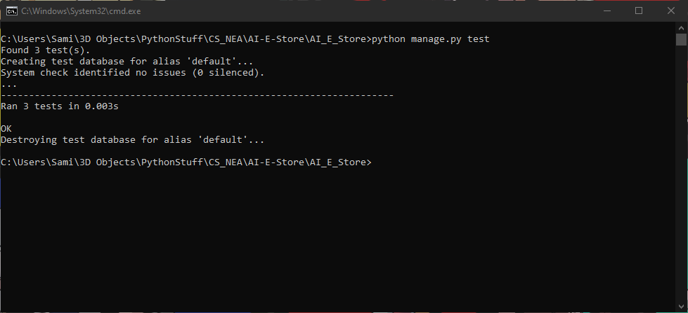

Knowing that the tests now work, I began work on the rest of the database.

I first added the rest of the tests from the success criterium 1.1.

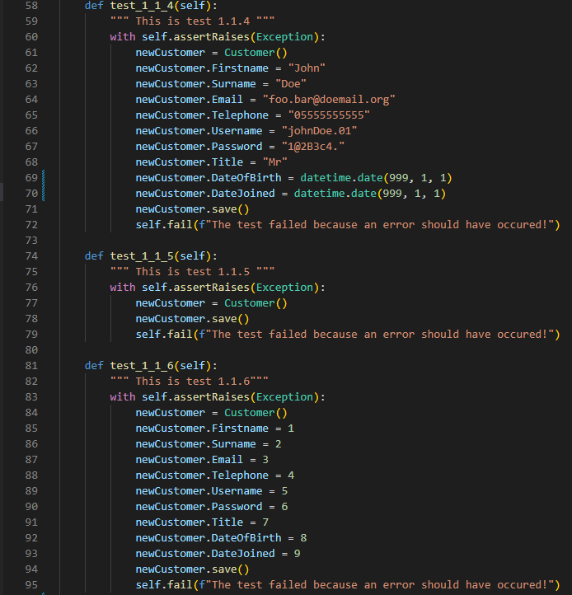

I ran them and the result was successful. I then implemented the customerSection models one by one. During the creation of the ItemInstance model, I thought that setting a standard resolution for the two image fields would save me a lot of hassle, so I decided that 1080x1080 is the HighResImg resolution standard, while 256x256 is the LowResImg standard. In the end, I defined ItemInstance, Order and OrderLine. Their model definitions are as follows: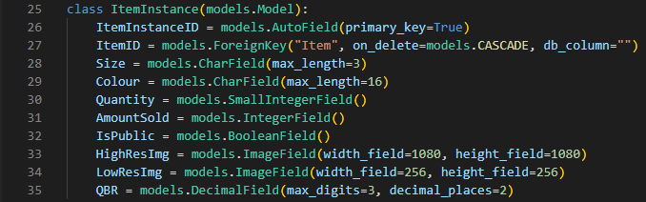

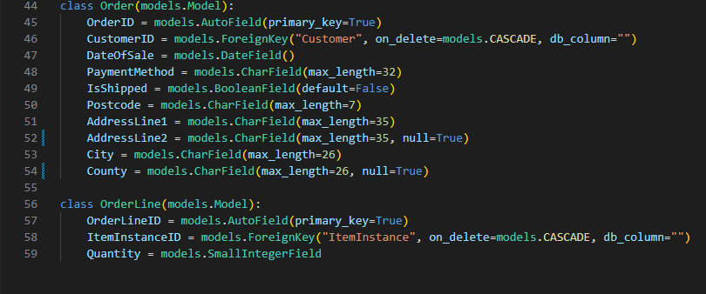

One thing to note is that I made the quantity field in OrderLine and ItemInstance a SmallInteger. A small integer in Django is a positive integer between 0 and 32767. An order of more than 30000 shirts is beyond my client’s intent, as they are not going to be owning that much stock in the near future, thus the choice of a small integer. This saves on a lot of space in the database.

With the order model made, I now have all the prerequisites to write the tests for the first success criterium, that of a functioning database, with the commands I need working as they should. As the tests started filling up more and more of my screen, I realised that having one class for all the database tests would be bad, in terms of organisation. I decided to make unit tests follow terms of which sub-success criterium they are of. 1.1, 1.2, 1.3 etc.

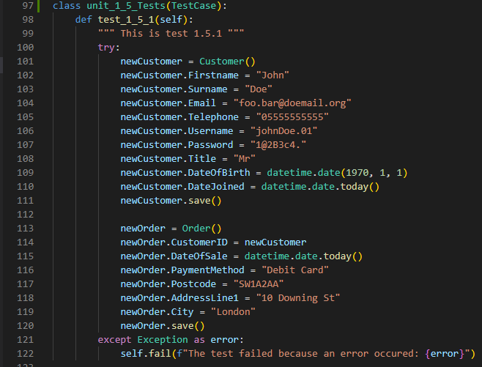

I wrote 1.5’s tests, which ran successfully, and as I was writing 1.6’s tests, I realised that Django’s get query is limited to a single item, and only using the primary key. In all other cases, a filter() method is used, which returns a QuerySet. The QuerySet is an indexable object which contains all the results. This solves the concerns about making a query that fits multiple records, so I wrote the tests with that considered. 1.6’s tests were running correctly until test 1.6.5. First, to establish context, in 1.6, I established records in advance to make the update and delete tests possible. The code for that uses the setUp method. This method is essentially an initialiser for tests, that establishes any needed contexts in a test class. The context is written as such:

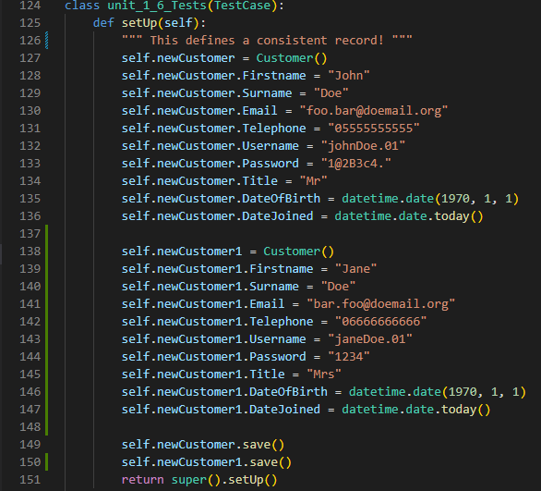

This defines two users in the database that will stay consistent throughout the whole testcase, as in most cases, changes to the database are deleted after a test method terminates. However, the issue that I face is with what are known as test “side effects”.

To explain how I came to that conclusion, I must go back to the test 1.6.5 that I originally ran which looked like this:

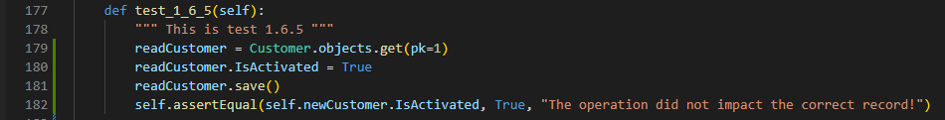

The code is not actually incorrect. It’s the ID that it’s accessing that is at fault. Logically, if only one record exists, its ID should be 1. However, if the previous tests are looked at, the problem becomes obvious. The tests interact with records of the customer table, but the database is not flushed until the very end, so the ID field increments from the 13th ID due to some unknown reason. The tests are supposed to be independent, but they sometimes affect each other when interacting with data meant to be carried over. That is what testing side effects are. With that, I decided to no longer use unit tests for the database in order to save myself the hassle of inconsistency.

Thus, I started with redoing unit test 1.6.5 manually. I added the John and Jane Doe sample data to the database, and they looked like this.

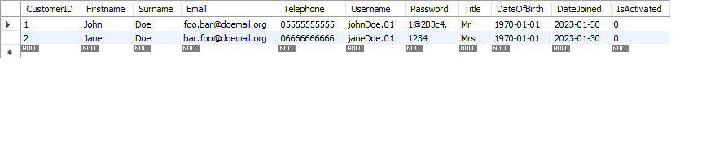

With that, I ran the test as so:

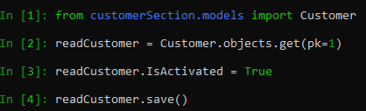

What these commands do is accessing the John Doe record in this context, and change IsActivated to True, saving the changes. The test ran successfully, and IsActivated changed to 1, indicating “True”.

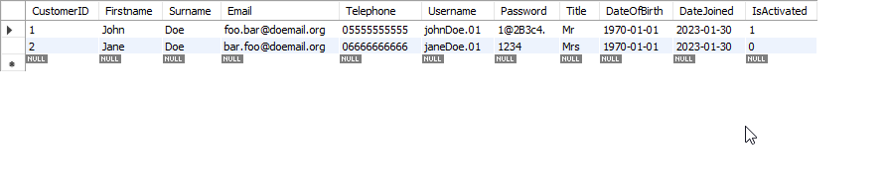

In the case of Django, tests 1.6.6, 1.6.7, 1.6.9, 1.6.10 are not actually testing anything, as there is no single command for updating or deleting a certain record. Instead, you have to access a record first, and then apply the change to them. Those tests are Null and Non-existence tests.

Test 1.6.8 involves an attempt of deleting a user, in this case John Doe. To delete John Doe, I ran this command after the previous test.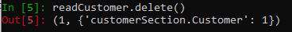

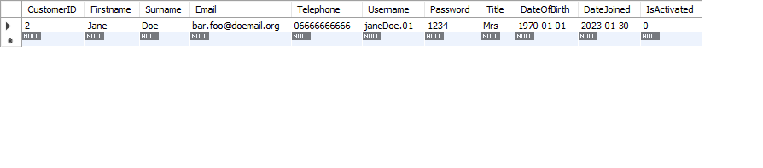

As a result, the John Doe record was indeed deleted, as well as returned. That concluded the database tests, that show that the database works as intended.

### Stage 2: The Hashing Algorithm and first response

With that, the next step is to move onto the hashing algorithm.

The hashing algorithm that I decided to use after some research was bcrypt. The reason for that is that it’s a secure hashing algorithm that produces consistent results. All bcrypt hashes with valid input produce an output of length 60. Therefore, I installed and imported bcrypt and stared work.

I wrote the unit 2 tests, and they ran successfully without error. Due to having two conditions to meet, test 2.2.1 doesn’t assert a comparison of hashes like test 2.1.1, but instead fails if either condition isn’t met.

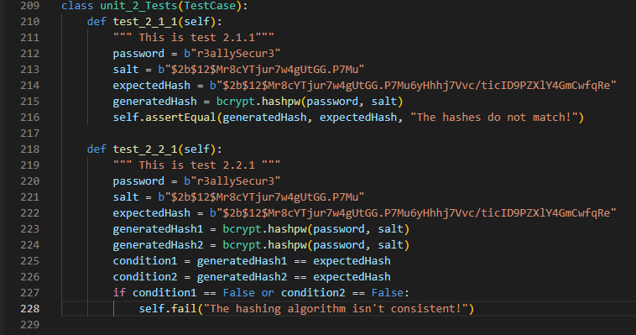

One thing to note is the use of a b prefix before strings. The b prefix has nothing to do with encryption. It merely denotes that the string is a collection of bytes. This is because bcrypt doesn’t function with UTF-8 by default. However, I am fine with that since the use of non UTF-8 characters for passwords is extremely rare in England anyway.

After I verified that the password hashing algorithm works as intended, I started work on the views, aka the response procedures.

The first thing I got to establishing is a view function for a default case. I wrote an easy loopback form that allows the user to type in a “Firstname”, which is then submitted to the server via a POST request. The server then returns an http response containing what the user typed in. This was to test if the flow and retrieval of data worked both ways properly.

The code is as follows:

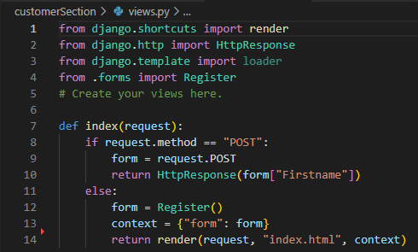

Upon the index view being triggered, it checks if it has received a POST or GET request. In the case of GET, a register form is created, a context is defined, and the template is rendered and returned as an http response.

But where is that form defined? In a separate file.

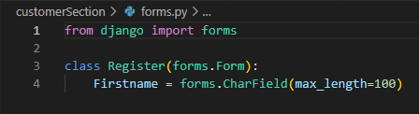

With the forms module, forms are defined as classes containing fields. Every field is required by default but can be made nullable.

To elaborate, Django has a template engine system, with a “template language”, which allows the user to define how to dynamically generate html webpages. The view renders and sends the generated webpage with the given context to the user after a GET request is received. To the user, it is a statically written webpage, while in the backend a webpage changes what is added and how it is added based on the context.Template commands are contained in curly brackets within html documents.

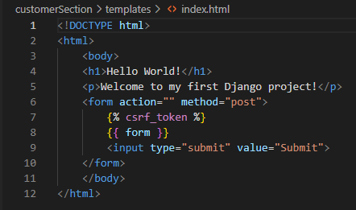

Most of the html looks simple until line 7. Django enforces a CSRF prevention token to avoid Cross Site Request Forgery. The token is unique and ensures that a user cannot submit a form which isn’t made by the server, aka forged. Line 7 essentially generates a token for the form it is inside.

In conclusion, The URL points to a view, the view has a pointer to a template, which makes a webpage and returns it to the view, which responds to the GET request.

In this case, if the path is empty, the index view will be triggered.

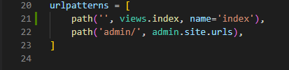

Now, whenever the index of localhost is visited, this is the resulting output.

This is a fully working form that when submitted to returns the input.



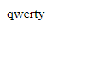

### Stage 3: Registration, Verification and Authentication

After that, I started working on the actual URL structure. Before development, I had already decided a structure for the URLs, and this diagram explains it.

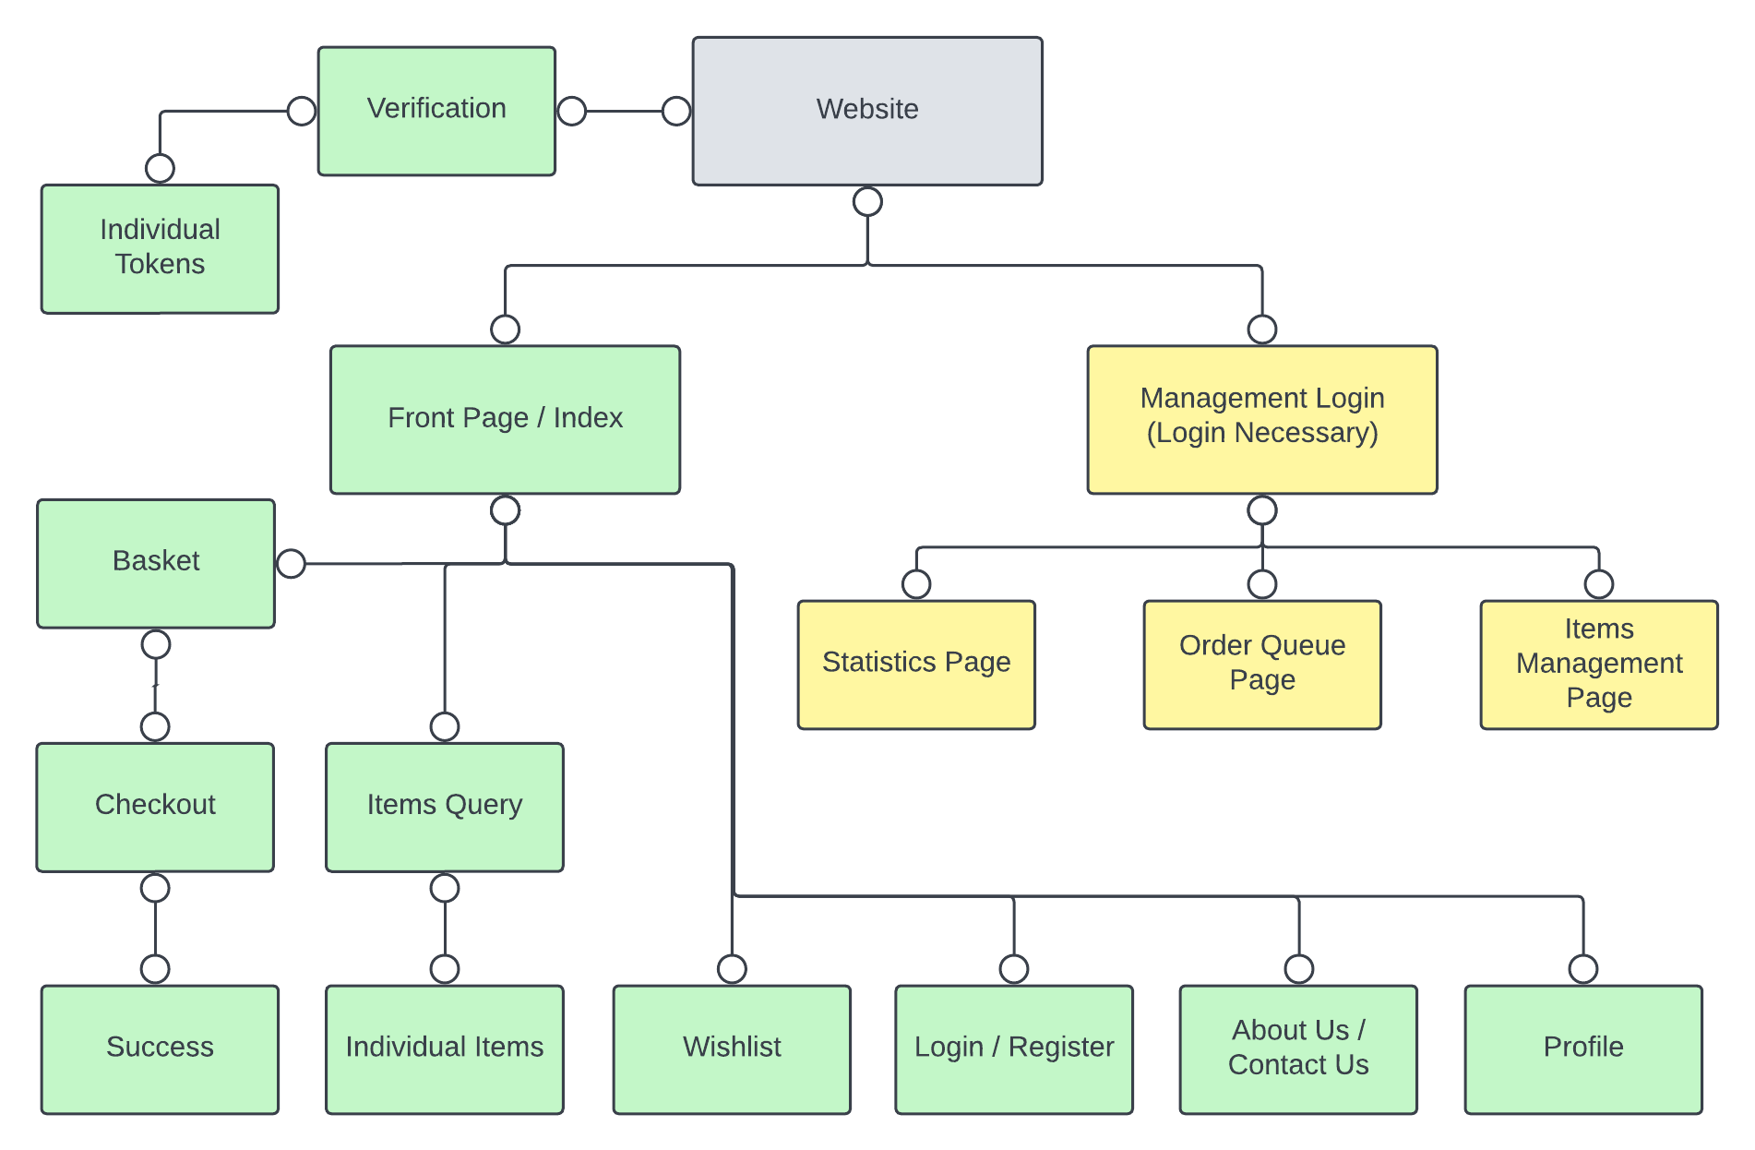

The thing that I will now focus on is the Login / Register quadrants.

The first thing I did is flesh out the URLs definition to be more accurate, by adding the registration and login paths, although I removed the login path until later.

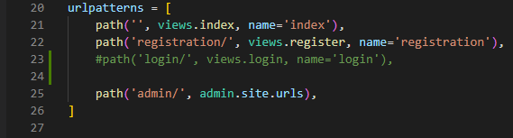

I updated the views to make registration possible. If the index and register were of the same URL, I wouldn’t be able to display different content without needless hassle. The index now doesn’t handle POST requests, and the register view is instead responsible for the registration form. If it gets a GET request, it allows someone to register, and if it gets a POST request, it calls the registerAccount function to add the account, then redirecting back to index.

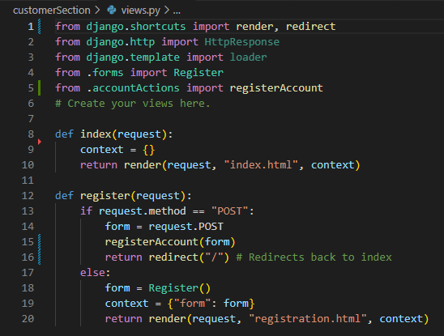

I also updated the html documents to fit the changes. Index contains a hyperlink to registration.

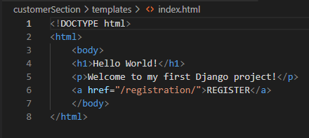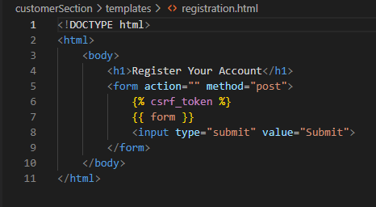

Then I made changes to the form to make it represent the actual registration form. The titles would be best represented as a dropdown option as there are a limited number of valid answers. To make a dropdown in Django, a certain format is used. Every choice is a tuple of 2. One is the internal value, while the other is the external value. Then, by calling forms.Select() the dropdown is rendered given the choices.

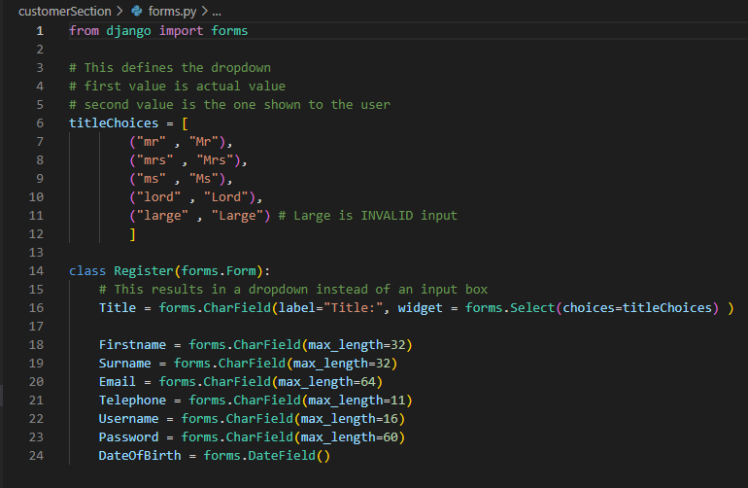

When I ran the code, the index page now looked like this.

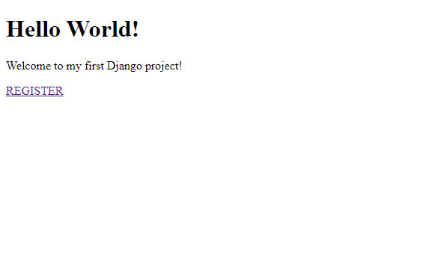

The hyperlink works. Clicking it redirects to the registration form.

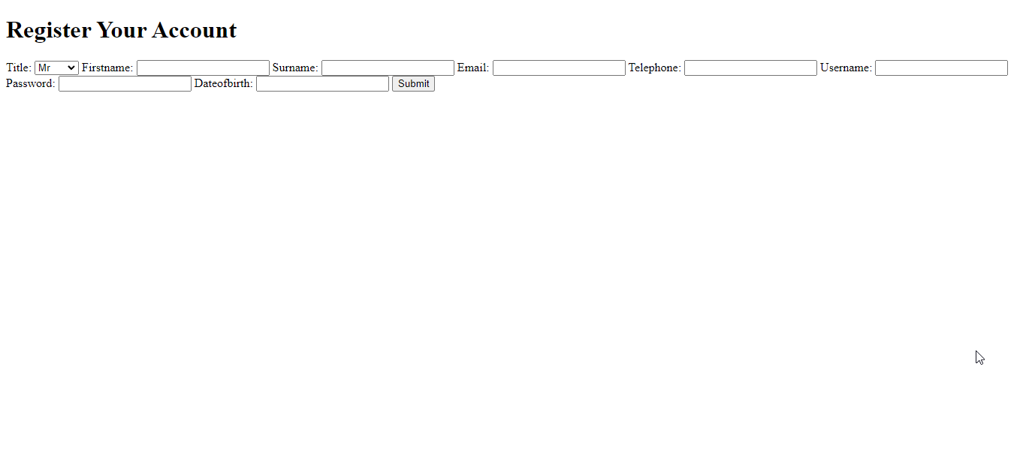

Although the current formatting is unappealing, the rendering is working as intended. The dropdown was correctly rendered, and clicking it shows all the choices it should show. 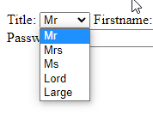

The next thing to do was to check if the page redirected correctly, so I filled the fields with placeholder data and submitted.

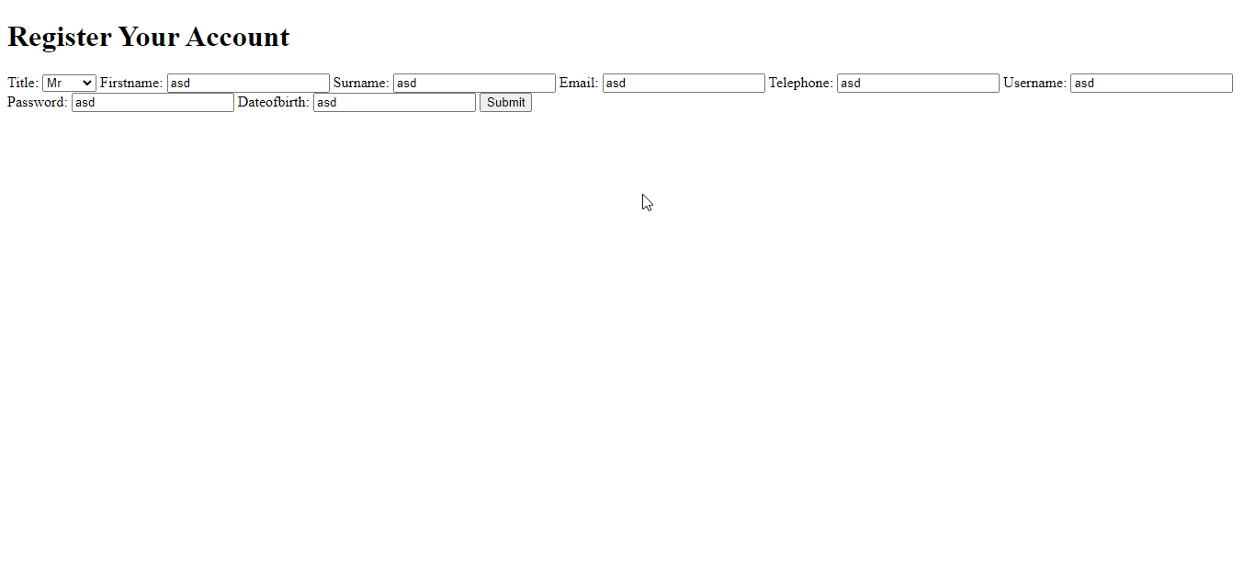

The redirection worked, and I could move onto the registerAccount() procedure. The first important thing was to have a constant salt to make hashing consistent, thus I picked the one from the test. The code takes in the form and assigns the form items to their given attribute in the account. However, for hashing I had to hash the password first. The password’s byte array form is stored as unhashedPass, which is then hashed with the salt. Then, the rest of the data is stored, and the account is added. The logging and email procedures have not been added yet, so I added a TODO as a reminder. If at any point an error occurs, the server shouldn’t crash. Instead, the command line should get an error message. To do that, the error is returned. I altered the POST view to check if the error returned was defined as None upon account creation.

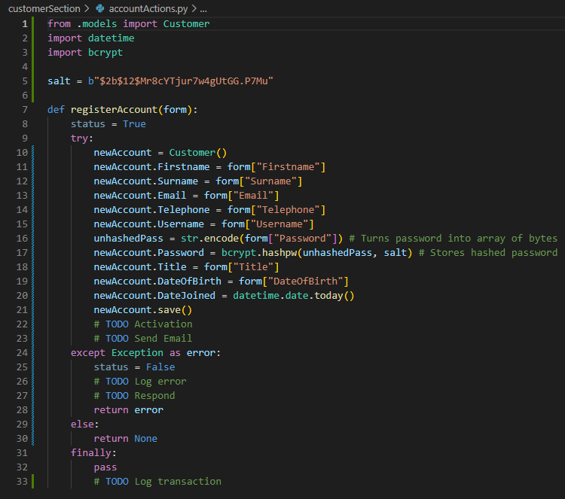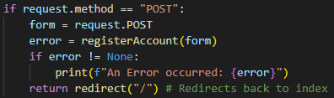

|  |  |  |  |  |  |
| --- | --- | --- | --- | --- | --- |
| Test ID | Testing |  | Input | Expected | Actual |
| 3.1.1 | **Valid data.** | V | **Firstname** = “John”  **Surname** = “Doe”  **Email** = [foo.bar@doemail.org](mailto:foo.bar@doemail.org)  **Telephone** = “05555555555”  **Username** = “johnDoe.01”  **Password** = “1@2B3c4.”  **Title** = “Mr”  **DOB** = “01/01/1970”  **DateJoined** = “01/01/2022” | **Success. Added user. Sent email with verification link.** | Error |
| 3.1.2 | Boundary tests for user creation. Each one of these values will be tested individually. | B | **Firstname** = “Vila Bela da Santíssima Trindade”  **Surname** = “Fernando del Valle de Catamarcas”  **Email** = “ReallyLongEmailThat  StretchesForWayTooLong  @ButStillValid.mail.org”  **Username** = “vilaCat.01011970”  **Password** = “ThisIsARe@llyL0ng  PasswordForSome”  **Title** = “Lord” | Success on any iteration. | Success |
| 3.1.3 | Overflow test for user creation. | I | **Firstname** = “Vila Bela da Santíssima Trindades”  **Surname** = “Fernando del Valles de Catamarcas”  **Email** = “ReallyLongEmailThat  StretchesForWayTooLong  @SeenAsInvalid.email.org”  **Username** = “vilaCats.01011970”  **Password** = “ThisWasARe@llyL0ng  PasswordForSome”  **Title** = “Large” | Error thrown on each iteration. | Error |
| 3.1.4 | Erroneous test for user creation. Each value will be tested individually. | E | **Firstname** = 1  **Surname** = 2  **Email** = 3  **Username** = 4  **Password** = 5  **Title** = 6  **DOB** = 7  **DateJoined** = 8 | Error thrown on each iteration. | Error |
| 3.1.5 | Null check for user creation. | E | **Firstname** = NULL  **Surname** = NULL  **Email** = NULL  **Username** = NULL  **Password** = NULL  **Title** = NULL  **DOB** = NULL  **DateJoined** = NULL | Error thrown on each iteration. | Added user with NULL field. |

Thus, with all this established, I ran test 3.1.1, and it caused an error. 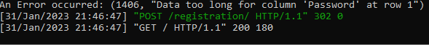

According to the error, the password is too long. I was confused and tried to print the password that was returned to see what the password was. Counting the characters inside the quotes, the character count is exactly 60. This was supposed to be valid. I thought that it might have something to do with the b prefix, as it was there even when I tried to return it as a string. After some research, I realised my mistake. The byte array would not be able to implicitly cast into its string form. Instead, it has to be “decoded”. After adding the line to decode, the code ran, and test 3.1.1 passed, and the user was stored successfully. The “Error Occurred” was just a print statement to see what the password string contained.



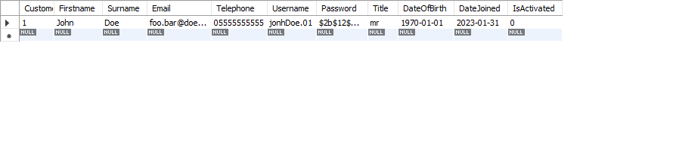

Test 3.1.2 ran successfully.

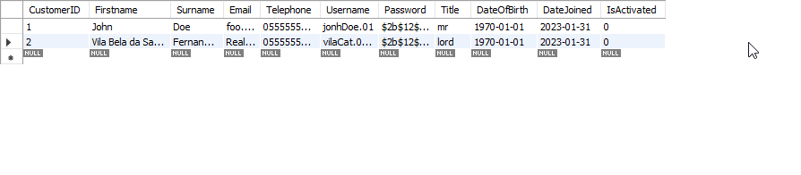

Test 3.1.3 received an error as expected 

Test 3.1.4 received an error as expected

Test 3.1.5 ran successfully, which wasn’t expected. This meant that if a user modified the form on the front end they could submit null records. This shouldn’t happen, so I searched around, and during the research I found that a field can be blank but not null and realised that the field wasn’t null, but blank. However, I don’t want a field to be blank, so I had to make a migration that made all non-nullable fields also not able to be blank.

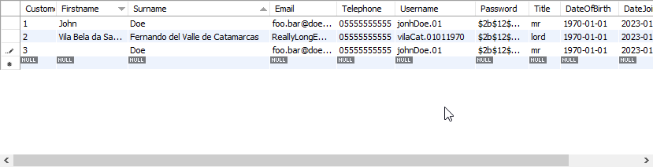

After making blank=False on every field in the models and migrating the database, the test ran as expected.



With a working registering procedure, the next logical step would be to make the activation links work. However, at this point after doing some research I realised that I had configured my user account system wrong. This would make most of the inner workings of Django not work, so I had to go back and redo some of my code. The changes themselves would be mostly inconsequential to the current website. I also switched to PyCharm for ease of use.

First, I had to change the structure of the Customer model in models.py to inherit the AbstractUserBase and PermissionMixin classes, which I imported. I also had to bind a certain field to be the username, in this case, the username field. Lastly, I had to put all the non-nullable fields in a list called REQUIRED_FIELDS. This now made my Customer models utilize the Django Authenticator. Some of the fields are now noticeably in lowercase with _ used as a spacing character. This is because those values need to be named as such to keep the default UserManager working. Otherwise, I’d have to rewrite the UserManager. Thus, I marked all those values. Values such as is_staff were also necessary additions.

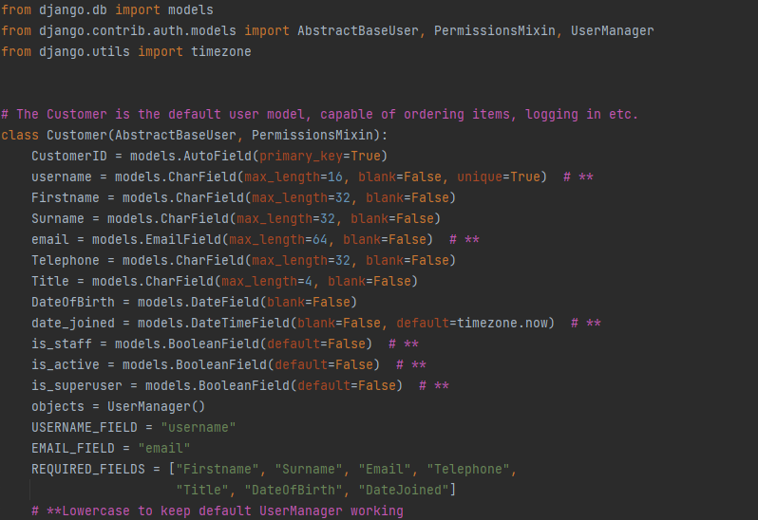

After that, I had to change the internal hasher to use bcrypt, as Django internally handles hashing. I also had to set the AUTH_USER_MODEL to let Django know what the default user model is. To do those things, I went into the settings.py and added the following extract. The AUTH_USER_MODEL now references the Customer model, and the top item in the list of PASSWORD_HASHERS is bcrypt. The hasher was now fully configured.

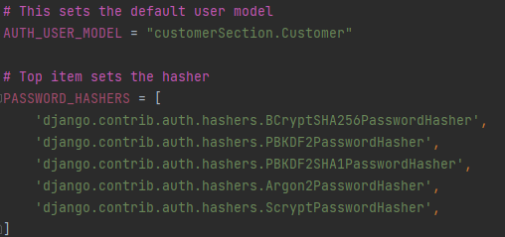

Lastly, I had to modify the way the form registers customers, as the method is slightly different. I had to initialise newAccount using Customer.objects.create_user() . What this code does is create a new user using the UserManager instead of as a simple object. It is essentially the same algorithm on the surface though.

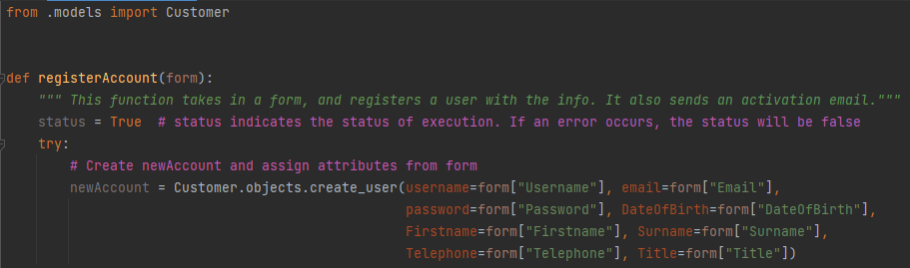

With that done, I had to test the registration again, and so I migrated the changes and input the default data.

The result was a success. In the process, I had to wipe the rest of the database though.

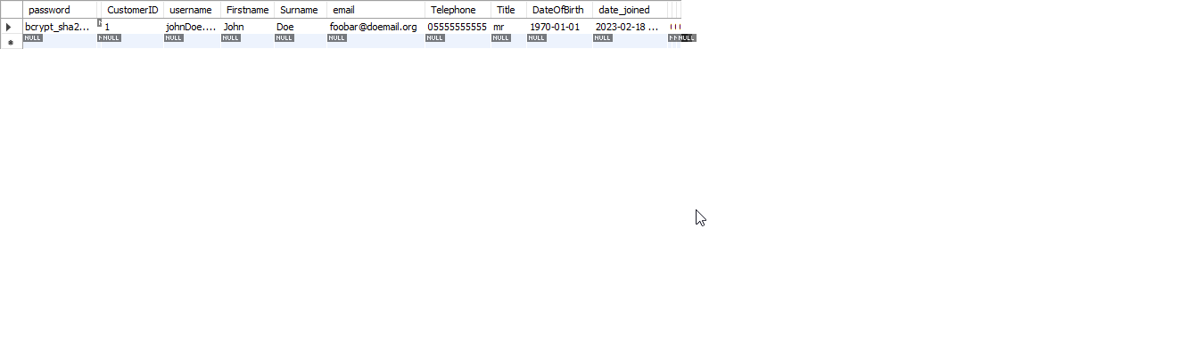

The rest of the tests worked as planned, and thus I could continue to the verification system. After some consideration, I decided it was better to not use a dictionary to store the token and action pair. This was due to the concept of Durability in ACID. If a power outage was to go off, all the tokens would be lost. Thus, I would make tokens a part of the database.

First, I had to implement a model to hold the token-action pair.

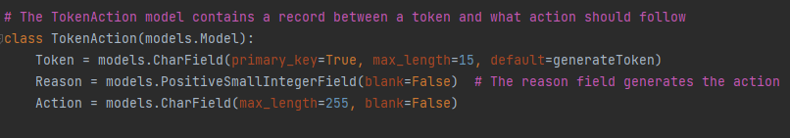

The TokenAction model holds a 15-character token as its primary key. The Action field contains the action that should be executed corresponding to the token. The token is never explicitly set. Instead, its default value is a function called generateToken().

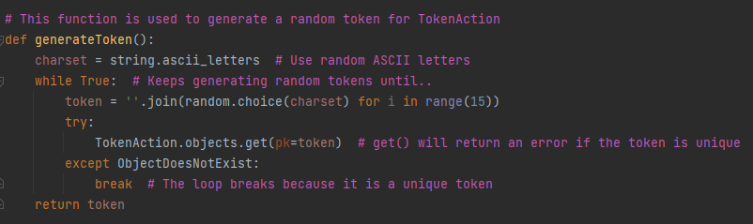

When generateToken is called, it defines a character set to use when randomising the string. In this case, it contains all capital and lowercase letters of the English alphabet. Then, a string called token is set to a random choice of any 15 characters from that set, with duplicates allowed. If the token has already been used in another instance of TokenAction, then the token will be regenerated until a unique token is made. This unique identifier is then returned and set to the primary key of the new TokenAction instance.

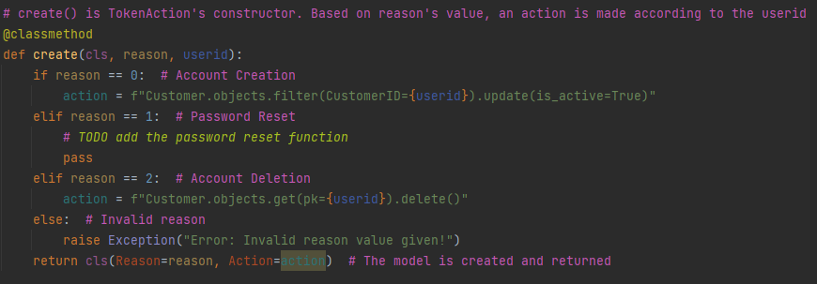

To create a new instance of TokenAction, the usual constructor of “TokenAction()” is not valid, as the __init__ method is already used by some of Django’s inner workings, and thus modifying it would cause internal issues. Instead, the create() method is used. The reason attribute’s purpose comes in when generating a TokenAction instance. Depending on its value, a different action is set. In the case of an unexpected reason value, an exception will be raised. Otherwise, the final TokenAction instance will be created and returned. As I have not implemented password resets yet, that case is not handled. That will also result in an error because an action will not exist.

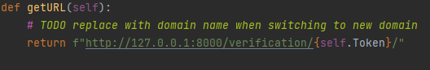

I also added a getURL method to TokenAction to make getting URLs easier.

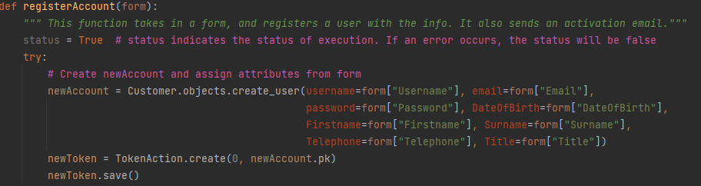

With that, I added the first use of TokenAction in the code. When registering, a user will be able to activate their account by going to the verification link for the given token. To handle that, I needed to add a view for verification.

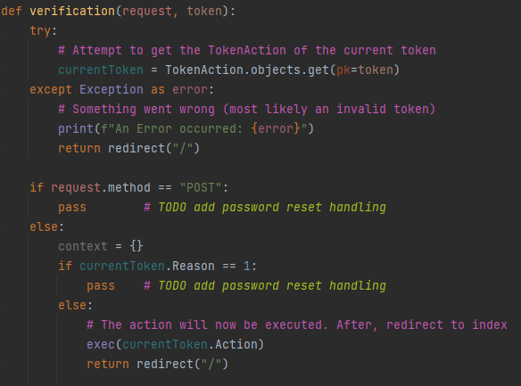

This is the current verification view. Given a request and a token, it will attempt to acquire the instance of TokenAction that matches said token. If it is invalid, the error will be printed, and the user will be redirected to the index. The POST and GET method are both used to handle the password reset handling, but for now neither are handled in the case of resetting. In the other cases, when a GET request is received, the currentToken’s action will be executed and a redirection will follow.

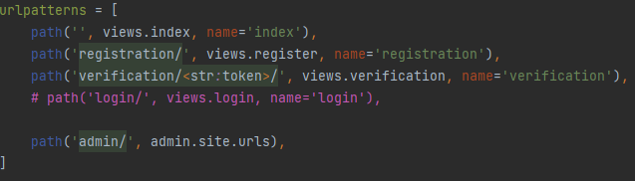

Lastly, I added the path to handle the verification view in the URLs. In the path of verification/, the string that follows will be given as input to the verification view.

With those changes done, I migrated the database successfully and ran the server.

The first thing to test was registering a user. A valid registration should result in a new TokenAction.

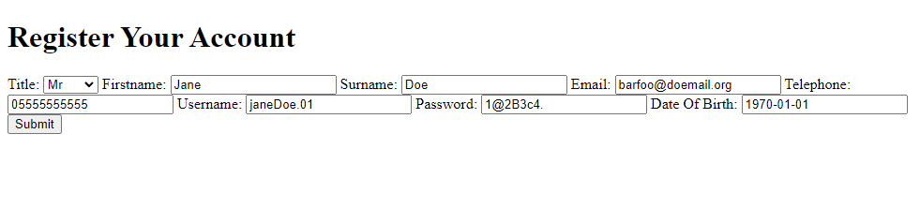

With this input, I submitted a registration, and the result was a successful registration and generation of a token.



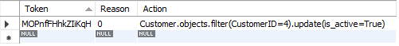

The token’s generation was as expected, so it was time to test the activation. As the system was slightly changed, the test values of the tests also had to be changed. Namely, tokens instead of usernames.

|  |  |  |  |  |  |
| --- | --- | --- | --- | --- | --- |
| Test ID | Testing |  | Input | Expected | Actual |
| 3.2.1 | Valid data for user activation. | V | **token** = “MOPnfFHhkZIiKqH” | Success. The Jane Doe should now be activated. | Error |
| 3.2.2 | Trying to activate non-existent user. | I | **token** = “doesNotExistAB” | Error thrown. No effect on database. | Error |
| 3.2.3 | Erroneous data type. | E | **token** = 1970-01-01 | Error thrown. | Error |
| 3.2.4 | Null check. | E | **token** = NULL | Error thrown. | Error |

With the correct URL in my search bar, I was ready to begin with test 3.2.1

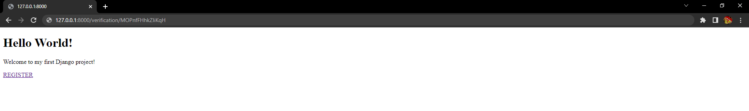



When I entered that URL, I got the following error.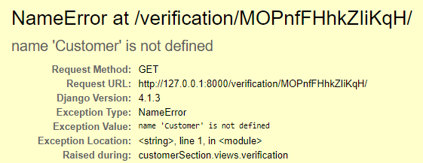

When I got this error, I had a suspicion of where the error came from. In the context of views.py, Customer wasn’t defined, so trying to access Customer.objects resulted in an error. To fix that, I imported Customer which would allow for the execution of the action in views.py.

When I revisited the URL, the GET request was successful. This resulted in being redirected to the index. 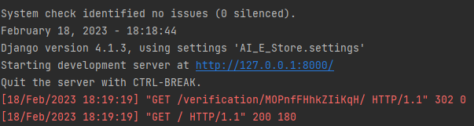

And as I thought, the change was in effect when I checked the database. The account was activated.



At this moment, I realised that the token was not removed as it should, and I realised I hadn’t implemented the removal of tokens upon use. That was a simple task though. At the end of the verification view, after a successful execution of the action, the currentToken would get deleted.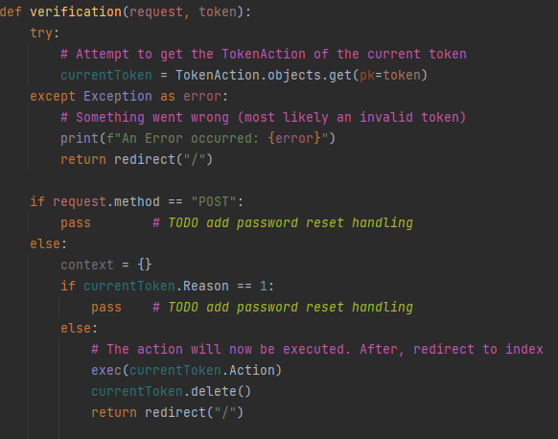

Testing that, I visited the URL again, and the TokenAction table was now empty.

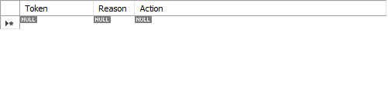

This marked test 3.2.1 as a pass.

I then tried test 3.2.2, which resulted in an immediate redirect. When I checked the server console, I got my answer to the reason.

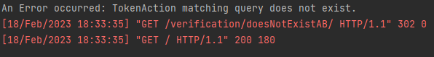

As expected, the test brought an error, which was handled correctly.

For test 3.2.3, I used an incorrect data type for the token, and this was printed out in the server console. 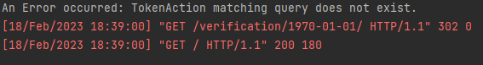

As expected, the test threw an error, which was also resulted in a redirection.

For test 3.2.4, I didn’t input anything in the token, and the result was a 404 from Django. 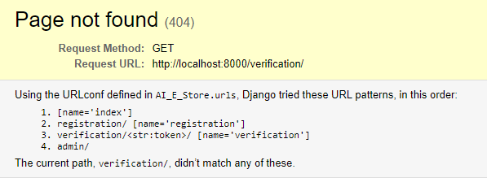

Checking the server console gave affirmative evidence that this was handled correctly, as if it was any other request.

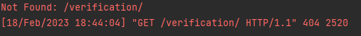

With that, the activation for users was now functioning as intended. Now I had to implement user authentication. One of the benefits of using Django’s user system was that logins and sessions would be better handled via the authorisation module.

As I was doing research on implementing logins, I found a much better way to use my forms that would be useful later in development. That meant I had to refactor the code for registration. The change was small, but it resulted in a lot of added functionality in the future, mainly in validation and data sanitisation.

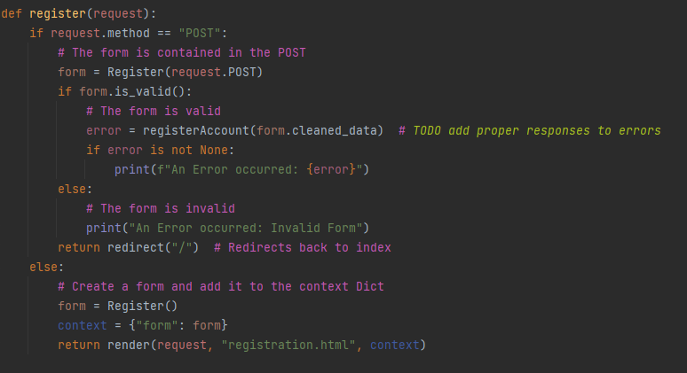

When assigning the form, instead of assigning it to request.POST, I instead make an instance of the Register form with request.POST as data. All forms have methods to use in validation. The is_valid method and cleaned_data attribute are the important ones for now. If the submitted data does not meet the requirements stated in forms.py , is_valid will be false. Now, because form is an instance of Register, the correct way to acquire the form submission data is via the cleaned_data attribute, which is the dictionary of answers. With those two, I can now know if the form is valid or not before it even reaches the registerAccount function.

To begin, I made a form for the login. It has the same restrictions as the registration.

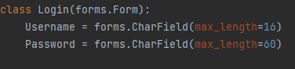

I’ll also briefly mention the changes in the templates.

I added a new template called login.html to GET and POST the log in form.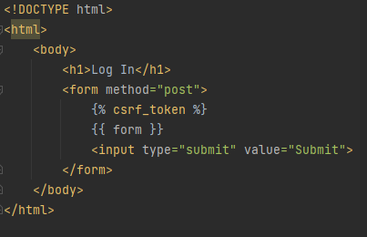

I then modified the index template. It will give a different output if the user is logged in. This is to differentiate between a logged in user and one that isn’t.

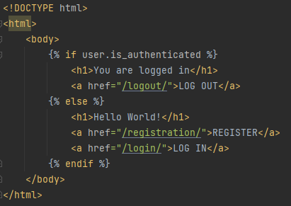

With that, I added the attempt_login view. When a GET request is made, the simple login form is sent to the user as a rendered webpage. When a POST request is received, a user is attempting to log in. In that case, the data they input is put inside an instance of the login form. If the form is valid, and the authentication goes through with no errors, they will be logged in and redirected to index. If the credentials are incorrect or any other unexpected error occurs, an exception will be raised and printed on the server console, and the user will be redirected to login to attempt again. This also happens if the form is invalid, but no authentication code is run in that case. The server will keep running though.

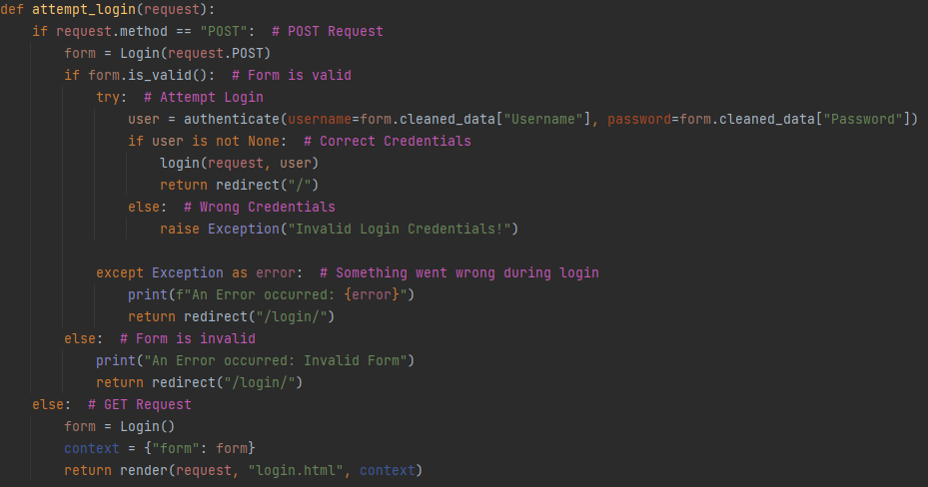

When a user is logged in, they must have a way to log out. This was simple to implement, via an attempt_logout view. Note that if an anonymous user tries to log out somehow, it won’t cause any errors. Another thing to note is the naming scheme. If I were to use logout and login as the view names, the view would recursively call itself instead of calling the authentication functions of the same name. To avoid that, I added an attempt_ prefix to the views.

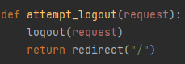

I also had to edit the index view to provide the user field as a context to the template. This would allow user.is_authenticated to be accessed.

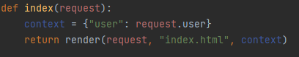

I then bound all the views to their respective URLs in urls.py.

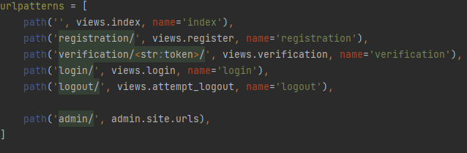

With that, it was time to do some unit tests. Before doing the tests, I added some users to fulfil the test data. The customers table now contains this data. notActivated’s password is 1234.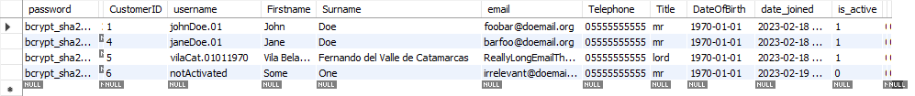

|  |  |  |  |  |  |
| --- | --- | --- | --- | --- | --- |
| Test ID | Testing |  | Input | Expected | Actual |
| 3.3.1 | Valid data for user authentication. | V | **username** = “johnDoe.01”  **password** = “1@2B3c4.” | Success. The user should be logged into a session. | Success |
| 3.3.2 | Boundary data for user authentication | B | **username** = “vilaCat.01011970”  **password** = “ThisIsARe@llyL0ng  PasswordForSome” | Success. The user should be logged into a session. | Success |
| 3.3.3 | User doesn’t exist. | I | **username** = “doesNotExist” | Error thrown. User is not logged in. | Error |
| 3.3.4 | Passwords don’t match. | I | **username** = “johnDoe.01”  **password** = “notCorrect” | Error thrown. | Error |
| 3.3.5 | Overflow data for user authentication. | I | **username** = “vilaCats.01011970”  **password** = “ThisWasARe@llyL0ng  PasswordForSome” | Error thrown. | Error |
| 3.3.6 | Erroneous Data Type. | E | **username** = 1970-01-01  **password** = 1970-01-01 | Error thrown. | Error |
| 3.3.7 | Null Check. | E | **username** = NULL  **password** = NULL | Error thrown. | Error |
| 3.4.1 | Attempt to log in with non-activated user. | I | **username** = “notActivated”  **password** = “1234” | Error thrown. User is not logged in. | Error. |

Starting with 3.3.1, valid data was to be given to the login form. I ran the server and was greeted by index with a new option. Clicking that redirected me to the login form.



When I entered the login form, I input the test data for 3.3.1, and submitted the form.

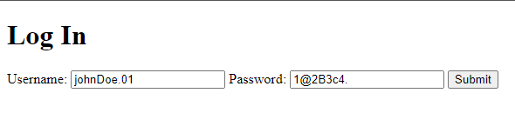

The log in was successful, and index now had a different output that showed I was logged in. When I clicked the log out hyperlink, it refreshed index to its previous state.

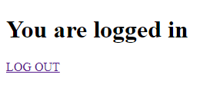

To further affirm the success of the test, I checked the server console, which contained no errors. The trajectory was GET index -> GET login -> POST login -> GET index -> GET logout -> GET index, as expected.

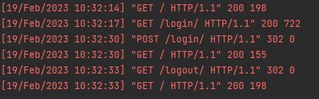

Next was test 3.3.2. I input the test data as such. The password field did not fully show the input, but that’s fine for now.

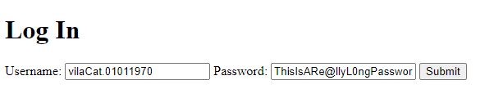

It resulted in a successful login, thus passing 3.3.2.

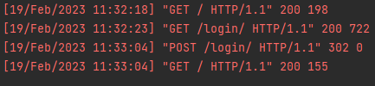

Next was 3.3.3. I input the test data and submitted the form.

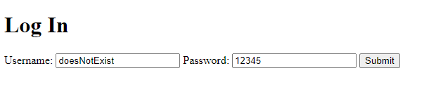

When I submitted it, it immediately turned all the fields blank, indicating redirection.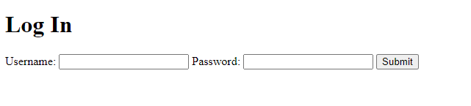

When I checked the server console, the output was showing an error, as expected.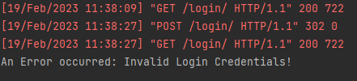

Next up was 3.3.4.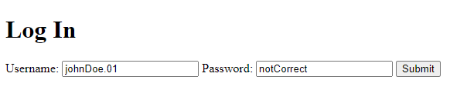

Submitting it also resulted in a redirection, and the server console showed an error.

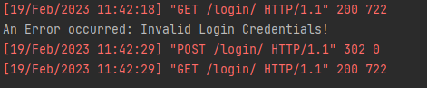

Next, I carried out 3.3.5. To allow for the warped input, I carried out a client-side modification attack by changing the frontend’s html in my browser to allow for a max length of 17 characters.

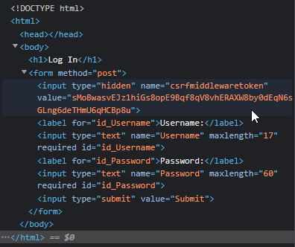

I inputted the test data and submitted it.

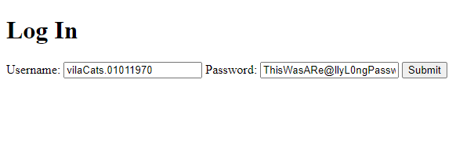

The result was a form reset and an error in the server console as expected. It showed the form as “invalid”, which starts to show the benefit of using the new method for forms.

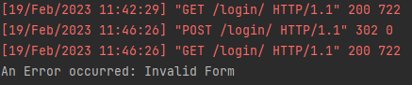

Next was test 3.3.6. I inputted the test data and submitted it.

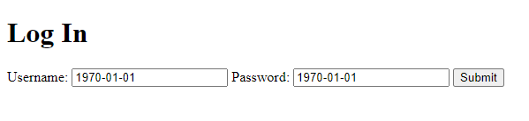

The form reset, and server console output an error as expected.

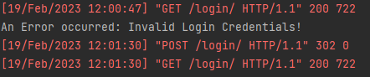

Next was test 3.3.7. To carry out this one, I used a similar method as the one in 3.3.5, a client-side modification attack. I make the fields nullable and submitted the form.

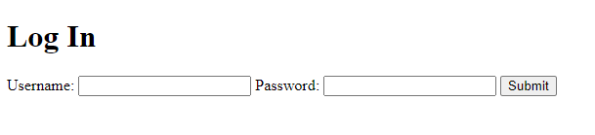

The result was an invalid form error and form reset, as expected.

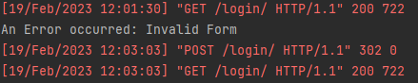

Lastly, I carried out test 3.4.1. Hypothetically speaking, Django’s authentication should handle this on its own, so I shouldn’t have to manually handle it. I attempted to log in with the notActivated account in the current state of the views.

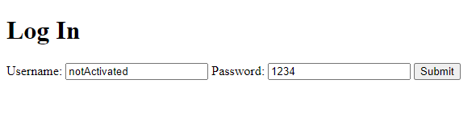

The result was indeed an error, but I realised that I had to account for this case and output a different error because the current one didn’t fit the context.

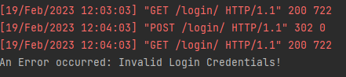

I edited the error handling to be a bit more fitting for the situation.

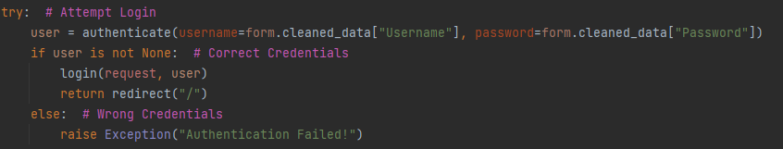

With that, user authentication was implemented. However, in its current state, the website makes no effort to notify users about any errors that occur. Now that user authentication was working, I decided to fix that using the Django messages module. This would allow for a simple response message to be sent back from the server in the case of any event. Successes, errors, etc.

Using it is very simple, but I had to do some basic refactoring on the login_attempt to avoid redundancy. The status and userID variables were added to make logging easier, and for readability. If the correct credentials are input, the userID is set to the CustomerID of the user logging in. Otherwise, an exception is raised. If that or any other exception is raised, the status is set to false. This also occurs if the form is invalid. At the end, given a status the user will either be redirected to the index or given a reset form and an error message.

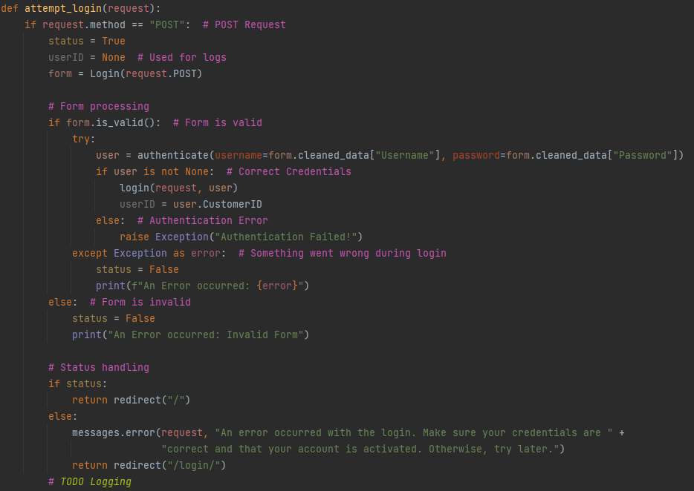

I also added messages to the registration. Upon successful registration, the user is given a response to affirm success. Otherwise, an error message is given. In both cases, they are redirected back to index.

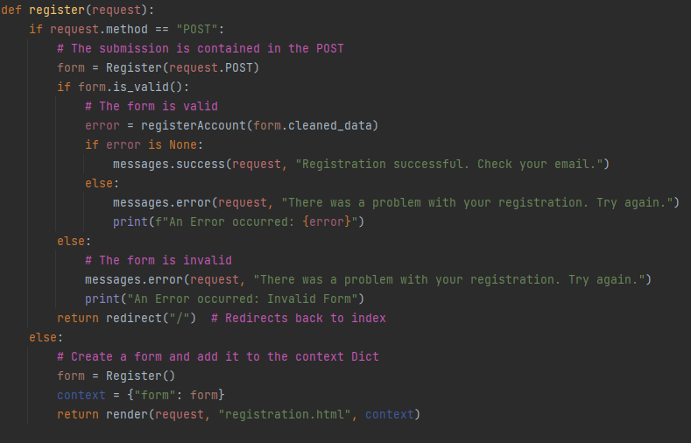

The last thing to do was to add message functionality in the templates. This block of code is responsible for that. They are all added as an unordered list.

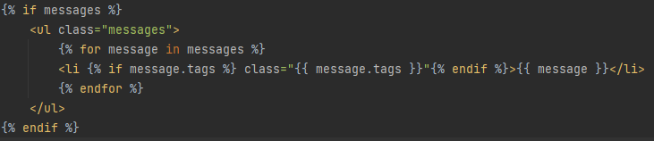

When a login is unsuccessful, the output is as such. While it currently looks rather underwhelming and static, when I use bootstrap, the render will be much nicer.

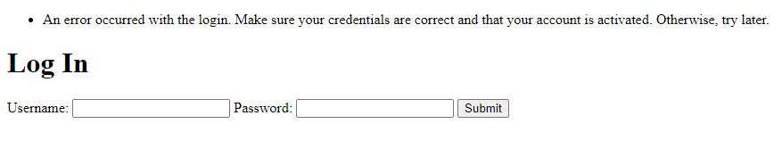

With that done, the next step was implementing user account deletion requests, which would be rather simple.

I first added a view that would handle requests for deletion. I changed my original concept of deletion slightly to make it much safer. Deletion is now only allowed for logged in users, as that allows for a deduction of which user is requesting deletion. If a user is not logged in, I simply use a 404 error to deter from any snooping, as a user who isn’t logged in shouldn’t be able to even attempt a deletion without a URL. The user is also notified with a message to affirm success.

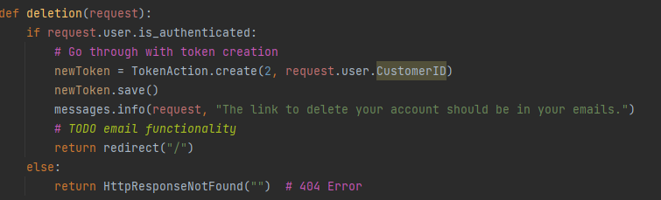

I then added that view to urls.py with a complementary URL.

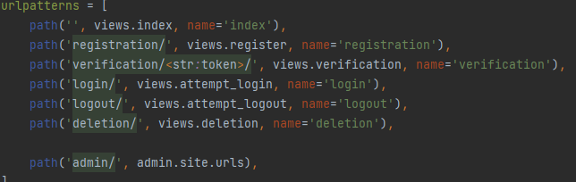

Lastly, I added a hyperlink for deletion on index.html if the user is logged in.

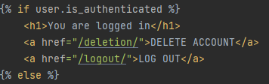

With that, it was time to test user account deletion. I needed to make some changes to the test plan to account for the changes in the algorithms. 3.5.3 was no longer valid because there is no parameter to make NULL.

|  |  |  |  |  |  |
| --- | --- | --- | --- | --- | --- |
| Test ID | Testing |  | Input | Expected | Actual |
| 3.5.1 | Valid data for account deletion. | V | **user** = “notActivated” | Success. The user is deleted. | Success |
| 3.5.2 | Deleting non-existent user. | I | **URL** = “verification/bBRnNgoEeNawERe”  After deletion of notActivated. | Error thrown. No impact on the database. | Success |

Since notActivated was now useless to me as a user account, I decided to use it as a test subject for 3.5.1. I activated it and logged in to the new index. There was now an option to delete the account.

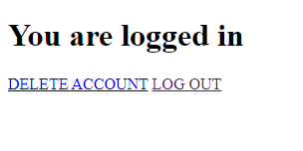

Pressing on that redirected the page back to the index with this new output.

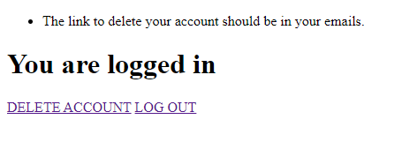

Checking the server console, no errors had occurred.

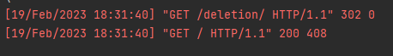

Last, I checked the TokenAction table, and the token generated correctly.

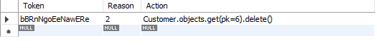

With that, I entered the verification link, and the user was successfully deleted. This is indicated by the server console and the fact that the user was now gone, thus passing 3.5.1.



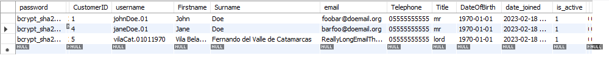

For 3.5.2 I attempted to revisit the same verification link, which resulted in this server console output.

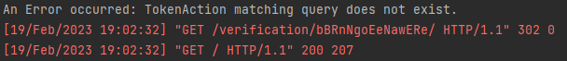

Thus, user account deletion was now working. The next thing to add was the password reset.

I began by modifying and adding html templates for my project. The login now links to the password reset request, and the password reset, and its request have forms.

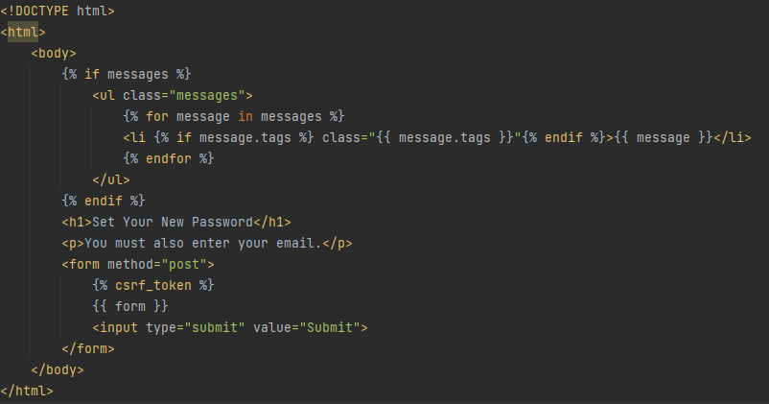

After, I defined the forms to be used in forms.py.

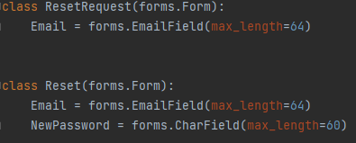

Then it was time to make the additions to the TokenAction class. For the create method I added handling for creation of password reset tokens. I then added a new method that allows me to acquire the userID from the TokenAction instance’s given data. It only works for password resets, as the string handling used to make it work is made specifically for that string. An invalid reason will return -1.

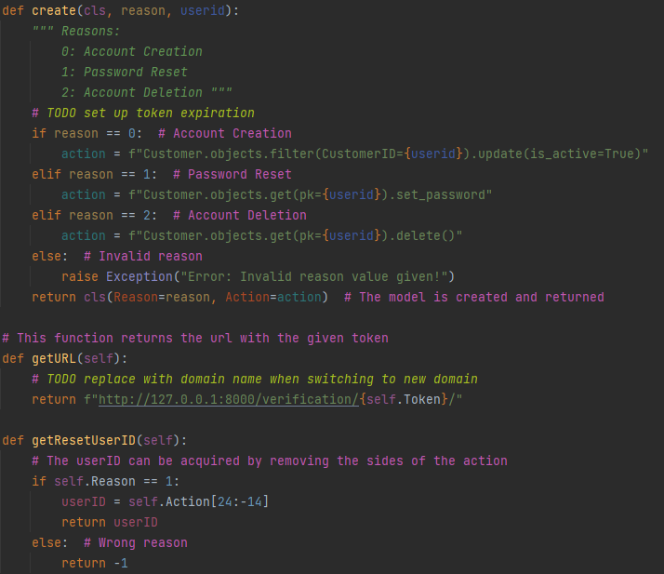

With those changes, I began added the request_reset view, which is used to handle password reset requests. When GET method is used, the matching form will be returned as a template. However, when using POST, the form will be used to get a matching user account and request a reset. If there is no matching account, the user will be redirected back to the form, and be notified of their mistake. In the case of success, the new Token will be defined and the account whose email address was provided will be open to a reset in a verification link.

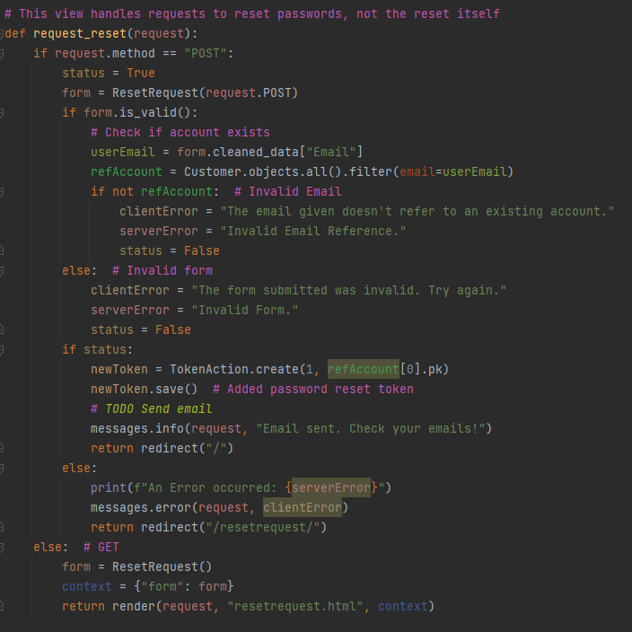

Then, I modified the verification view to add handling for password resets. When a password reset GET request occurs, the form is sent as an http response.

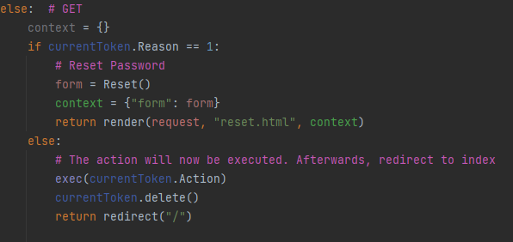

Lastly, the most important part of the password reset is the post request on the verification link. If the form is valid and the token is used for password requests, the reset will proceed. The user email from the form gets the user that has a matching email, and then the token’s userID for the action is gotten. If the query provides an existing account, whose ID matches that of the action, the new password will be set. This involves an impromptu construction of the command’s final missing segment with the new password on the spot. This is then executed, and the token is deleted. Any errors will be caught.

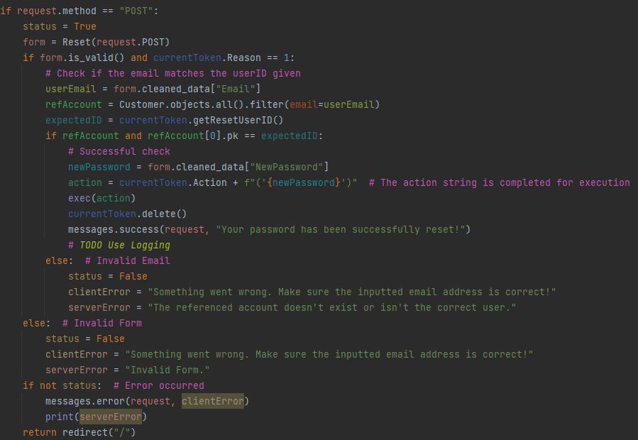

With that, it was time to test password resets.

|  |  |  |  |  |  |
| --- | --- | --- | --- | --- | --- |
| Test ID | Testing |  | Input | Expected | Actual |
| 3.6.1 | Valid data for password reset request. | V | **Email** = “foobar@doemail.org” | Success. A verification link for password reset should be generated. | Success |
| 3.6.2 | Valid data for password reset. | V | **Email** = “foobar@doemail.org”  **newPassword** = “mor3Secur3” | Success. The password of the given user should change to the new one. | Error |
| 3.6.3 | Erroneous data type test. | E | **Email** = 1970-01-01 | Error thrown. Password isn’t changed. | Error |
| 3.6.4 | Null check. | E | **Email** = NULL  **newPassword** = NULL | Error thrown. | Error |

To start, I carried out 3.6.1. The login screen now had a functional gateway to the password reset request.

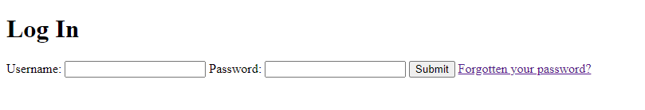

Clicking that transported me to a form. I filled in the valid data and submitted it.

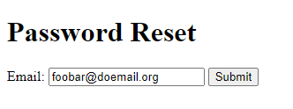

When I submitted it, I checked if the TokenAction instance was created, which it was.

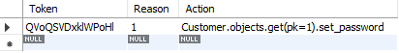

Thus, the test had passed.

With that, I carried out test 3.6.2. I went to the correct URL and was met with this form. I filled it in with the test data and submitted it.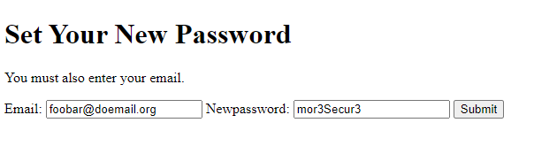

This was faced with an error, which puzzled me.

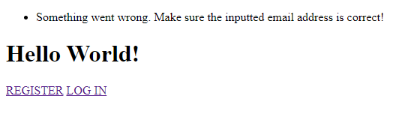

When I printed out the IDs, they both had the same output. The refAccount was existent because I also checked for its existence. This lead me to believe that the data types were different, so I tried to cast one of them as an int explicitly. After casting expectedID to an integer, it worked as expected, and gave me a message of success.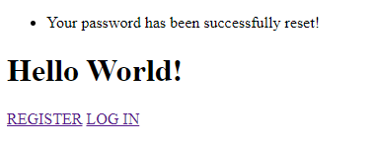

Testing for the login, I thought it’d work flawlessly, but it surprisingly failed.

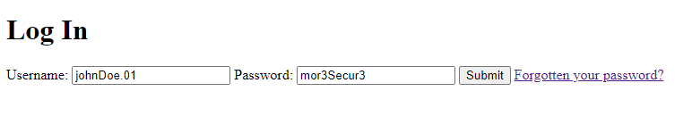

The error that came back from the form was as such.

I checked the server console and that came back with the following error. This error implied that the authentication attempted and failed, meaning an invalid password was given for the user.

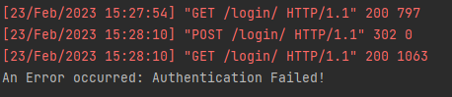

Tracing back to the code where that occurs, the following line returns None, which gives proof of that, as the username has worked before. Thinking of what could be wrong, I tried the original login credentials, and they worked. This implied that the changes weren’t saved.

To fix that, I had to employ the use of semicolons in python to fit the action into a single line string. I defined the Customer object as c, changed its password and saved it. With that change, I was finally able to log in again, now using the new password, “mor3Secur3”.



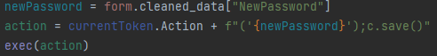

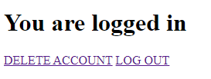

With that pass, it was time for test 3.6.3.

I modified the client to allow for an invalid submission and provided invalid data.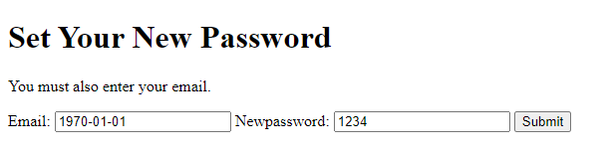

The result of that was an error, as expected.



Then, it was time to carry out test 3.6.4.

I did a similar modification and submitted an empty form.

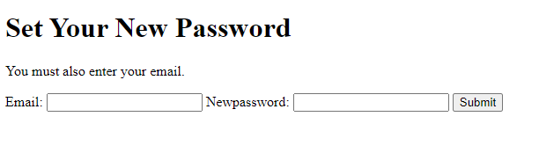

This also returned an error, which rendered this test as a pass.



Thus, I have fully implemented password resets. Before adding reviews, I also did a quick test to see if 3.7.1 would pass.

|  |  |  |  |  |  |
| --- | --- | --- | --- | --- | --- |
| Test ID | Testing |  | Input | Expected | Actual |
| 3.7.1 | Attempt to register with already registered user. | I | **username** = “johnDoe.01” | Error thrown. The pre-existing user shouldn’t be impacted. |  |

To carry this out, I entered the given input data into the form and submitted it.

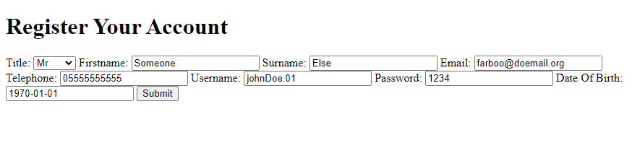

Upon submission, I got an error, as expected. The error stated that it was a duplicate entry. This showed that the registration would not override users.

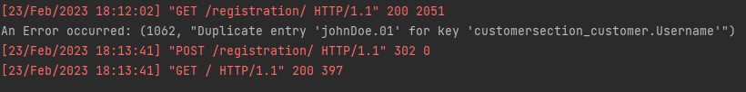

### Stage 4: Reviews and Emails

With that done, the next step was the addition of reviews. Before that, I added base.html as a template. This was to simplify the process of creating new templates. I added all the basic repetitive tags and text in the base.html as so. I also defined two blocks, title, and content.

If data wasn’t provided for any of them, their default value would be shown.

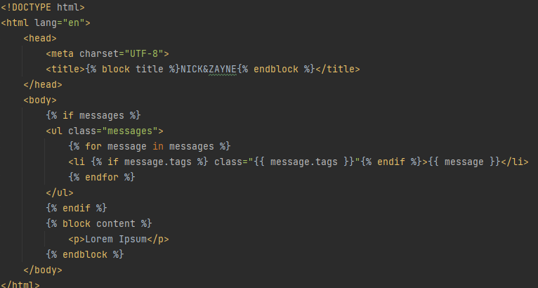

This is how this extends over to index.html. The extends keyword sets the initial template to base.html, and then the content is set to the necessary html which is exclusive.

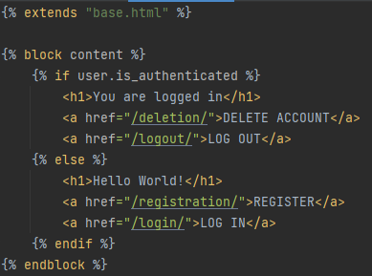

All the webpages worked fine, and the project could continue.

It was time to implement the reviewing system.

I began by setting a Form to which the standards of what I write would conform to.

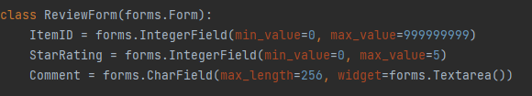

With that taken in mind, I had to make some modifications to the models to make the hasBoughtAlready validation function easier to create. I first renamed ItemInstance to a more useable name to avoid ItemInstance with an instance of the model Item. This would assist with any needed code maintenance later into development or after. I also added a function to return all styles of an item.

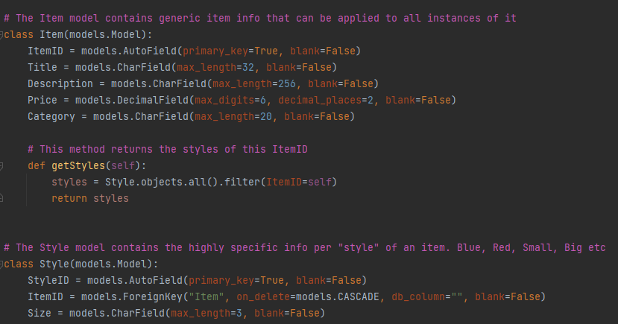

With that groundwork set, I had to create the hasBoughtAlready algorithm. I also decided to rename that to something more reasonable. Given a user and an item, it can validate the eligibility of a user to place a review based on whether the item has been ordered before while also not being reviewed by the user yet. The result is a Boolean expression of eligibility.

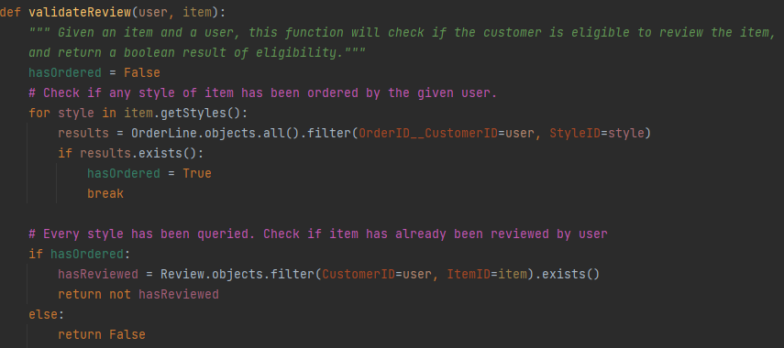

The last thing to implement was the ability to review an item via a temporary view. The get method is the same form initialisation and context render. However, in the case of the POST, there are a lot of moving parts. First, the form is assigned as form, and if the input is invalid, then an error occurs. After that, the server attempts to assign the itemID given to an instance of the Item model. If the ItemID is invalid, an error will occur. If that also succeeds, then the customer instance will be acquired, so that the review can be validated against the previously stated function. If that is successful, the comment and star rating will be assigned, in order to instantiate the review, but if it doesn’t yet again, an error occurs. Depending on the place in the code where the error occurs, a different error message will be shown. In the end, the review will be either placed, or an error will be processed, with their respective redirections taking place.

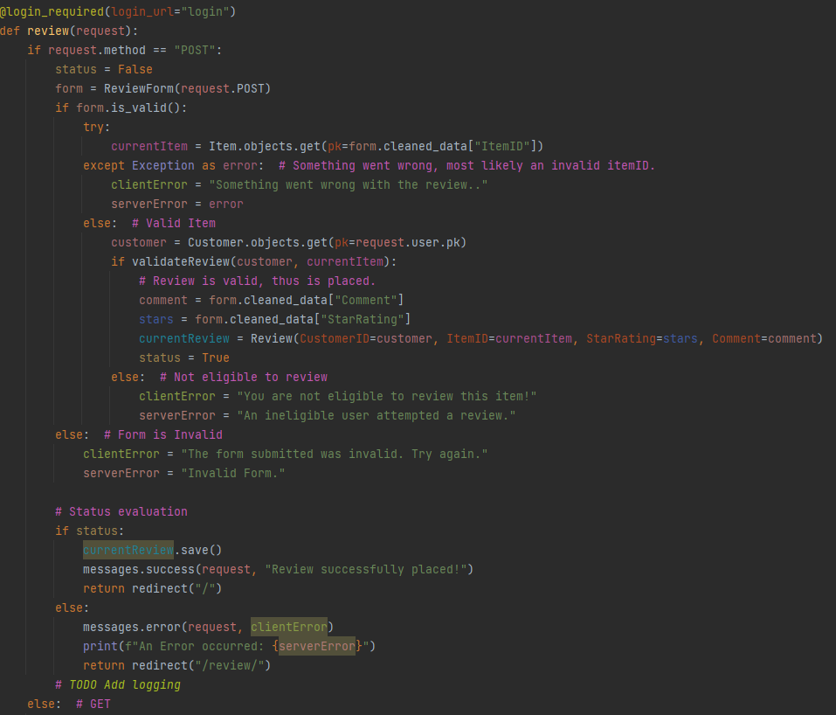

That was followed by review’s addition to the URLs.

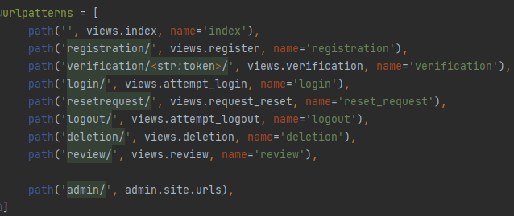

With that done, I added an item with the id of 1 that corresponds to a hoodie. It has an instance where it is blue, and the database entries are as follows.

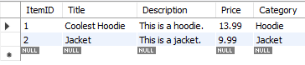

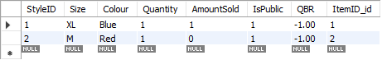

With that, I also created an order artificially to make review placement possible. It was now time to test it. I also had to make modifications to the tests because of the change in procedure.

|  |  |  |  |  |  |
| --- | --- | --- | --- | --- | --- |
| Test ID | Testing |  | Input | Expected | Actual |
| 4.1.1 | Valid data for review placement | V | **ReviewedItem** = 0001  **Comment** = “This was a lovely piece of apparel.”  **reviewStars** = 4 | Success. The Review should be now in the database. | Success |
| 4.1.2 | Upper Boundary check for review placement. | B | **reviewStars** = 5 | Success. | Success |
| 4.1.3 | Lower Boundary check for review placement. | B | **reviewStars** = 1 | Success. | Success |
| 4.1.4 | Review can’t be placed twice. | I | **ReviewedItem** = 0001 | Error thrown. No impact on the database. | Error. |
| 4.1.5 | Item not bought. | I | **Username** = “johnDoe.01”  **ReviewedItem** = 0002 | Error thrown. | Error. |
| 4.1.6 | Erroneous data type. | E | **ReviewedItem** = 2  **Comment** = 3  **reviewStars** = “joe” | Error thrown. | Error. |
| 4.1.7 | Null Check. | E | **ReviewedItem** = NULL  **Comment** = NULL  **reviewStars** = NULL | Error thrown. | Error. |

With that, I ran the server to a new index after logging in. Mind that this is not how reviews will be handled in the final solution.

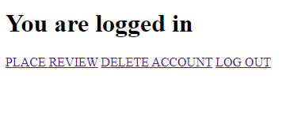

Clicking “Place Review” put me in the following form. That was my queue to enter the test data for 4.1.1.

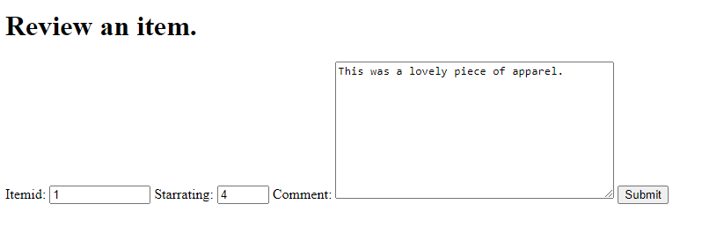

Submitting that returned the following results.

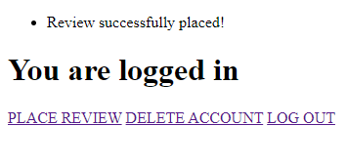

Checking the database, the review was indeed placed.

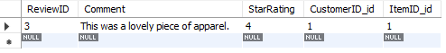

With that, test 4.1.1 passed.

I next had to do a boundary check using 5 and 1, which were the tests 4.1.2 and 4.1.3.

I first deleted the previous review, so that I could place the new one. I then input the test data.

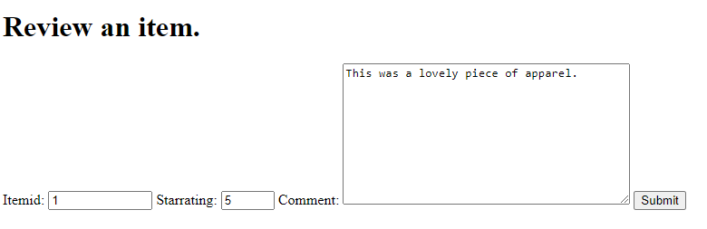

After doing so, the review was successful, with the following database record as a result.

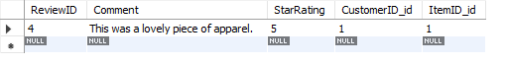

With that, test 4.1.2 passed. Next, I conducted 4.1.3.

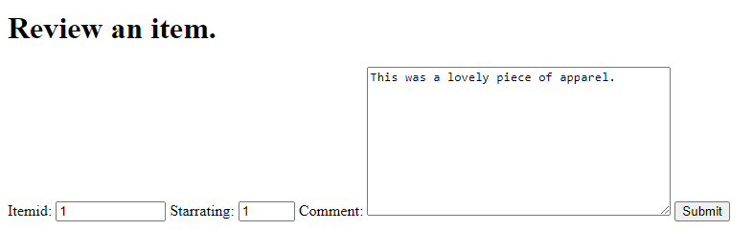

The review placement was successful, and so 4.1.3 passed.

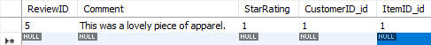

Thus, it was time to conduct test 4.1.4.



After submitting the review, the response was the following.

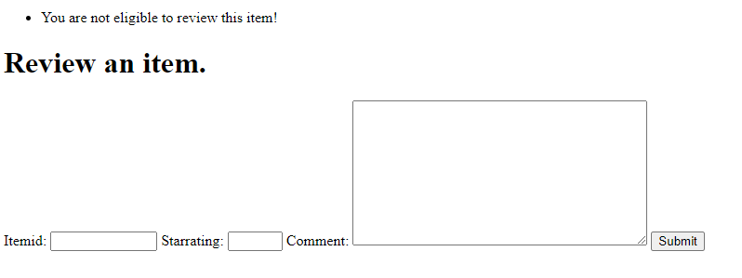

This marked test 4.1.4 as a success.

Afterwards, I conducted test 4.1.5.

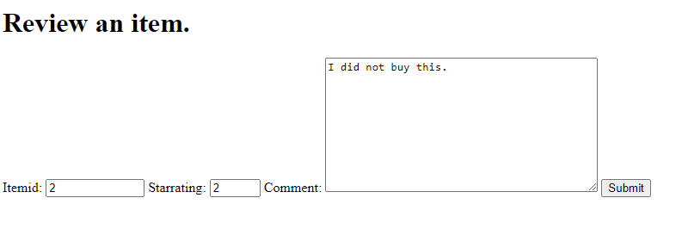

The result was as follows:



This proved that 4.1.5 passed, which allowed me to move onto 4.1.6.

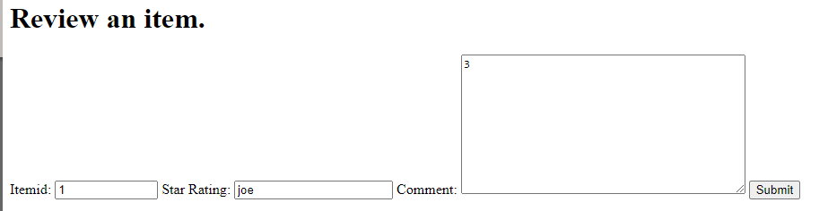

Submitting this form resulted in the following output, confirming this test as a pass.

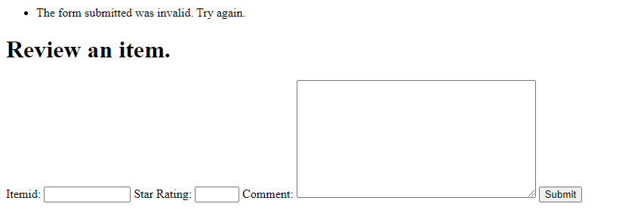

Last, I had to conduct test 4.1.7.

Submitting an empty form returned the following:



This was evidence of a passed test, which allowed me to move forward. This now marked the reviewing system as working.

With that, the next step was that of setting up emails.

I started by adding these lines of code to the settings.py file.

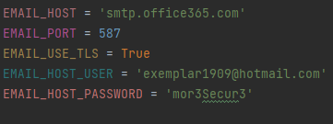

What those do is essentially configure where to send emails from. At the moment, due to not having a deployed server, I cannot use a custom email address. Instead, I used a burner hotmail account. With that, the email sending behaviour should be configured.

I then had to implement a temporary use of the code to attempt a sending operation to see if it worked. For that, I made an “email” view which I would delete after testing.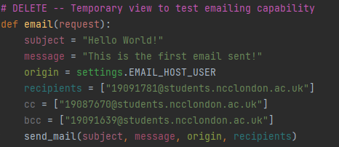

I then added that to URLs.

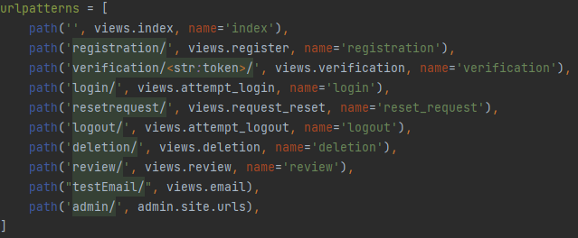

With that, I began the tests.

|  |  |  |  |  |  |
| --- | --- | --- | --- | --- | --- |
| Test ID | Testing |  | Input | Expected | Actual |
| 5.1.1 | Attempt to send Email to no-reply address. | N/A | **N/A** | No impact on server. | No impact. |
| 5.2.1 | Use the built-in emailing function. | V | **recipient** = “19091781@students.ncclon-  don.ac.uk”  **subject** = “Hello World”  **content** = “This is a test.”  **cc** = “19087670@students.ncclon-  don.ac.uk”  **bcc** = “19091639@students.ncclon-  don.ac.uk” | Success. The email should send successfully. | Success. |
| 5.2.2 | Null check for nullable values. | V | **cc** = NULL  **bcc** = NULL | Success. | Success. |
| 5.2.3 | Attempting to send not an invalid email. | I | **recipient** = “asdasd” | Error thrown. | Error |
| 5.2.4 | Erroneous data type. | E | **recipient** = 1  **subject** = 2  **content** = 3  **cc** = 4  **bcc** = 5 | Error thrown. | Error |
| 5.2.5 | Null check. | E | **recipient** = NULL  **subject** = NULL  **content** = NULL  **cc** = NULL  **bcc** =NULL | Error thrown. | Error |

The first thing I did was 5.2.1, as 5.1.1 was currently not applicable.

I ran the test by going to the designated link, and as I did, the redirection was successful, which was a sign that it worked. With that, I checked my emails only to reaffirm that.

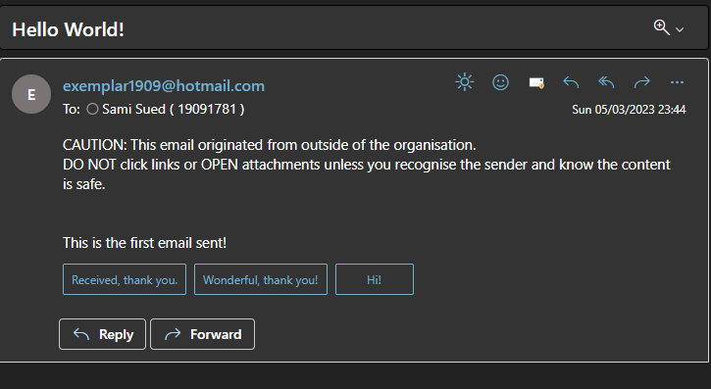

The emailing system was now working, and 5.2.1 passed.

For test 5.2.2, I did the same thing without cc and bcc and it still worked.

For test 5.2.3, I attempted to use an invalid email address.

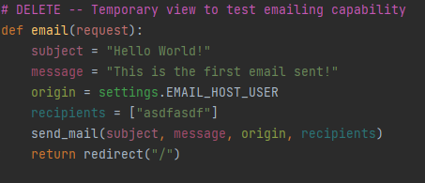

Going to the emailTest page gave the following output. It was an error as expected.

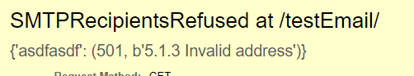

With 5.2.3 passing, I assumed that the other methods would reasonably work due to them being tried and tested APIs. With that, I added the emailing functions to the different locations in the code. Thus, I could conclude the first prototype.

### Prototype 1 Review

In this prototype, I have successfully implemented the bulk of the backend work which will be crucial during the later stages of development. This is obviously missing the features that are crucial to the frontend, like browsing items and the final structure, but it lays the groundwork for what will become the final solution. At this stage, the interface is also very unfriendly for new users, due to it being a placeholder design.

I asked the stakeholders for some feedback, and it went as follows:

Client 1 and 2: “The prototype looks like it’s doing its job, but it still looks quite barebones.”

User 1: “The website currently looks like it doesn’t do much, I think there’s still a lot of work to be done.”

User 2: “This looks pretty responsive to me so far. Can’t wait to see the next prototype.”

## Prototype 2

### Stage 5: The Featuring Algorithm

Now that the first prototype was developed, it was time to start the second prototype. This prototype would mainly be focused on AI and the featuring algorithm. I began with the featuring algorithm as a start. The algorithm was all implemented in one big go because of its nature, so I’ll explain its segments of code gradually.

One of the first things that I did was add a model that can hold the details of a given featured week. This includes the date used and the items that were featured. The primary key of the model is the date when it was generated, as featured items are only generated once per a certain date on any given year. This means that the dateUsed can act as a unique record identifier, as no two dates will ever overlap. It also has two functions to make interfacing with the model easier, which are to return or write to the 8 item fields. This allows for an easy access of the 8 fields. The order of the list given always matters, which means that the given way of accessing the itemsGiven list in the writeItems function is always correct.

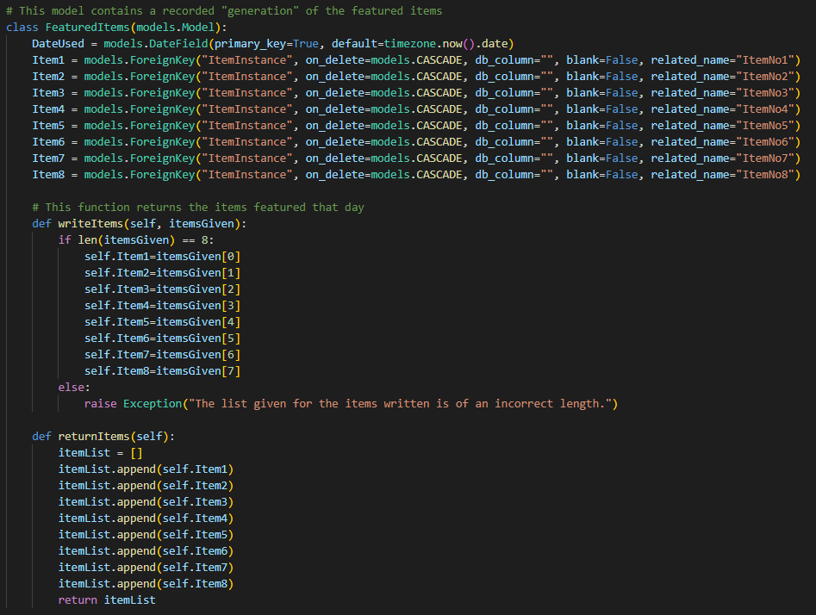 The featuring algorithm is all packaged into a single function that handles all its needs. It begins with simple validation that ensures that the algorithm can and should run. Then, it gets the last weeks instance of featured items, as a featuredRecord, which it used to get a list of all the items featured the previous week. For each item in the list, a QBF is calculated by getting all items whose date of sale was during the period featured, and then the QBU is the next thing to be calculated. To acquire that, the time when it wasn’t featured needs to be found. To achieve that, I loop through each generation of the featured items.

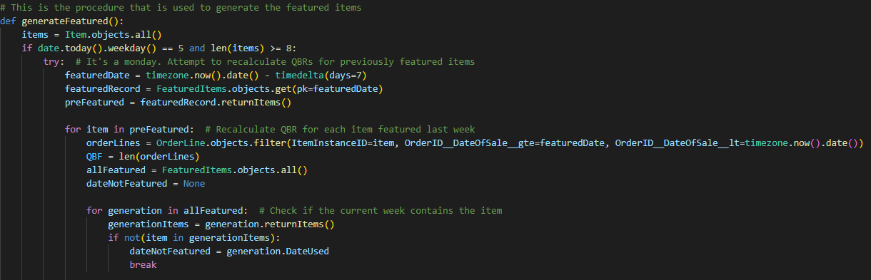

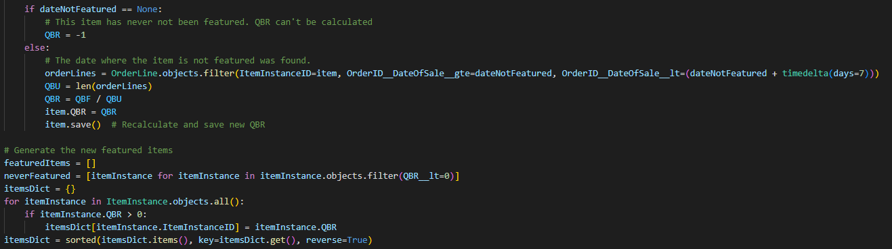If the generation where the given item isn’t featured is found, then the dateNotFeatured is set to the date of that generation. Following that, if a dateNotFeatured is not found, then the item has been featured ever since its release onto the website, which makes it a difficult situation to get through, which leads me to instead put it in the -1 QBR, which allows for a certain outcome that won’t influence the potential of good items. However, if a dateNotFeatured is found, then a QBU can be calculated, which then allows for the calculation of a QBR. This repeats for each item that was featured in the previous week before the generation of the new featured items begins. The items are split into two groups. The items with a positive QBR which have been featured before go in itemsDict. The ones that have never been featured before which have a negative QBR are put into the neverFeatured list. The itemsDict is sorted based on the value of the QBR, from highest to lowest.

With the itemsDict, the new featured items can be generated. The first row of items is picked by simply taking the top 4 QBR items with iteration. After the itemInstance is picked, all other instances that share an item of origin are removed from the list, to remove redundancy. With that, the next row is made in a similar fashion. The first thing done for each iteration is checking if the neverFeatured list is empty. If it is the runners up of the current order is picked, or an item is randomly picked. In the case that the list is not empty, that item is added for that row instead. This is done until 8 instances are appended to the featuredItems list. With that, a new instance of FeaturedItems is created, the featuredItems list is passed onto newFeatured’s writeItems function. The new model is then saved.

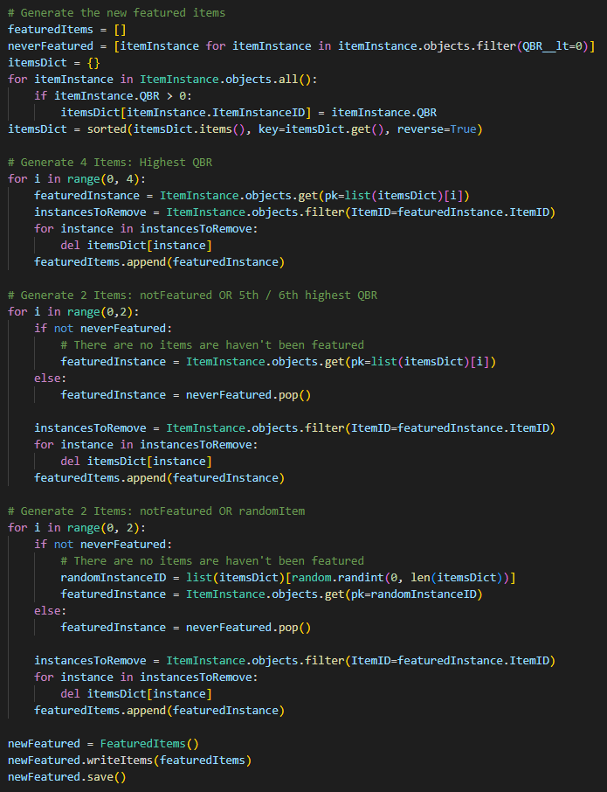

Last thing to mention is the fact that the above code is all wrapped in a try statement. If any error occurs, then the except block will run. If the current featuredDate is not on a Monday, it is most likely an unexpected error. If it is indeed a Monday, there hasn’t been a previous week, which means that it is likely the first time that the algorithm is being run. A collection of random items is returned in that case. In the case of a successful generation, a statement will be printed for information logging. The last piece of validation is to check if the initial if statement has less than 8 items or in the other case, that it wasn’t a Monday.

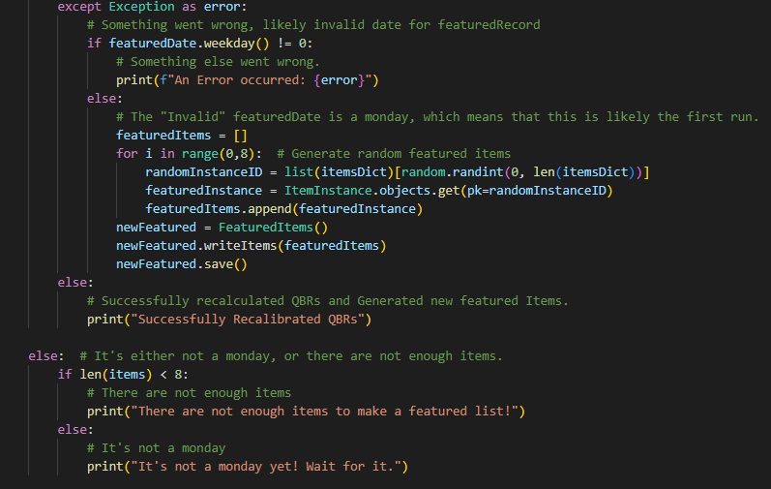

That is all the code that was created for the featuring system. With that, I now had to move onto the recommendation system.

### Stage 6: The Recommendation System

Due to my stakeholders being unable to provide me with a dataset to train the AI with, I thought that the best course of action was to make the algorithm as a proof of concept and implement it only after the official release which is not within the scope of this project. After some searching, I decided to use Amazon’s reviews dataset to train the AI, to best reflect the e-commerce recommendation style.

After downloading both datasets I needed, it was time to begin. The first one is the metadata of all the clothing, jewellery and shoes that was recorded in 2018’s Amazon dataset of reviews. Then, the other one was the reviews that were placed on those items. Those two formed the basis of my dataset. However, my client does not currently sell jewellery and shoes. He doesn’t sell female clothing or babies clothing either. After some failed attempts, I was able to filter those out of the dataset. With that, it was time to actually begin the development.  
  
First things first, pre-processing had to be done on the dataset to ensure the maximum accuracy of the AI, by providing well-rounded data. I started by checking what the distribution of reviews was, as I didn’t want to overfit or underfit the model to a dataset. Overfitting is when an AI learns the given training dataset so well that it can’t provide accurate predictions outside of that. Underfitting is the equal opposite, where a lack of data is provided, which results in the AI not being able to provide accurate reviews.  
  
I needed to use a Jupyter notebook for this, as Jupyter notebooks are the most convenient environment to use when performing machine learning tasks.

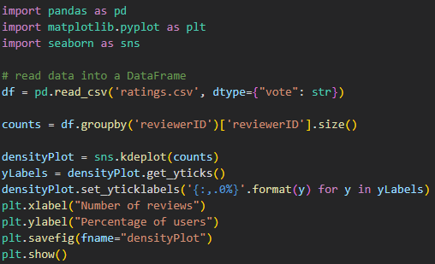

What this code does is present the distribution of reviews placed by a certain reviewer as a plot. The on the assignment of df, I explicitly stated the data type for the vote column to avoid automatic type guessing on it, which reduces memory usage. I then grouped the dataframe by reviewerID’s size. This results in a “reviewerID” to “number of reviews”, pair being generated each row. This was easy to then feed into seaborn’s kdeplot function which visualised the data as a density plot. The next last lines were there solely to make the graph show a percentage, for easier readability. Then it gets saved as densityPlot.png.

Executing it provided a surprising distribution. The graph showed that there were occasions of reviews exceeding the 200s, which meant that some users were placing an insurmountable number of reviews compared to the rest. This would heavily skew the dataset, even with the 2.4 million reviews in the current data.

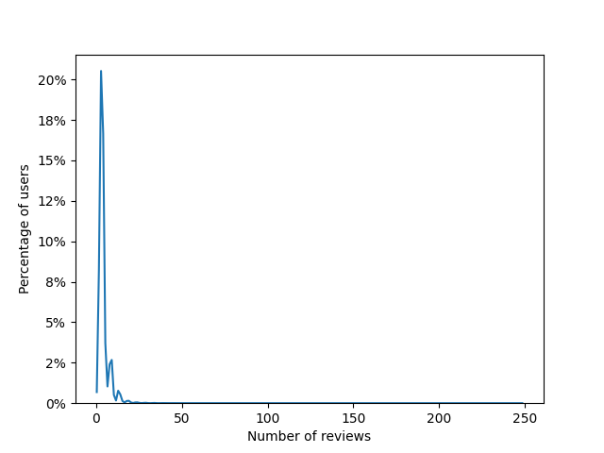

I wanted to see what the effect of this would be. I removed all users who placed less than 5 or more than 10 reviews. This would hopefully be rather balanced, so I checked what number of reviews I had left by summing up the two separately. This filter resulted in about a 60% loss in reviews. However, the total number of reviews was still above 900,000, which meant that the loss of 60% was permissible to remove to increase accuracy.

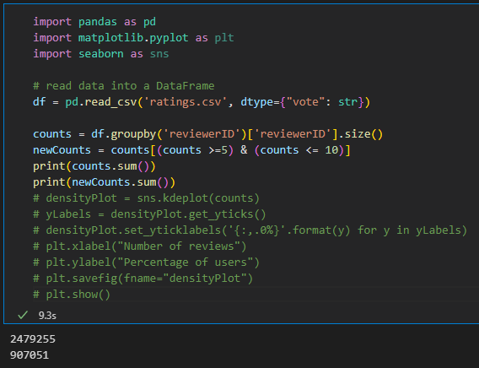

I plotted the graph again, to see the new distribution of reviews.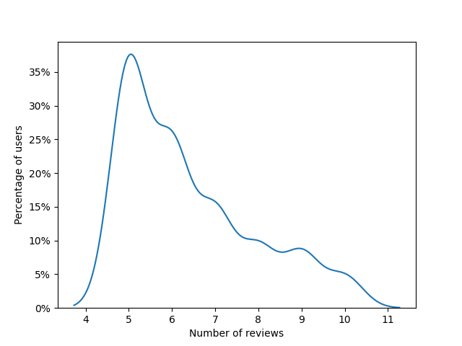

This is much better. 35% of reviewers place 5 revies, while the rest of the distribution is above. This is much more balanced. The next step is to remove all the items which are not referenced anymore in the metadata, and to evaluate that scenario. I now had to remove all the entries from metadata that had no references in the new ratings. This was done by first using count’s index of reviewerIDs as a mask that filters the ratings. All ratings from reviewers that aren’t in the desired range are omitted. Then, given that new dataframe, I converted the series of asins in the ratings to a set. All duplicates are removed, which makes it much easier to use as a mask. The .isin() function returns a series of all the indices whose asins are contained in the provided data structure. In the case of metadata, the series used_asins contains the asins. Any index of metadata whose record has an asin contained in used_asins will be stored in mask. The rest won’t be added. Then, applying the mask only keeps the entries which are referenced.

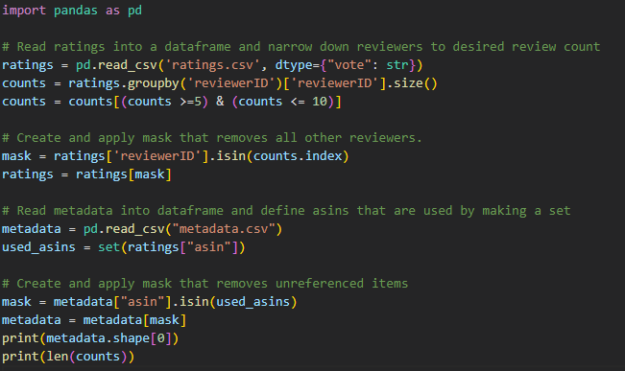

The output of this program is the amount of items referenced in the dataset, and the number of reviewers. In the end, 68354 items are referenced over 907051 reviews placed by 141755 reviewers. Approximating naively, every item is reviewed 13 times. This should be sufficient to train the AI.

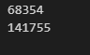

With that, I no longer needed the data to be human readable, so I used pickle to dump the datasets in a serialised format. This would result in a much smaller file size, significantly faster reading speed and an easier conversion of file to dataframe.

With that, it’s time to do the last pre-processing. Creating the Item-User review matrix. To elaborate, I should give a high-level explanation of SVD. What SVD aims to do is decompose a large matrix into 3 much simpler ones. The original matrix should have a format such that every entry of the matrix is seen as a result of two input variables. In the case of the diagram below, a use and a movie. Given a user and a movie as input, the review is the entry result. In the case of my model, it will be user and item. The matrix which has users as one axis, items for the other and review scores as the entry is called a utility matrix.

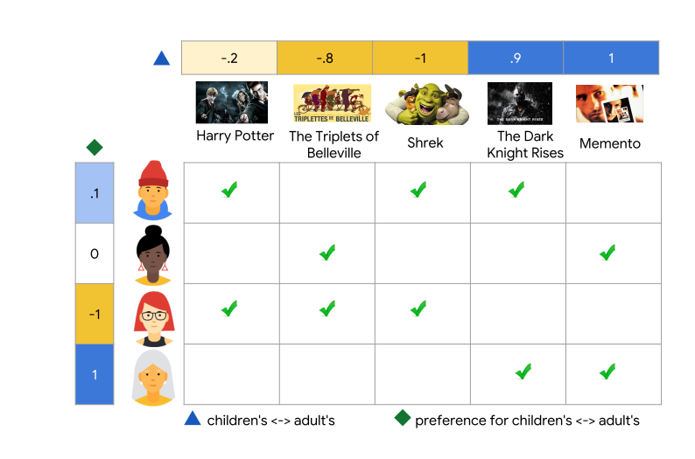

Given this matrix, the SVD algorithm decomposes it to three matrices that can show an accurate representation of what the utility matrix represents. Two matrices represent “features” of the users and items called latent factors, and the third being a heavily compressed “key” to convert the two previous matrices back to the utility matrix. Then, the SVD algorithm can use the “features”, the latent factors to predict a review score by getting the dot product of the two feature vectors, as they are factors of the utility matrix.

To get started, I put the serialised files into dataframes and removed the unnecessary data from the ratings dataframe. For now, the metadata dataframe will be useless, since the asins in the ratings can be used for the utility matrix.

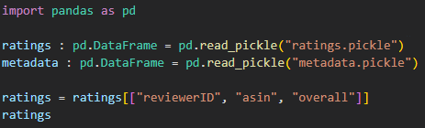

As the output shows, the new dataframe only contains the data needed for the utility matrix

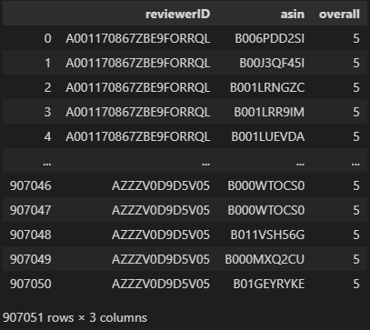

Knowing that the data formatted correctly, I wrote some simple pandas code that would pivot the table such that the index is the reviewer’s ID, and that the columns are the asins. The values would be set to the “overall” column’s value per unique combination of reviewer ID to asin. The “overall” column’s value is the star rating out of 5, but this is how the provided dataset called it, so for the sake of convenience, I left it as is.

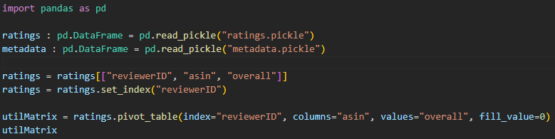

Running the above code resulted in an error. According to the program, I was out of bounds for the axis 0, which is that of rows, and by a large amount, too. The index digit was above 1 billion 53 million. My dataset doesn’t have an index that large.



After doing some research I learned that pandas had an ongoing bug where pivoting such large tables would be essentially impossible due to the sheer amount of entries. In my case, the dataset would yield 9 billion entries, of which only about 900000 would contain data. I had to find a workaround to continue and decided that the best course of action was to use NumPy.

Rewriting my code resulted in the following algorithm. Transferring this data to a NumPy array would be difficult, as I couldn’t use strings as indexers and had to stick to a single data type per array to benefit from the efficient framework of its arrays. I start off by creating two series containing the unique values for asins and reviewerIDs. With those, I can make a dictionary map that corresponds a positive integer index to the string given. Once I have the two dictionary maps, I can define the NumPy array that will hold the utility matrix as a zeroed array with a shape that can hold a Y amount of reviewerIDs and X amount of asins. Defining the items was as simple as iterating over the rows that contain the ratings and assigning the review scores to their mapped location for the dictionaries. The resulting variable should hold the utility matrix of the data.

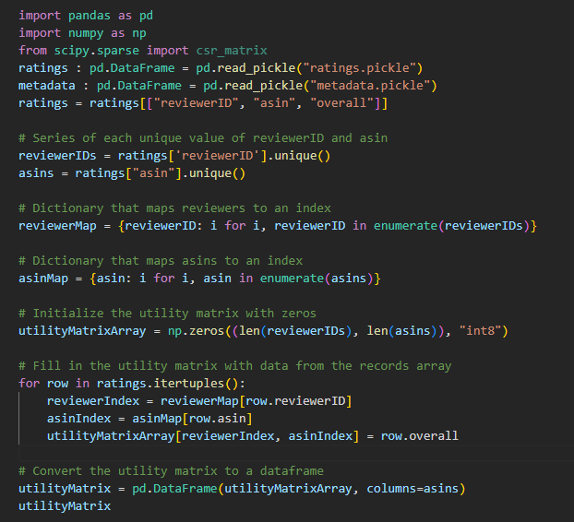

Running this code outputs the following table. I have successfully overcome the setback of memory usage and internal framework bugs. With that, I decided to attempt a conversion back to the original dataframe.

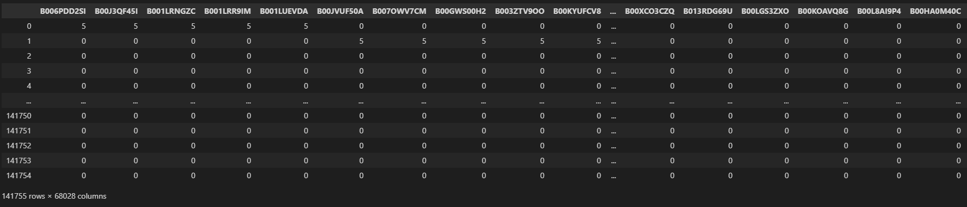

After several failed attempts to convert the table back to its original format with no data loss I realised that it wasn’t the conversion backwards that resulted in a data loss, but the conversion to a utility matrix. I then noticed the slight mismatch in asins that I have. In the earlier statement on asins, I had 68354 asins. However, when checking the length of asins in the conversion to utility, I saw a value of 68028. That meant a loss of about 326. I had to investigate what was causing this loss, as I had already removed all unnecessary asins, and the dataset should not have a single duplicate asin. If this data loss converted continuously, it could result in an inaccurate dataset.

After some checking, I realised that the data loss occurred on the line where I used .unique(). I had to further investigate this, as unique() should not cause unnecessary data loss. Seeing as unique removes all duplicates, I tried to print the duplicates in metadata.csv, which contained a reference to all the asins inside the dataset.

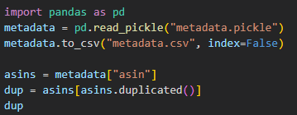

Lo and behold, the missing asin values. Exactly the amount which was missing. So what caused them to be considered as duplicates? Are they duplicates or is there a logic error? I decided to export the pickle to a csv to check for any duplicate values.

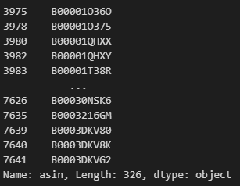

In excel, I highlighted all the duplicated values to check if there was some type of mishap. Turns out, there were indeed duplicate entries inside the metadata, as shown by the repeating values.

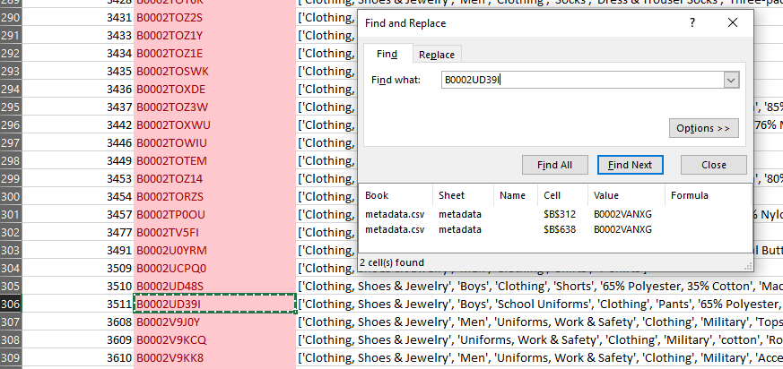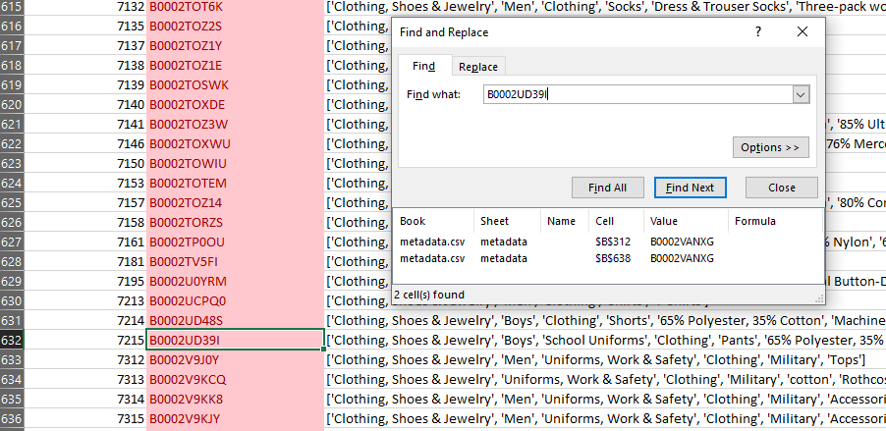

This made me sceptic about the uniqueness of the dataset that contains the reviews.

I had to check in pandas, as excel was proving itself as too heavy for this task.

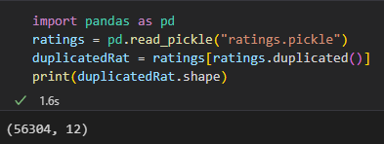

There were indeed duplicate entries in the ratings as well. Taking them out was simple though. Now, the updated number of reviews is 845813, with 68028 items. This cashes out at a naïve approximate 12 reviews per item. Still valid enough to go ahead.

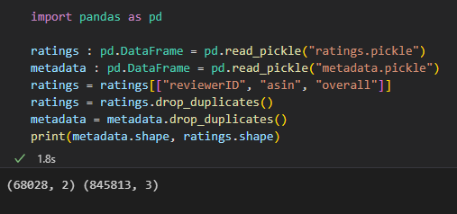

With that, I exported the new dataframes to pickles, and attempted to compare the two tables again.

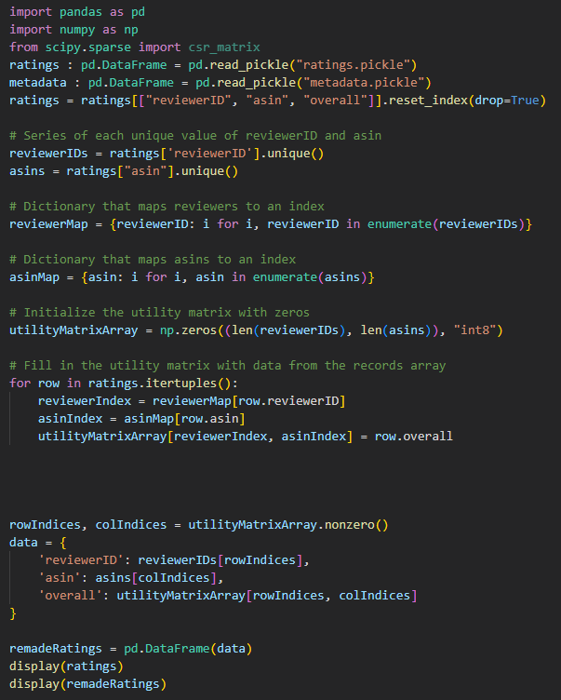

The output still lost a small amount of data. Printing numpy.count nonzero() shows that the non-zero elements are correctly counted, so I decided to move on, and saved the utility matrix array as an npz file.

With the last part of this prototype being the development of a recommendation system, I coded a first algorithm, which wouldn’t end compilation even after hours, presumably due to the size of my dataset. After attempting a lot of different parameters for SVD, it seemed that a dataset as large as mine could not possibly be sorted through by a consumer computer, which led me to need a different method.

I instead went for a nearest neighbours’ algorithm, as it was significantly lighter in terms of complexity, which would make it easier to compute.

The code below is what I wrote for the recommendation system. It starts off by acquiring the datasets and making an asinMap index. With that, a collection of all hoodies is made, in order to create a test set, in this case hoodie 5-8. With those, a model can be trained. In this case, 20 predictions are made based on a given item. E.g. , finding what is similar to this asin based on how “distant” other objects are in terms of similarity. Once a model is trained, the indices of the neighbours are stored, and converted from a 4x20 array to 4 separate lists put in a dictionary that contains the asin as a key with the list as a value. With that, the way to measure the accuracy of the system is to calculate the number of hoodies that appear in the predictions. This whole test aims to assess whether the system can tell whether it is given hoodies without external pointers. A success would be 80% or more hoodie predictions.

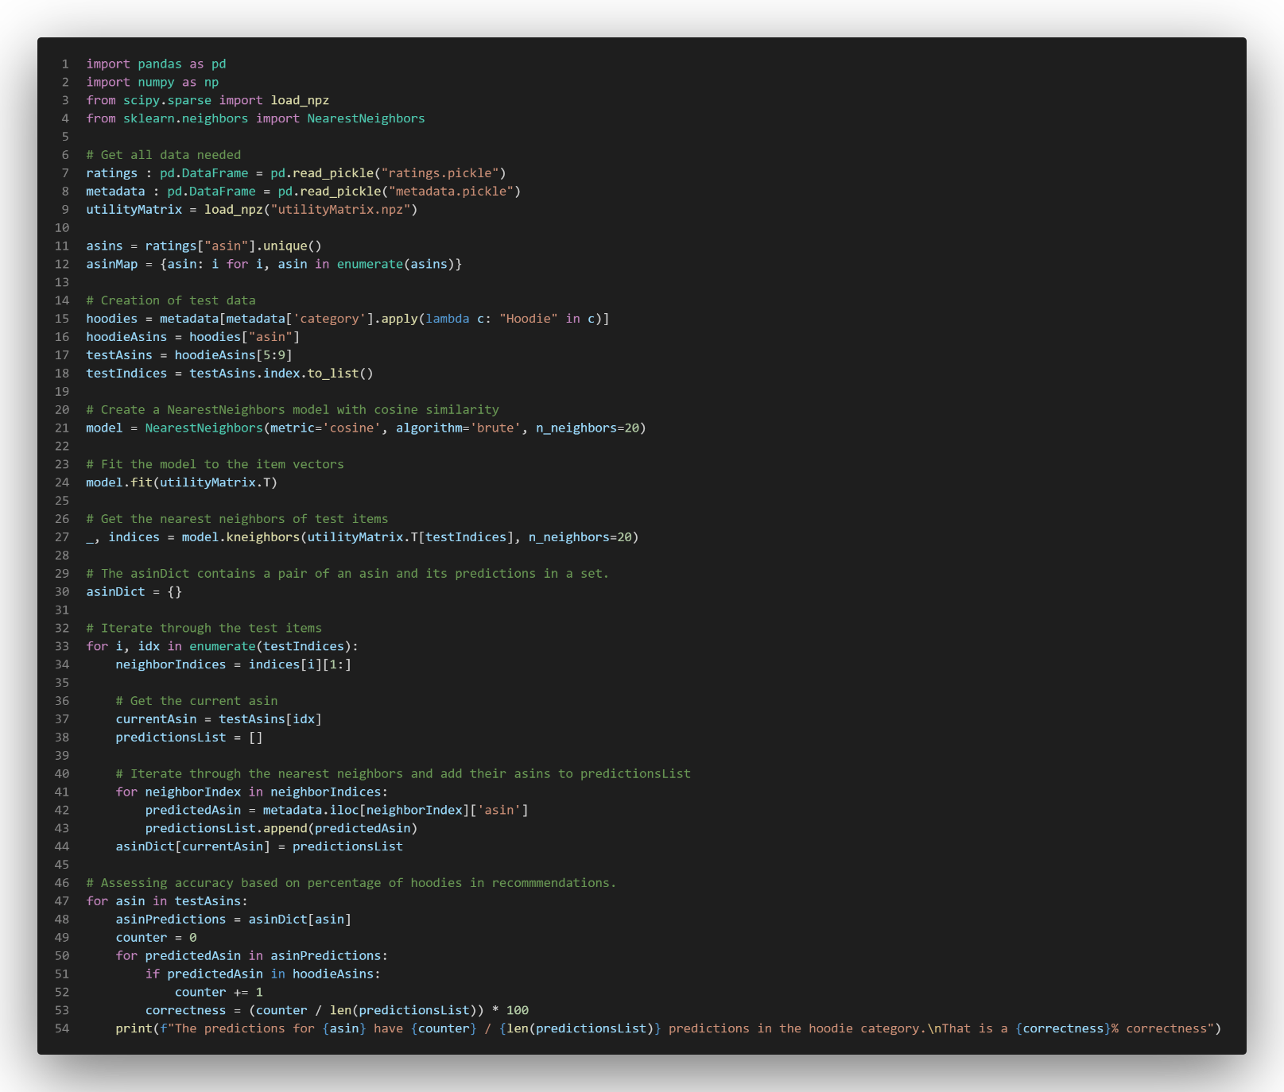

Taking that into account, I ran the program, and got the following results.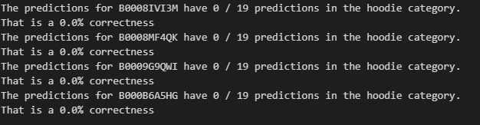

This led me to necessarily put my AI development to an incomplete conclusion due to significant time constraints not allowing me to work through what was causing the error. Thus, I had to terminate the implementation of the prototype here in order to finish the other success criteria in a timely manner.

### Prototype 2 Review

With the process of this prototype, a functioning featuring algorithm was implemented, as well as a proof of concept that nearly worked for the recommendations AI. The recommendations given showed a failure of the recommendation system, as it did not recommend a single hoodie, with 80 predictions when provided 4 hoodies as references. Even with that failure, the featuring algorithm was working, which allowed me to move onto the implementation of the last prototype. Due to the changes being solely internal, I wasn’t able to ask for any feedback from my stakeholders.

## Prototype 3

### Stage 7: Implementing Bootstrap 5

With all of this AI implementation done, I now had to do a revamp of the UI in order to utilise bootstrap. It was also at this point that my PyCharm license expired, which led me to return to using VS code.

After some refactoring and rewriting, I eventually got bootstrap to fully integrate into the templating system, and the resulting appearance is as follows:

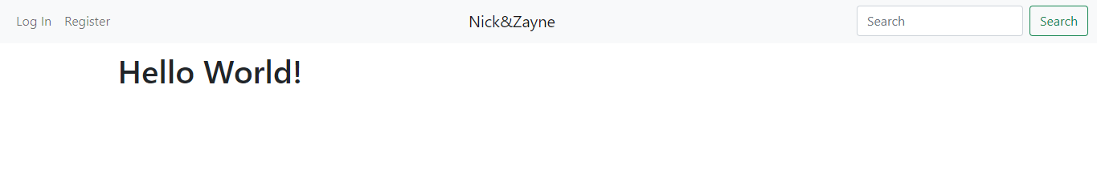This is how the index currently looks:

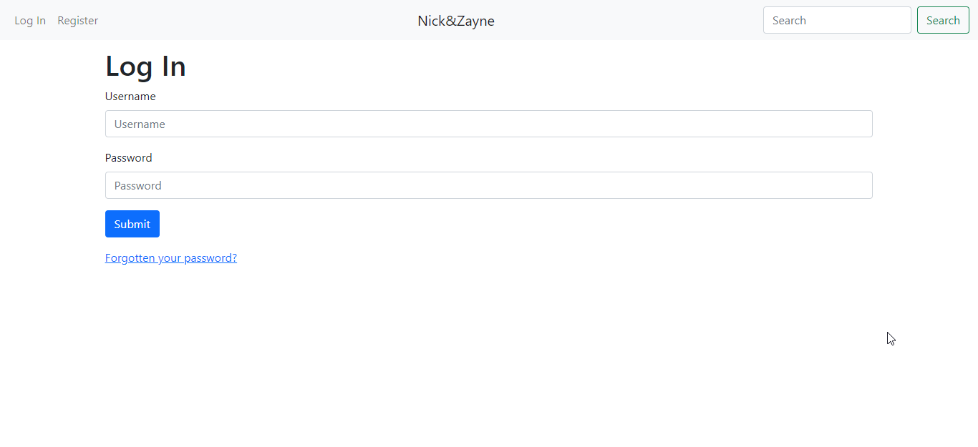And this is how the current log in looks:

Lastly, subject to a successful log in, the new index looks as such. The navbar contents change to accommodate the circumstance.

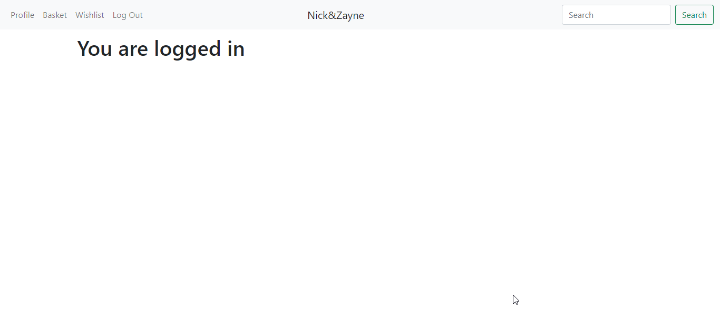

At this point, I had to set a discrete definition of what categories would be valid in the current solution. I decided upon the set of “coats, jackets, shirts, t-shirts, shorts, trousers, hoodies, sweaters, hats, socks”. This was a good enough representation for the prototype. In the navbar, I added a dropdown for categories. Although the original idea was to use a “hamburger” type side menu opener, bootstrap 5 seems to not have compatibility for such a menu, which led me to use a dropdown instead. Making that set into a dropdown for categories was done with the following code.

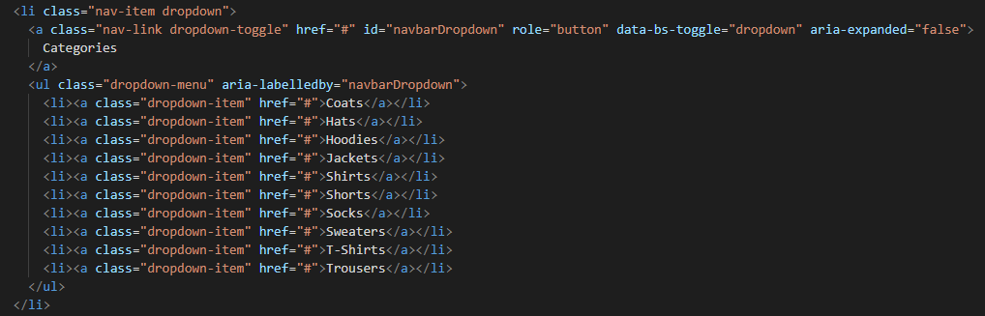

The resulting dropdown worked perfectly.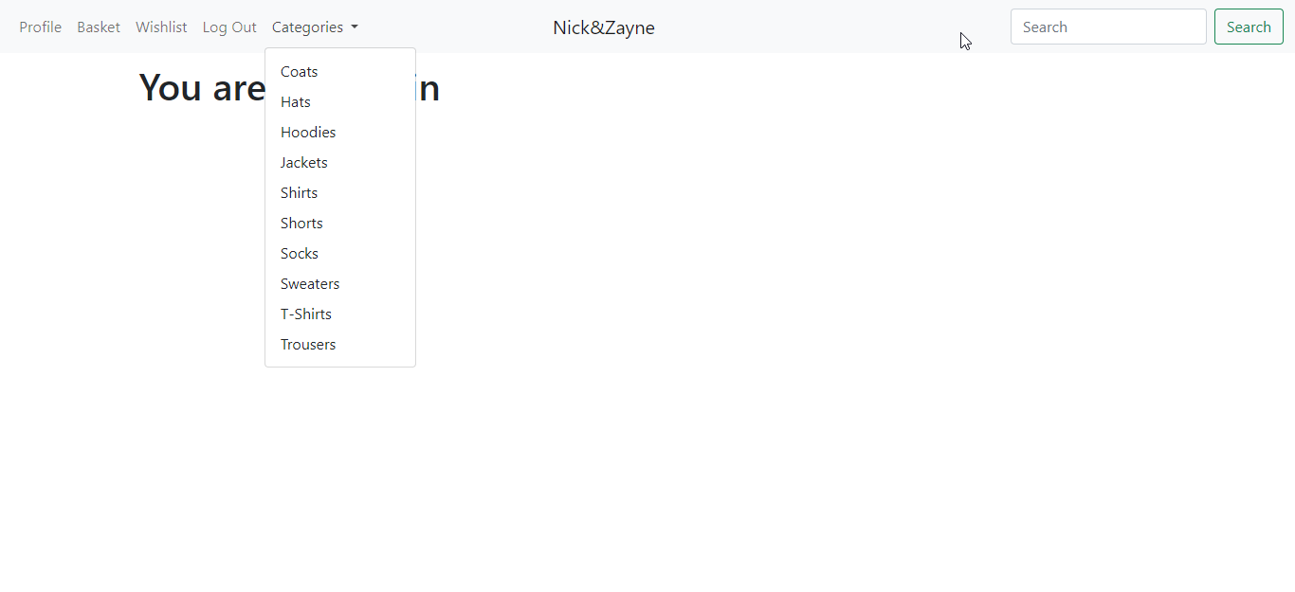

With that, the next step was to make item queries available to the front end.

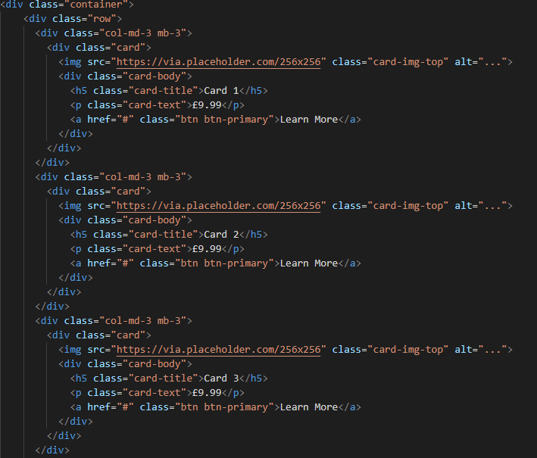

This extract of the code for cards is what I used to display items, and they showed as follows:

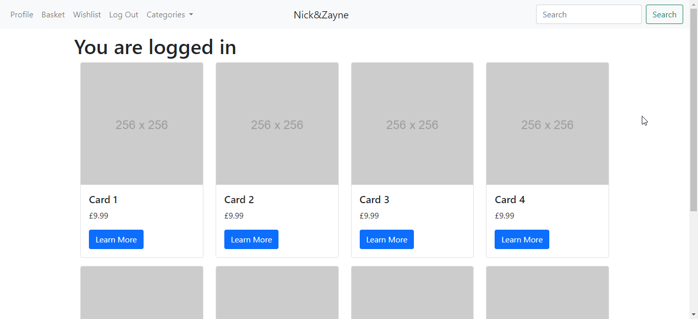

This was the way that I wanted the items to be displayed, which marked this as a success. The next step was to get this process automated such that search queries and category queries work correctly. The first step to achieve that was to assume a given QuerySet and make it able to show correctly on the frontend. For that, I split all the results into itemsShown, which mixes information from an Item and the first style of that item that appears. With that, all the items can now be easily displayed as cards. However, the template has no easy way of knowing at which point a row has reached 4 items. To address that, I made the displaying much easier by splitting the itemsShown list into rows, which each contain 4 or less item entries. Given a query, a correctly formatted list of rows is returned.

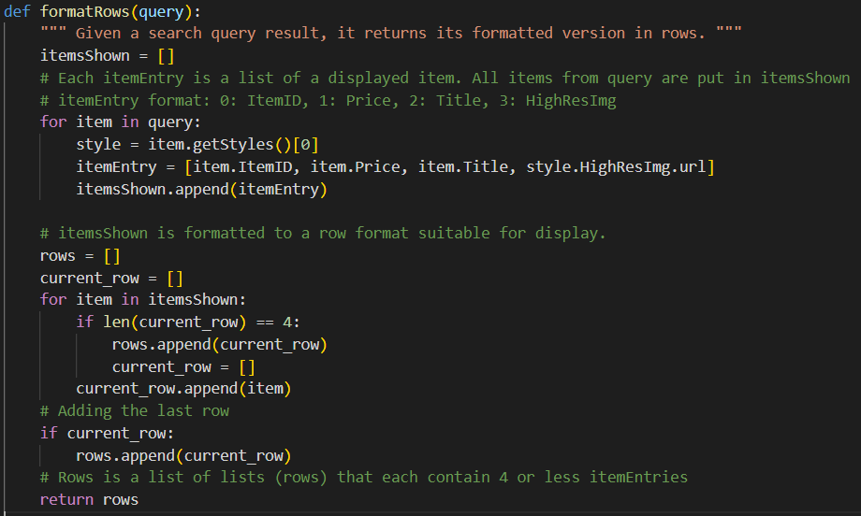

With that done, the next step was to test that.

After adding many sample items, I made the index display all the items that exist.

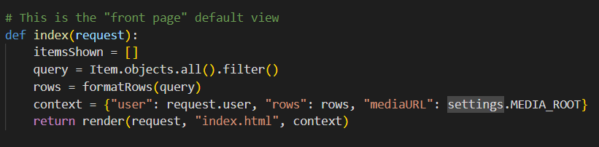

The template loops through the rows and adds as needed, and the resulting html looks like this.

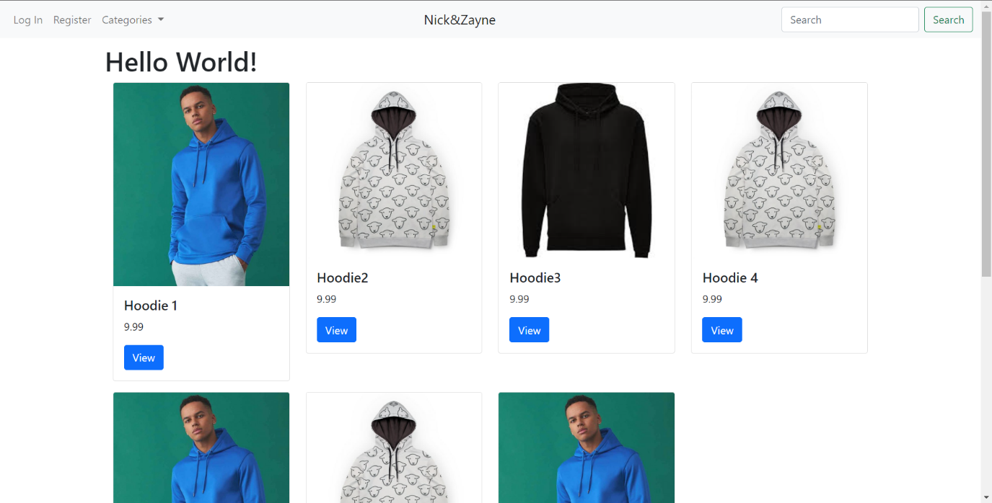

With that done, I now had to implement viewing with categories. I did that by making changes with the html and also through the views. I added a category view and set. Given a category, the category view essentially acts like an easy search function.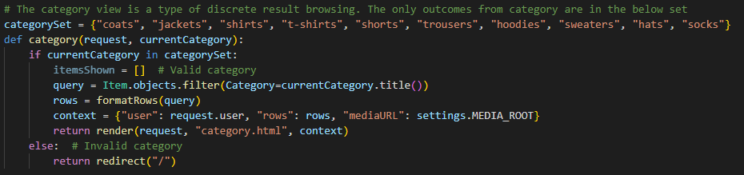

Given that, I added category to the URLs.

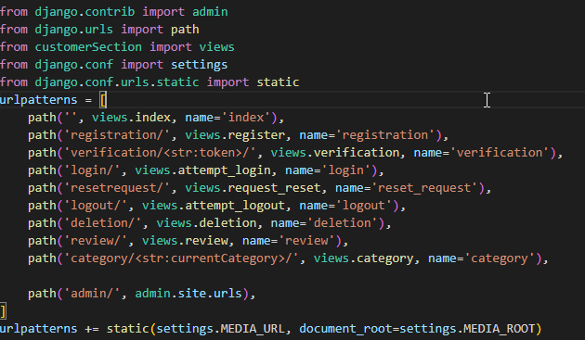

With that, I attempted to use the categories and it worked. The images are obviously placeholders in this case.

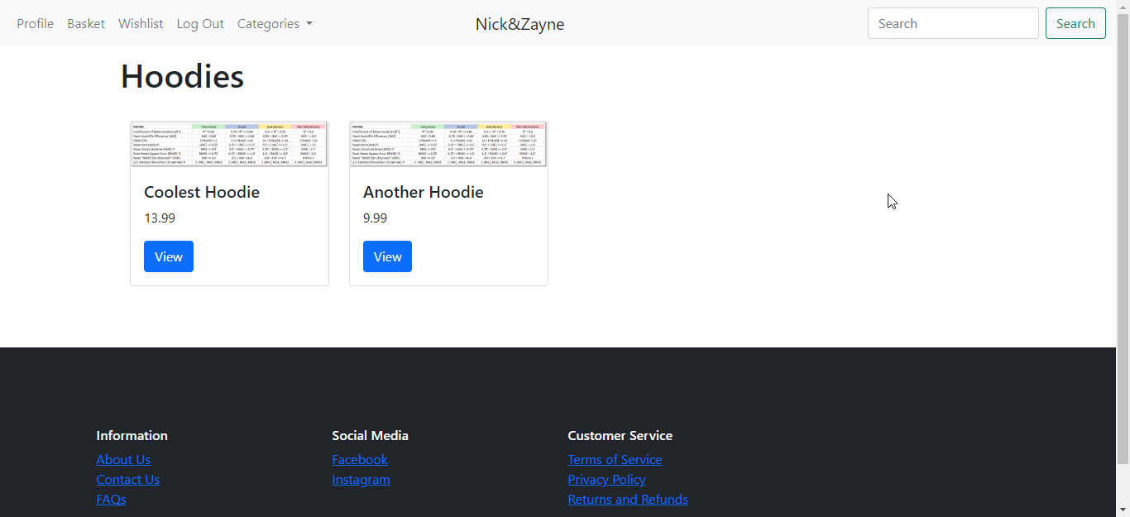

The next step was to get searching working.

First, I added a new segment to the function for formatting rows. Although it was initially perfect, I had to also implement sorting into the code, and the best place I could think of doing so was in the place where every item being displayed is all held within one easy to access list.

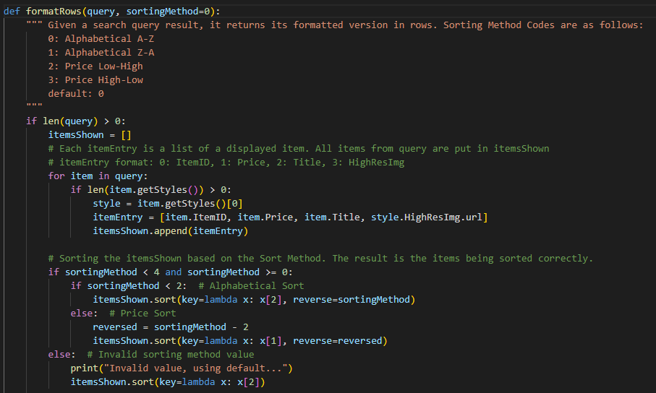

The modifications that were carried out are essentially the new middle section of the function. There is now a new parameter called sortingMethod, which is a type of code similar to the logging enum. However, the possible cases are much more reduced, so I decided against any declarations or use of switch cases for the sake of ensuring strict control. The sorting is done by selecting the correct case based on gradual selection. If the code is incorrect, it is assumed to the default. If it is an alphabetical sort, then the items will be sorted using the 3rd item of the lists (the title), with the sortingMethod code being able to be used as a conditional (0 or 1, True or False) to decide on the order. Then, if under condition of price, the 2nd item is used. In that case, the same order trick can be done with sortingMethod by subtracting 2.

With a functioning sort, the searching could now be implemented.

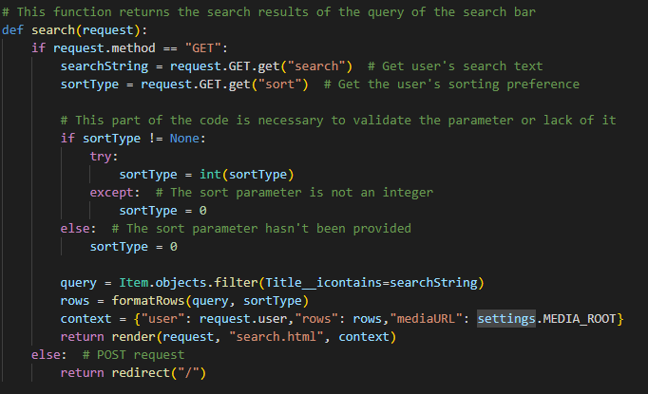

How the searching works is by taking search and sort parameters from the URL of the request. These can be taken from said request, and easily converted to their workable form. Then, an important validation must be carried out to weed out any unexpected values on the sort parameter, which would cause crashing. If the parameter is empty, or cannot be easily cast to an integer for whatever reason, it is extremely unlikely that it will be an integer. Thus, a value of 0 is assumed. With that, the searching can be carried out using the filter __icontains. This filter is case insensitive and captures any occurrence of the search string inside the titles. “hood” should return all hoodies and so forth.

A normal URL for this would look something like this:



With that, I added it to the URLs, and then ran it.

When I ran it, everything seemed to be fine. Thus, I typed in the example string and searched it.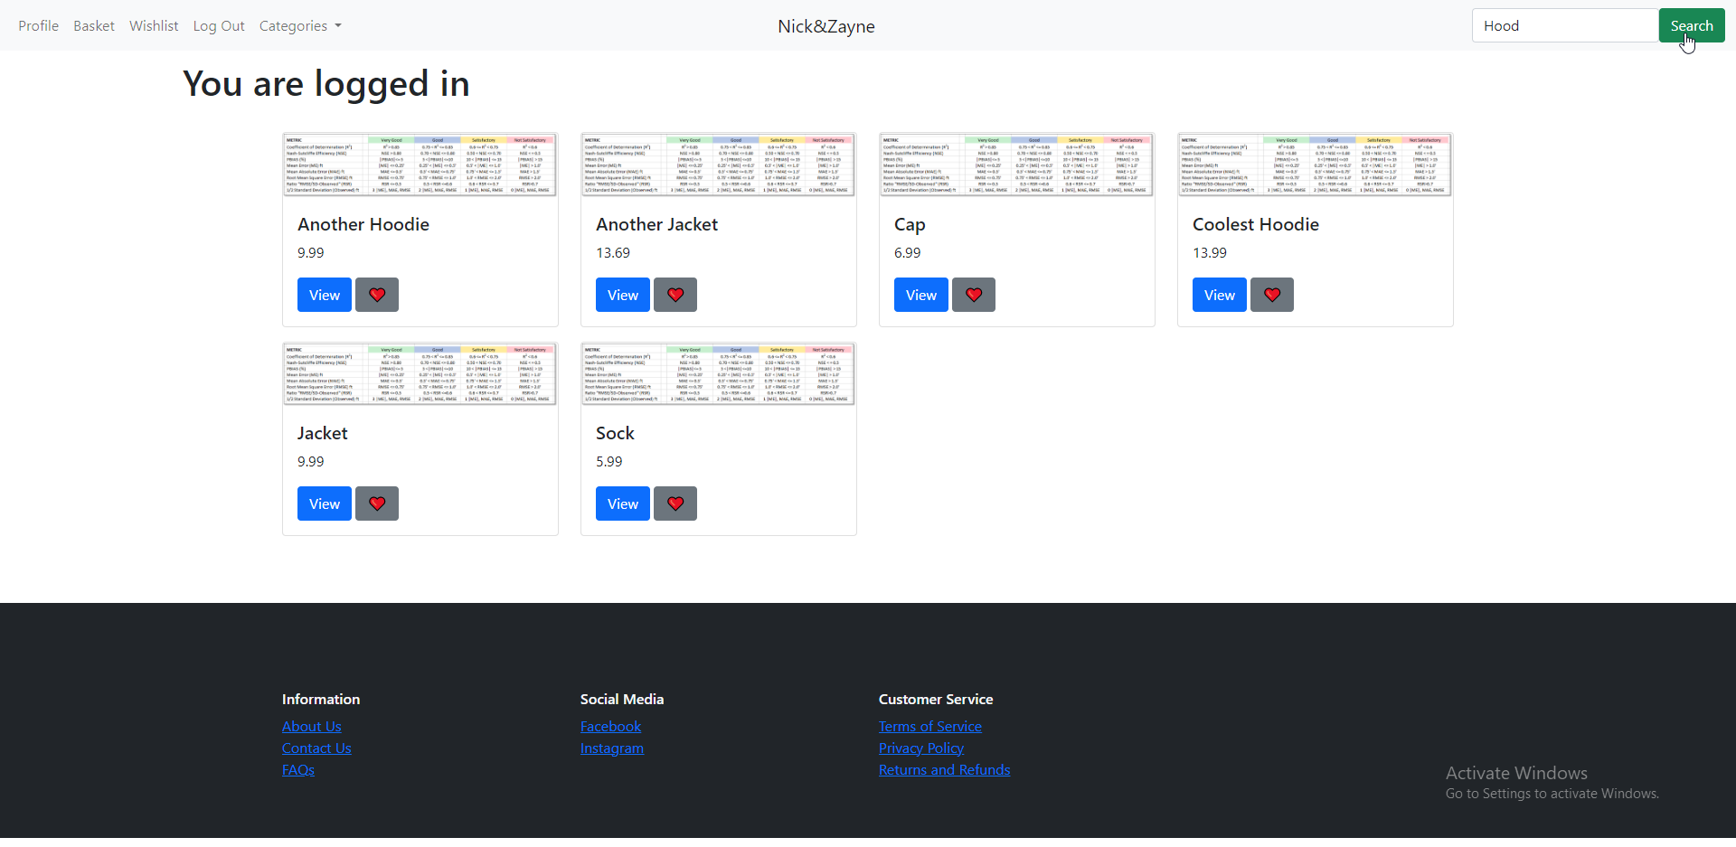

The example result was as expected. Only Hoodies showed up, and everything had formatted correctly. Thus, I tried to use one of the sorting options.

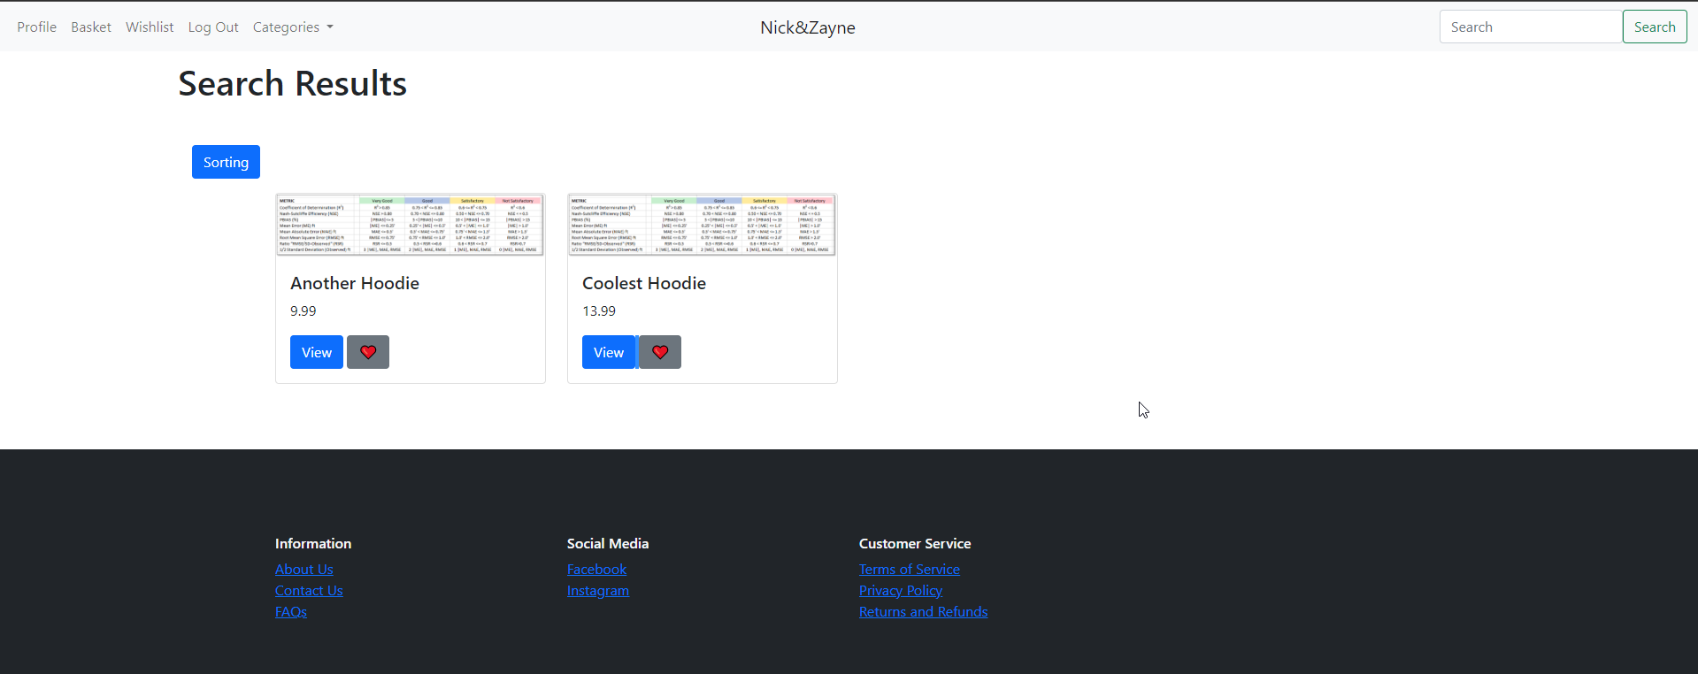

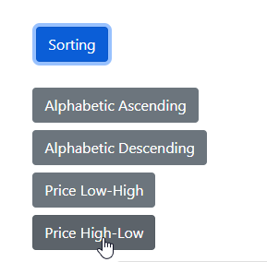

The result was successful.

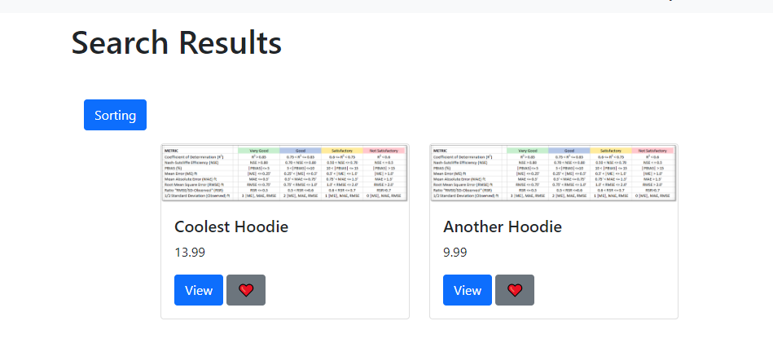

With that, searching and sorting was now functional.

The next thing to make was detailed viewing of items. This wouldn’t be too complex, as the only thing to really do is show a collection of information already known. I first began by making the function used to sanitize query parameters from links its own entity, to avoid repetitive code. This is because I ended up using it for the display of the detailed item as well.

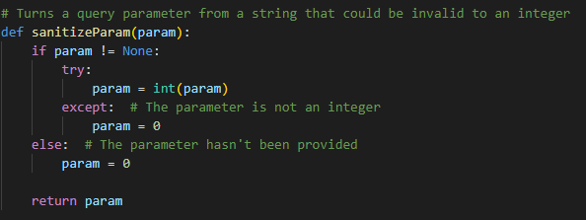

I then began the implementation of the view. A lot of work went behind the template that I used to display the content, but the actual view was quite simple. It would define an item, along with its styles, reviews and average rating. Then the style currently being shown has the image used for its display linked to a URL, to make access easy. The last step before handing the context to the renderer is to let the detailed item render know whether the current user is eligible to review the given item. If so, then the validity variable is set to True, and vice versa.

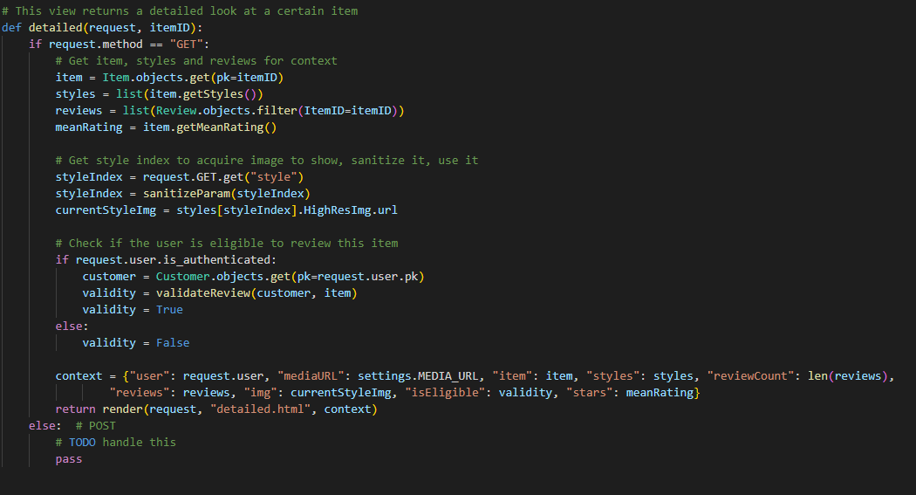

After implementing this, I added detailed to the URLs list, and ran the code. There are a lot of things going on at once. Once view is pressed for a certain item, the item’s icon is shown to the right, along with the number of reviews, the mean rating expresses as stars, the title and price of the item, and a button to add it to the basket (not yet implemented).

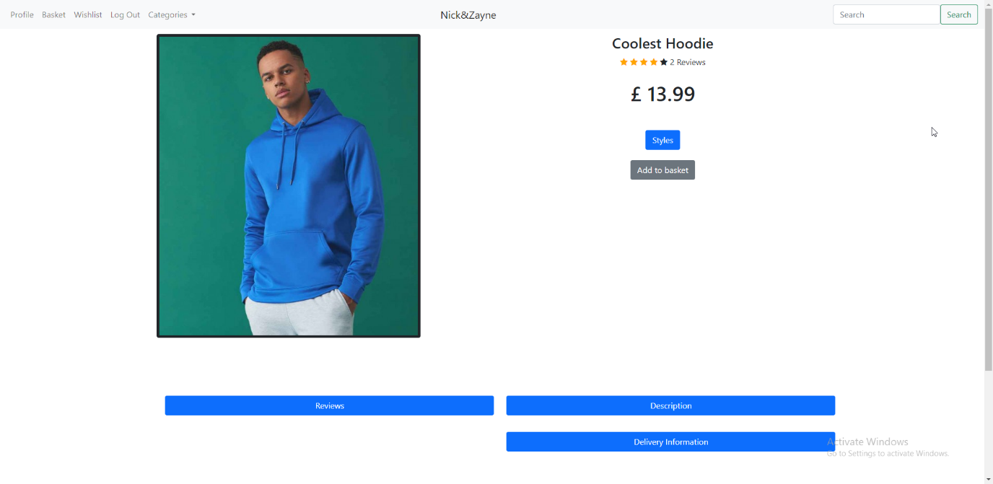

Clicking on any of the blue buttons expands them into a wider list of elements. The reviews one shows all the reviews placed on the given item. The “styles” shows all the styles of the item which have stock left. The description is as the name implies, where the description of the item provided upon creation is shown. The delivery information, however, essentially contains lorem ipsum, placeholder text. The reviews portray a user’s username, rating and comment in a well formatted display.

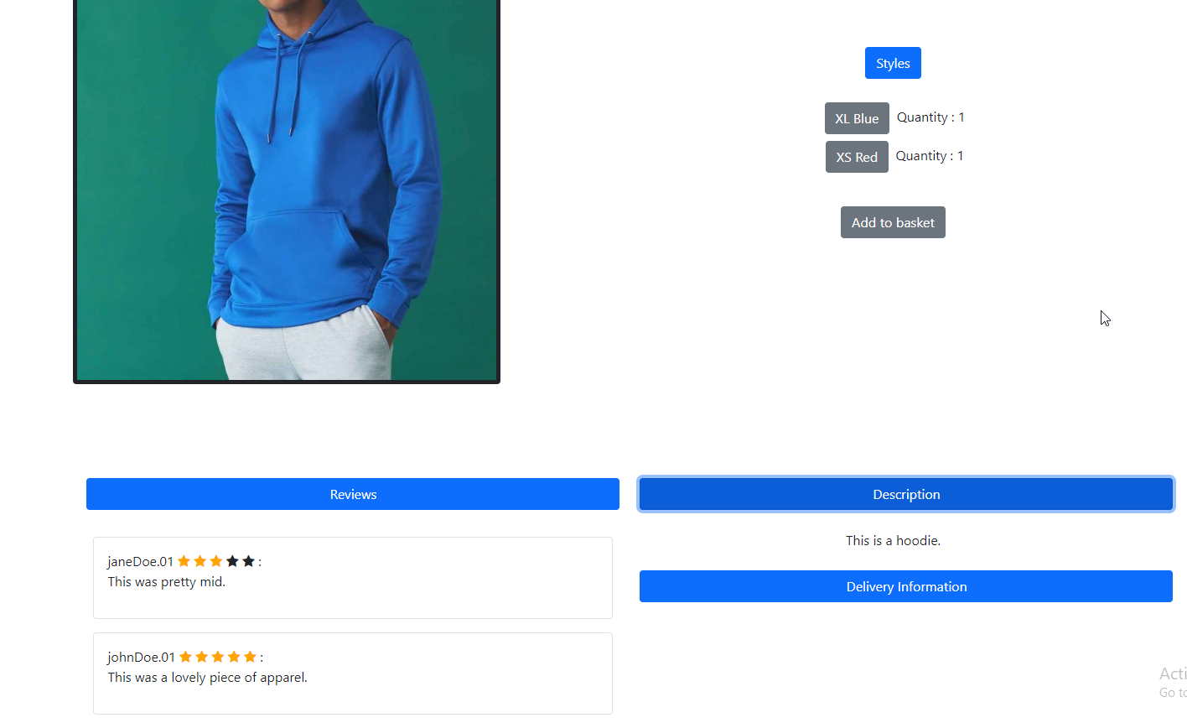

With that done, I now had to implement the earlier mentioned basket.

I added the following views to do so:

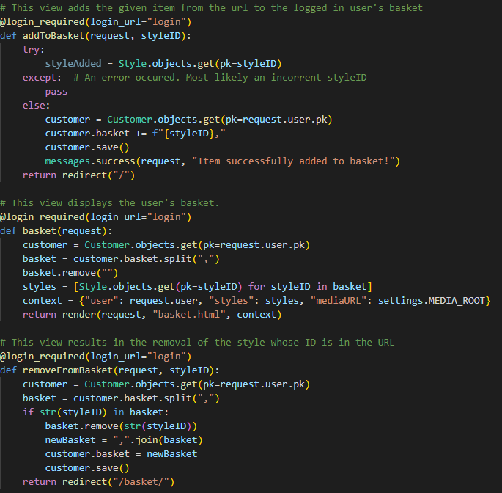

The first view, addToBasket, adds a style to the basket when the view is triggered, based on the styleID in the URL. If an invalid style is given, nothing is done, as there is no handling needed to be done. If successful, the basket string is appended to with a new id and a comma for formatting purposes. The changes will then be saved. The basket view is instead used to display the basket’s contents. The customer’s basket is gotten, and then split by commas. The comma split will result in an empty item at the end due to it being placed after a residual comma. To fix that, the blank item is simply removed. Then, the styleIDs are all converted to their respective styles. They are then passed onto the rendering engine as context. The last view removes the provided styleID’s style from the basket as long as it is inside.

With those made, I ran the code to test the functionality of the basket.

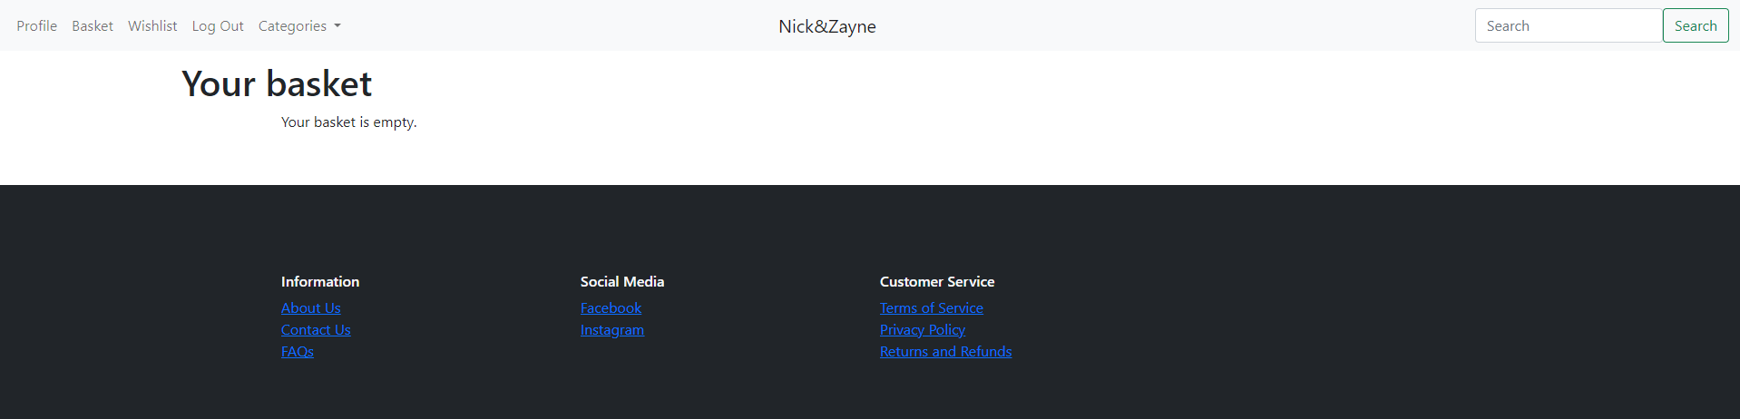

The basket view worked when the basket was empty, so I now had to try to add something to it.

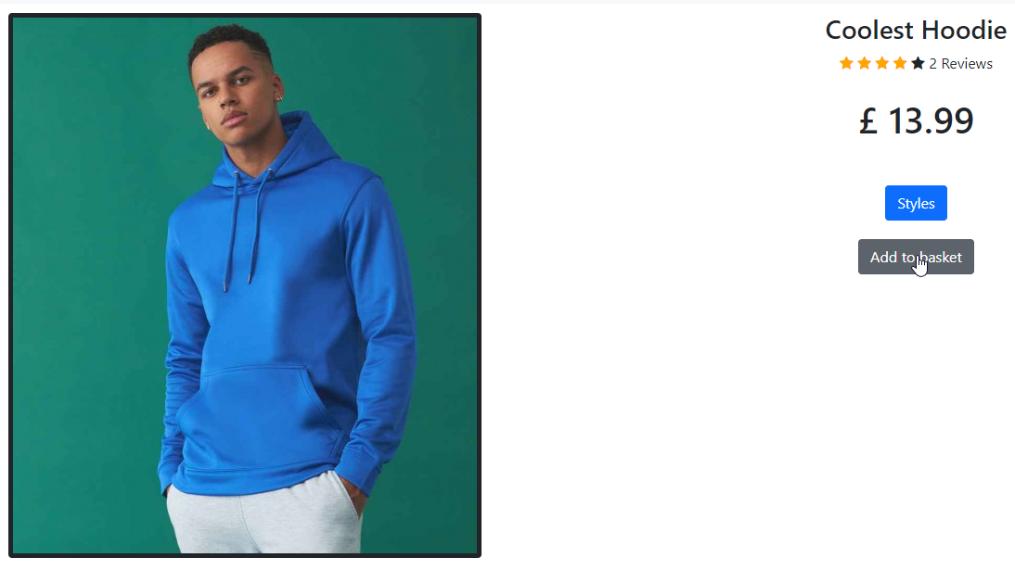

I went to the “Coolest Hoodie” item, and I added it to the basket. The task succeeded, and so I went to the basket to see if it was added correctly.

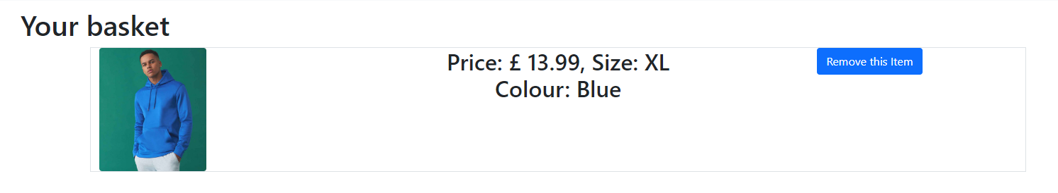

As expected, the item was added to the basket and formatted correctly. One last thing I wanted to try before moving on was adding another style of the same item.

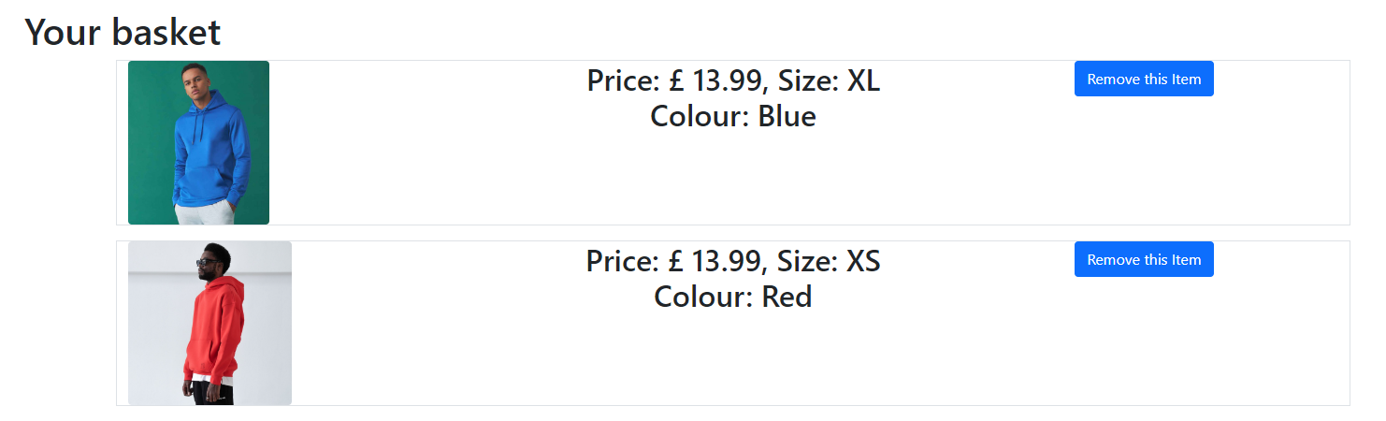

The test was successful. This led me to add the wishlist’s functionality with mostly copied code from the basket.

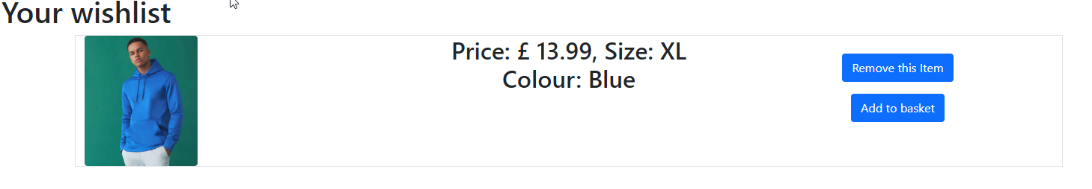

This was the finished result for the wishlist. I was a satisfied with it, and thus moved onto the implementation of the profile screen, the last step before the implementation of the orders.

The addition was as simple as providing the default context, as all the information is either already known or found in the user model’s properties. The final profile outputs as such.

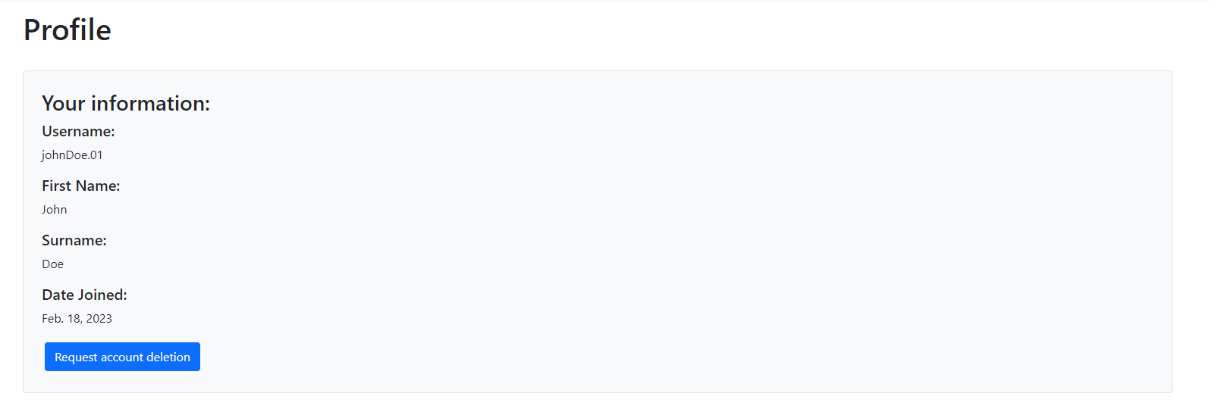

The request account deletion button is just a pointer to the deletion request URL.

### Stage 8: Order Processing

With that, I now moved onto the order processing. Due to heavy time constraints, I had to cut out the implementation of the payment processing with Stripe, and I instead decided to make a system for reservations for the items and quantity provided, treating them as shipped the moment they are bought from the physical store. Getting in touch with my stakeholders about this, they deemed it a fair compromise.

In order to implement those, I first decided to create a checkout screen that shows the user what their final order contains and how much the total is going to be. The total price is calculated by looping through each itemID in the basket and getting its corresponding item’s price. The styles are then also gotten in order to display the full names (itemLines) of the basket.

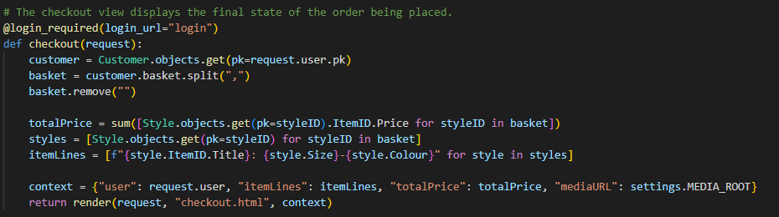

Then, I checked how the checkout looks, and the result of a basket appears as such:

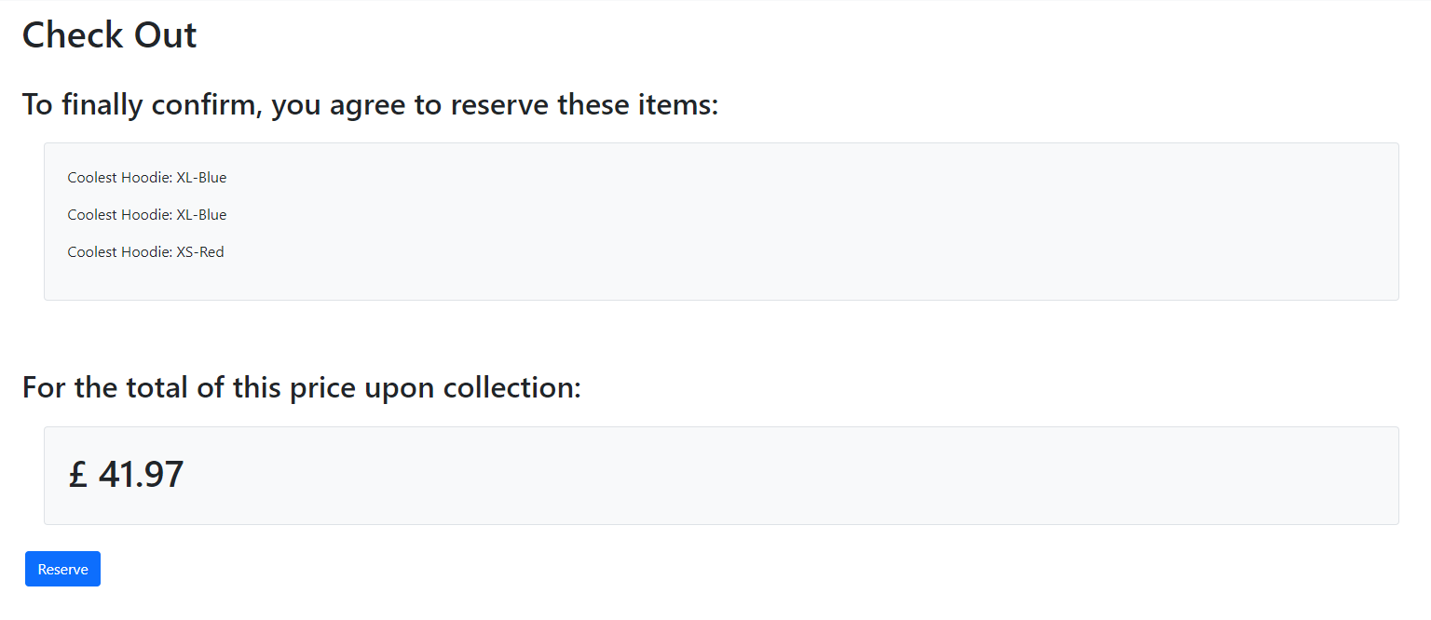

With that, I started writing code for the reservation. I made a few changes to the previous code to accommodate the change of methods for the ordering. The main one was that of the order model. I ended up stripping out a lot of information from the properties because of the fact that the data wouldn’t be needed anymore in a physical store setting. I also added a method that gets the total price of the order after the placement, as the price would be needed at the time of purchase in the store. Lastly, due to some issues with the django framework not being able to handle the use of timezone.now.date as a default value, I made a function that generates the current date according to the current Django timezone.

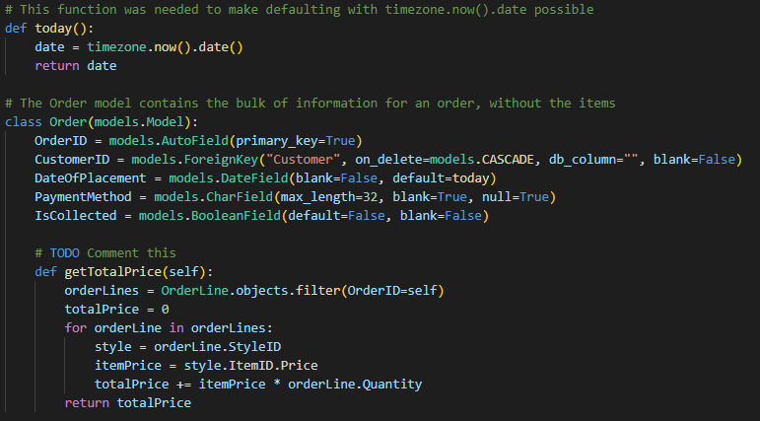

With that done, I now began work on the reservation view. Reservations essentially apply to click and collect. They take the items in the customer’s basket string and they convert that into a list, whose values are used to also get the quantities of the items ordered. The new order is then initialised, where finalLines contains all the OrderLines in the finished order. The reason for that is that the creation of OrderLines might result in errors, so holding the finalLines in one final list instead of saving them immediately increases the robustness of my solution. For example, ordering too much of something will invalidate the whole order, which means you need to be able to stop the transaction in the middle to keep the Atomicity intact. If nothing goes wrong, the final order is saved with its OrderLines. Otherwise, an error message will be prompted both at the console and the user.

`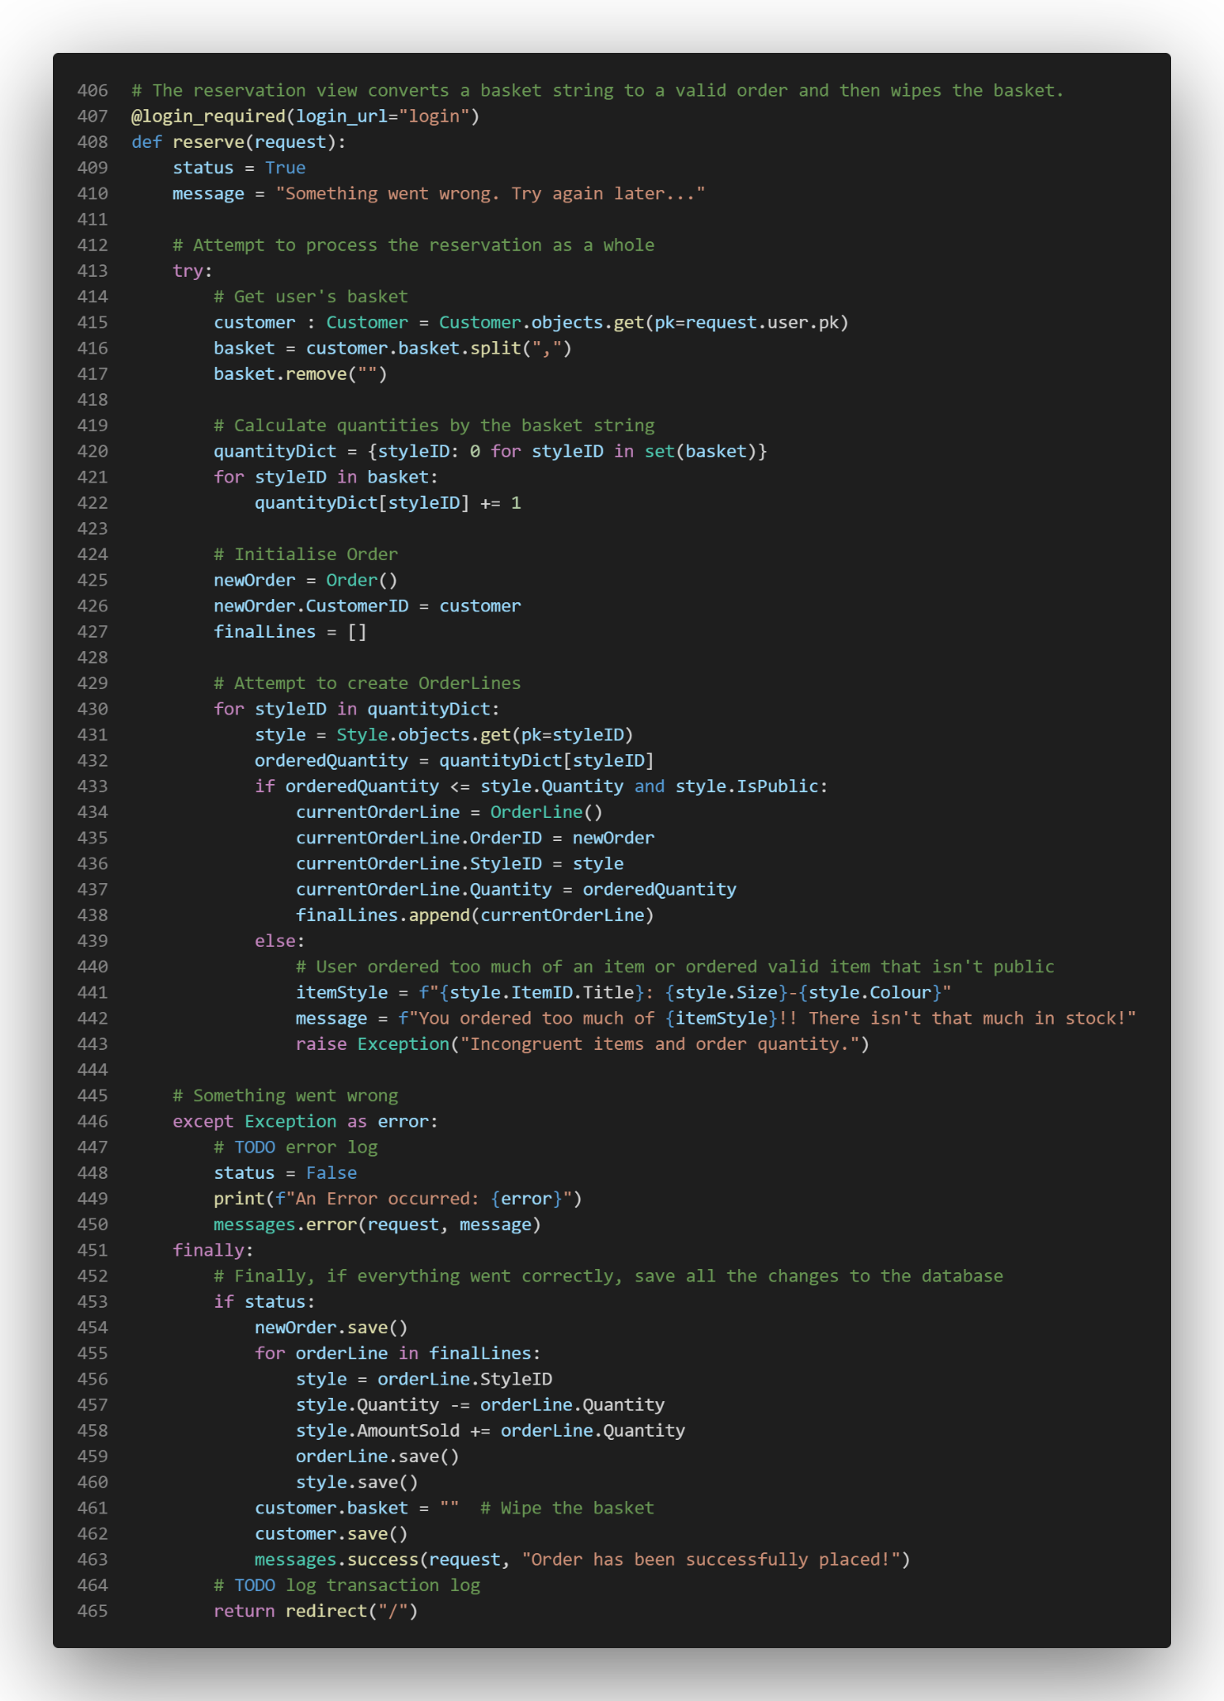

With that code done, it was time to carry out the tests for the reservation system. The tests that didn’t fit into the new system were cut to only test the robustness of the system.

|  |  |  |  |  |  |
| --- | --- | --- | --- | --- | --- |
| Test ID | Testing | Test Type | Data | Expected | Actual |
| 7.4.1 | Valid data for reservation. | V | Items = 1 , 2 , 3  User = “johnDoe.01” | Success. | Success. |
| 7.4.2 | Attempt to force an order with empty basket. | E | Items = NULL | Error. |  |

With that, I had to also now test the featuring algorithm because it is working.

For test 7.4.1, I added styles 1, 2, and 3. The transaction looked as such

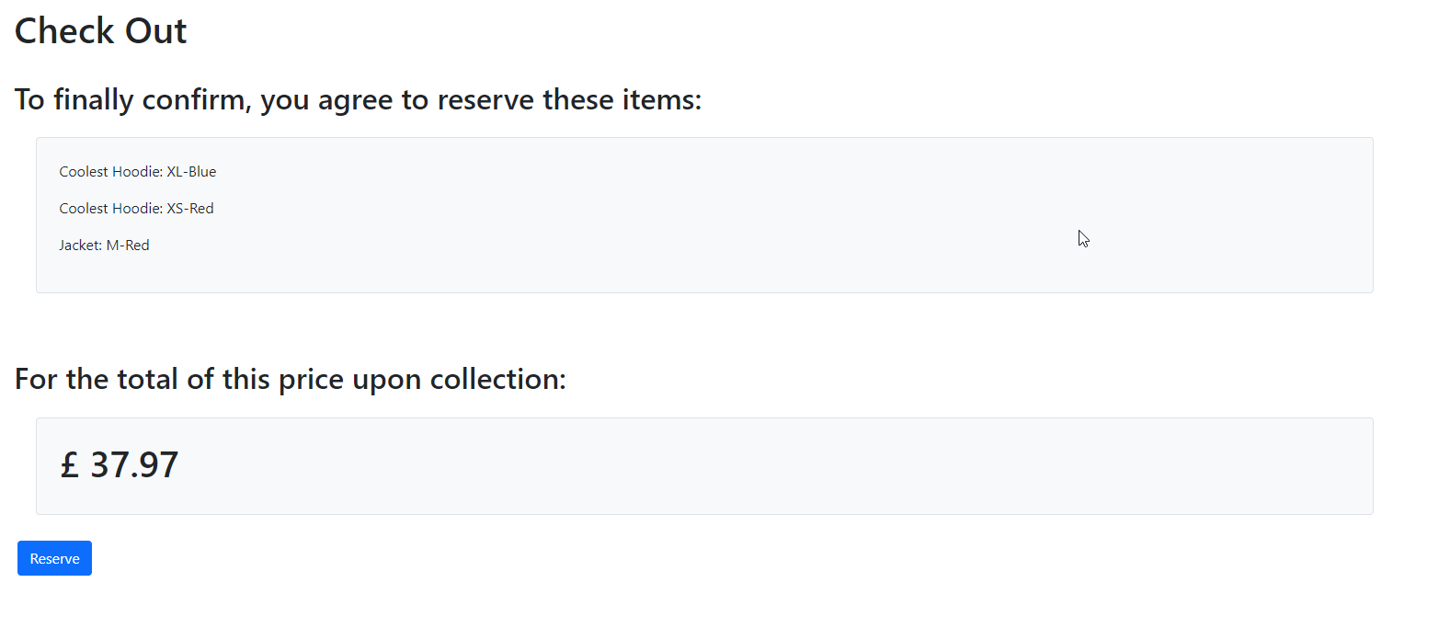

Going through with the transaction gave me the following output.

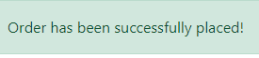

Checking the database, the styleIDs had all made it in the final order.

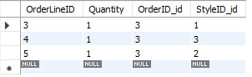

With that, it was time for test 7.4.2. I skipped to the checkout page, and this was the shown screen.

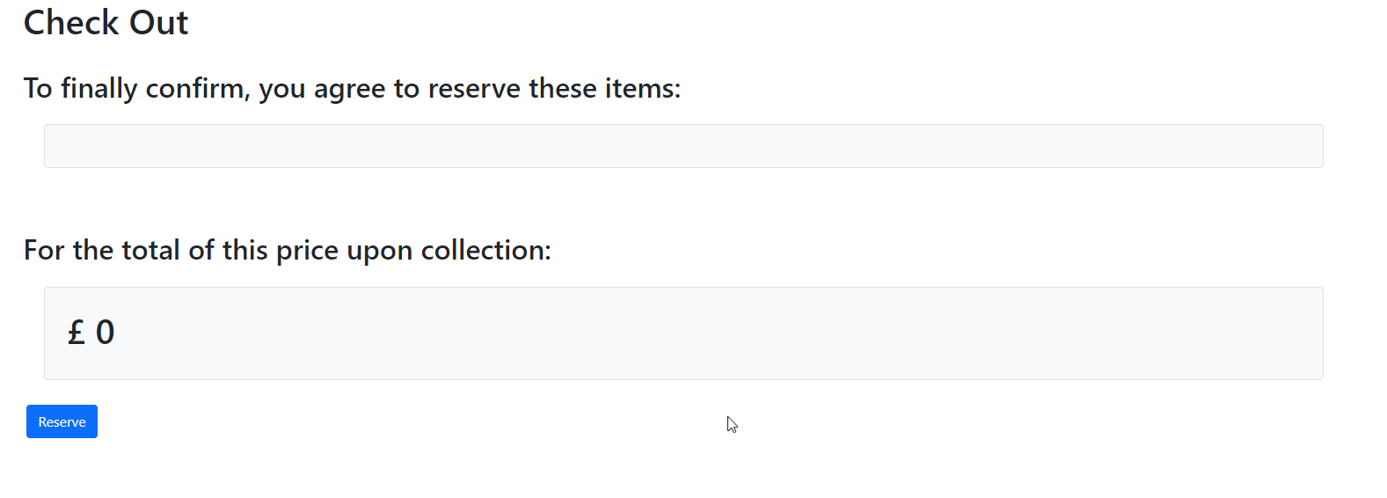

This already prompted some concern, and so I placed the order.

To my surprise, the order went through, and showed as successful. I checked the console log, and it didn’t show any errors either. This prompted me to check if it was added to the database. It ended up being indeed added.

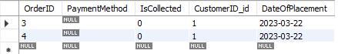

To fix this, I made a check for the fact of whether or not the basket is empty before continuing.

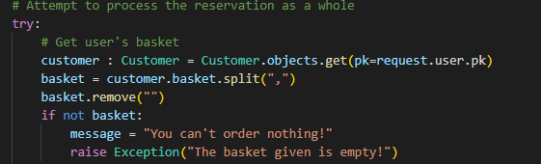

With that, the reservation system was done, so I moved onto the management section.

### Stage 9: Management Section

The next part of the development process is now to implement the management section. This would be a rather simple task due to the fact that Django has a utility for sections of websites like these. It is called Django admin. With the code below, the bulk of the work is done.

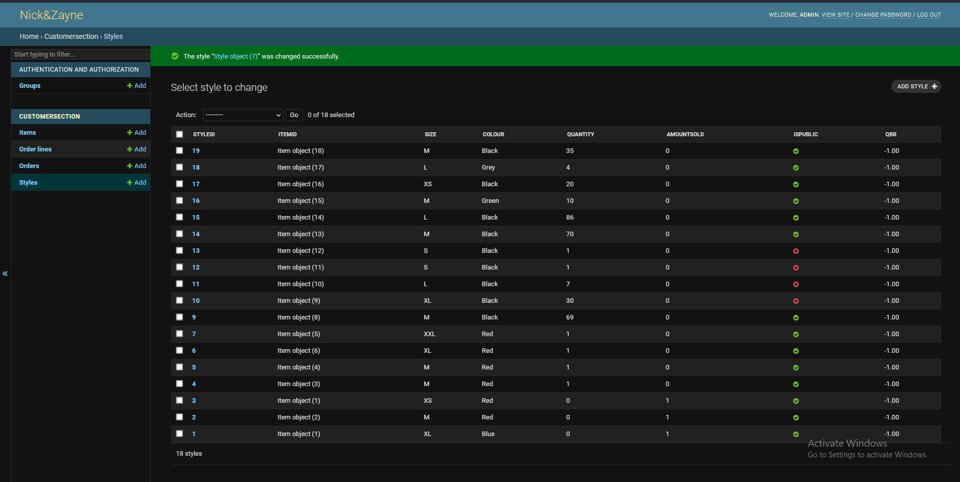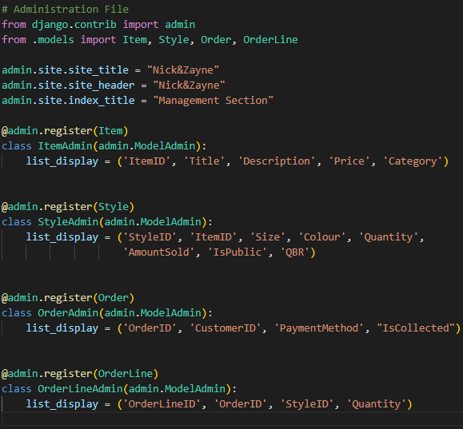

This results in this management website.

As it is visible, a lot can be achieved through a few lines of code. However, there is one feature that I need to add onto this before continuing, and that is the display of order costs. If a reservation’s total cost exists, it is difficult to calculate by hand, as each individual OrderLine would have to be calculated. Instead, the use of a custom field could alleviate that burden. Instead, I added a block of code that automates that.

This is handled in two ways. First of all, on the model side of things, the Order model has a getTotalPrice method. It gets the sum of prices for each order line when accounting for quantities. This is then returned.

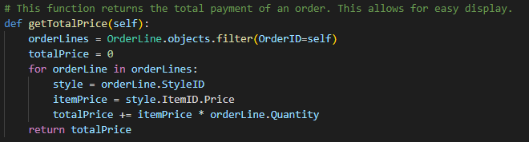

This might initially seem useless, but it allows for significantly more elegant and editable code for the administration page, as such. The totalPrice field is just defined, and its value is set to the return value of this function. The field is also renamed slightly. These together make a more readable, modular solution.

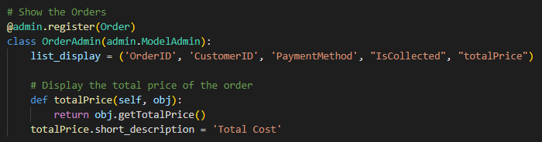

Thus, I had finished the management section of the website.

### Prototype 3 Review

The visualisation and recording of statistics, had to be omitted from the current solution due to the given time constraints that I had to abide to. However, with that done, I was completely done with the development of the solution. Conducting iterative tests on this would be rather useless, as it is mostly handled by a framework, which means that those tests would be redundant. The effectiveness of the administration system will be proven in the post developmental testing.

# Evaluation

## Post Development Testing

**Test scenario 1**: Customer using the website.

1. Visit front page.
2. Set website to dark mode.
3. Register account.
4. Attempt to log in.
5. Activate account via email link.
6. Attempt to log in with wrong password.
7. Reset password via email link.
8. Log In with the new password.
9. Browse hoodies via categories.
10. Wishlist some hoodies.
11. Add hoodies to basket.
12. Place order through basket.
13. Review item.
14. Delete account via email link.
15. Attempt 4-11 while logged out.
16. Rate the usability of the system from 1-10

**Test scenario 2**: Manager using the website.

1. Log in via the manager log in.
2. Look at current items.
3. Create an item.
4. Make a change in that item after initialisation.
5. Delete that item.
6. Look at the order queue for current orders.
7. Remove an order from the queue.
8. Look at statistics of the previous week.
9. Rate the usability of the system from 1-10

Link 1: [CustomerSectionPDT.mp4](https://ncclondon-my.sharepoint.com/:v:/g/personal/19091781_students_ncclondon_ac_uk/ERwnExh_dB1Ir-_N3-_Tl3QBeWhx1bfH_v3Z8omP3TD_aA?email=John.Ngwa-Ndifor%40NCCLondon.ac.uk&e=eCcJyz)

Link 2: [ManagementSectionPDT.mp4](https://ncclondon-my.sharepoint.com/:v:/g/personal/19091781_students_ncclondon_ac_uk/EU-zGIpkAvBKkMSyZ-LdPkIBh1zksPWwXyfyPPByAkVQWQ?e=9ChKiD)

After having all my stakeholders rate the usability of my system, the ratings were as follows:

Peter: 7/10. “I really think this has potential. It’s easy to use and looks appealing.”.

Nick: 9/10 “I loved the designs, and I think you followed up great on them. The Interface is intuitive.”.

User 1: 7/10 “It was decent. I have seen better designs, but it is a great start.”.

User 2: 5/10 “I personally think you could have done a better job, as the buttons occasionally didn’t work, and I couldn’t even review items. The website didn’t even have a dark mode.”.

## Criteria Met

|  |  |  |  |  |  |  |
| --- | --- | --- | --- | --- | --- | --- |
| Requirement ID | | Requirement | Status | Evidence | Reason | |
|  |  | **Database** |  |  |  | |
| 1 | 1.1 | The Database can contain user accounts. | Met | Pg 65, Post Development Testing | The solution was able to store the data given. |
| 1.2 | The Database can contain items. | Met | Pg 66, Post Development Testing | The solution was able to store the data given. |
| 1.3 | The Database can contain manager accounts. | Met | Pg 62, Post Development Testing | The solution was able to store the data given. |
| 1.4 | The Database can contain reviews. | Met | Pg 61, Post Development Testing | The solution was able to store the data given. |
|  | 1.5 | The Database can contain order info to show past orders. | Met | Pg 66-68, Post Development Testing | The solution was able to store the data given. |
|  | 1.6 | The Database can handle CRUD queries. | Met | Pg 67-68, Post Development Testing | The solution was able to carry out the tests for 1.6 successfully. |
|  |  | **Password hashing algorithm** |  |  |  |
| 2 | 2.1 | The server can convert a plain text password into a hash. | Met | Pg 69 | The solution was able to carry out the tests for 2.1 successfully. |
| 2.2 | The hash function is consistent with a provided sample text. | Met | Pg 69 | The solution was able to carry out the tests for 2.2 successfully. |
| 2.3 | The hash function has virtually no collision cases. | Met | The bcrypt specification. | The bcrypt algorithm’s specification clearly states that there are no collision cases in the algorithm, which shows that it was a correct choice. |
|  |  | **User account system** |  |  |  |
| 3 | 3.1 | The server can create user accounts without activating them. | Met | Pg 78-80, Post Developmental Testing | The server can create user accounts without activating them because the evidence shows that the default value of activation is “inactive”. |
| 3.2 | The server can activate accounts. | Met | Pg 85-88, Post Developmental Testing | The server can activate accounts, as inactive accounts were activated in the iterative and post developmental testing. |
| 3.3 | A login can be authenticated by the server by comparing credentials (username and password hash). | Met | Pg 92-97, Post Developmental Testing | The reason this criterium is successful is because logins were successfully enacted during the iterative and post developmental testing. |
|  | 3.4 | The server won’t allow accounts that aren’t activated to log in. | Met | Pg. 96-97, Post Developmental Testing | The server was shown to reject log in attempts from inactive users during the iterative and post developmental testing. |
|  | 3.5 | The server can delete a user’s account. | Met | Pg 100-101, Post Developmental Testing | This is met because of the clear evidence in the iterative and post developmental tests of this criterium. |
|  | 3.6 | The server can reset a user’s account password. | Met | Pg 105-109, Post Developmental Testing | This criterium was met as there was clear evidence in the iterative and post developmental tests. |
|  | 3.7 | The server can’t overwrite existing account when registering user. | Met | Pg 109, Post Developmental Testing | This criterium was met as there was clear evidence in the iterative and post developmental tests. |
|  |  | **Reviewing System** |  |  |  |
| 4 | 4.1 | A user who has bought an item can review it, and vice versa. | Partially Met. | Pg 114-119 | The reviewing system was functional in the skeletal betas, but ended up forgotten at the end due to time constraints. Given a little time, this is an easily fixable issue, which leads me to deem this as partially met. |
| 4.2 | Reviews that are placed can be stored and read. | Not Met | N/A | This criterium was not met, as there is no evidence of this working. |
|  |  | **Email Automation System** |  |  |  |
| 5 | 5.1 | The server has its own “no reply” email address which can’t receive messages. | Partially Met | Pg 120-121, Post Developmental Testing. | This was partially met because the email address isn’t a no reply email, which means that it can receive emails. |
| 5.2 | The email address can send mail to other addresses. | Met | Pg 120-121, Post Developmental Testing | The emailing system was clearly working, as shown in the iterative and post developmental testing. |
|  |  | **“Featured” Algorithm and Recommender AI.** |  |  |  |
| 6 | 6.1 | The Featured Algorithm is not too slow to run. | Met | The design document, explanation, and flow chart. Pg. 44-45. | The Big O notation of the algorithm is linear, which makes it rather efficient. |
| 6.2 | The Featured Algorithm segregates the well performing and bad performing items. | Met | The way the featuring algorithm is made, it can separate good and bad performing items using QBRs, a rating system. |
| 6.3 | The Featured Algorithm is implemented and works. | Partially Met | Pg 122-126 | Although the featuring algorithm’s code is very robust and most likely works, I had no time to test it due to time constraints. This is due to the needed complexity of proper testing scenarios. |
| 6.4 | The Featured Algorithm is automatically called every week. | Not Met | N/A | This criterium was not met because no automated tasks were implemented in the solution. |
| 6.5 | The Recommender AI is trained and can produce expected outputs. | Partially Met | Pg. 139-140. | This was partially met because even though it can make recommendations, the recommendation system is completely unpredictable. The reason for its inaccuracies is likely a small hurdle away from accuracy, but in the end, the recommendations are inaccurate. |
| 6.6 | The Recommender AI is implemented into the server. | Not Met | N/A | This was not met because of the fact that there was no way to integrate a broken AI into a working website reasonably. |
|  |  | **Order Processing** |  |  |  |
| 7 | 7.1 | The website has a checkout section. | Partially Met | Pg 156 | The website has a checkout page which shows a conclusive summary of an order before its placement. Thus, this success criterium is met. |
| 7.2 | The API chosen can process credit and debit cards. | Not Met | N/A | This criterium was not met, as there is no API to handle payment processing on the website. |
| 7.3 | The website can take in payment info and make a withdrawal. | Not Met | N/A | The criterium was not met, as the website does not have the ability to withdraw money from a bank account. |
| 7.4 | The website can handle the placement of orders. | Partially Met | Pg 159-160 | Although order processing wasn’t implemented, it was replaced with the reservation system, which works flawlessly. Thus, it was partially met. |
| 7.5 | The website can process refunds. | Not Met | N/A | Refunds were not implemented into the solution, which resulted in this criterium not being met. |
| 7.6 | The website can process cancellation of orders. | Not Met | N/A | Order cancellation was not implemented into the solution, which resulted in this criterium not being met. |
|  |  | **Management Sector** |  |  |  |
| 8 | 8.1 | The management sector can only be accessed by “managers”. | Met | Post Developmental Testing. | The framework that I picked makes sure that only managers may enter the management section. |
| 8.2 | The management front end only supports dropdowns for input | Not Met | N/A | This success criterium was not met because of the framework restrictions coupled with time constraints. |
| 8.3 | The management sector can execute, and output read instructions. | Met | Post Developmental Testing. | CRUD operations were all proven to function correctly during the post developmental testing. They work as expected, as such, the success criterium was met. |
| 8.4 | The management sector can execute deletion instructions. | Met | Post Developmental Testing. |
| 8.5 | The management sector can execute update instructions. | Met | Post Developmental Testing. |
| 8.6 | The management sector can execute creation instructions. | Met | Post Developmental Testing. |
| 8.7 | The backend must also validate if a user has the permission to execute a certain instruction. | Met | Post Developmental Testing. | The framework that I picked makes sure that no malicious actors can attempt to execute instructions outside their permissions. |
|  | 8.8 | The order queue must be visible and functional. | Met | Post Developmental Testing. | The order queue is visible, in the form of the IsCollected checkmark, as the orders no longer have other complications to make this process difficult to do. |
|  | 8.9 | The design of the management sector must be easy to use. | Met | Post Developmental Testing. | The stakeholder feedback from the managers was rather positive, which acts as evidence that this success criterium was met. |
|  |  | **Visualisation of Statistics** |  |  |  |
| 9 | 9.1 | The management sector can retrieve statistics from the backend. | Not Met | N/A | These criteria were all not met, as I had not been able to implement visualisation of statistics due to time constraints. |
| 9.2 | The management sector has visually representations of data. | Not Met | N/A |
| 9.3 | The visualisation result has gotten the approval of the stakeholders. | Not Met | N/A |
|  |  | **Appealing Front End User Interface with Quick Loading Time** |  |  |  |
| 10 | 10.1 | The front end represents the UI designs made in the design stage. | Partially Met | Post Development Tests | This was partially met because the UI that was used for the management section does not reflect the design. However, the rest of the UI was reflective of the design document. |
| 10.2 | The front end has been reviewed by the stakeholders. | Met | Pg 163-164 | The stakeholders reviewed and generally approved of the current state of the UI. This shows that this criterium was met. |
| 10.3 | The front end can load within the given threshold. | Met | Post Development Testing | As shown in the post developmental tests, the website loaded quickly. |
| 10.4 | The front end has a dark mode setting. | Not Met | N/A | This criterium was not met simply because I hadn’t been able to implement the dark mode setting as a result of time constraint. |

There were many criteria that ended up not being met. This was mostly regarding the payment processing and AI, due to the time limitations that arose. Although those requirements were not met, the post development testing shows that the website in its current state is still functional. I will touch on the different aspects of the solution regarding its success.

## Usability

The solution that I created for the stakeholders’ issue has many usability features that make it easy to use for the uninitiated customers that are new to shopping for clothes online. First, the UI is very presentable, due to the use of HTML templates mixed with bootstrap. The index is a perfect example of how there is a very carefully executed UI that focuses on usability. The buttons that are used to search, wishlist, log in, go back to index and register are all larger than 3 cursors put next to each other. This shows that the solution has an easy to use UI.

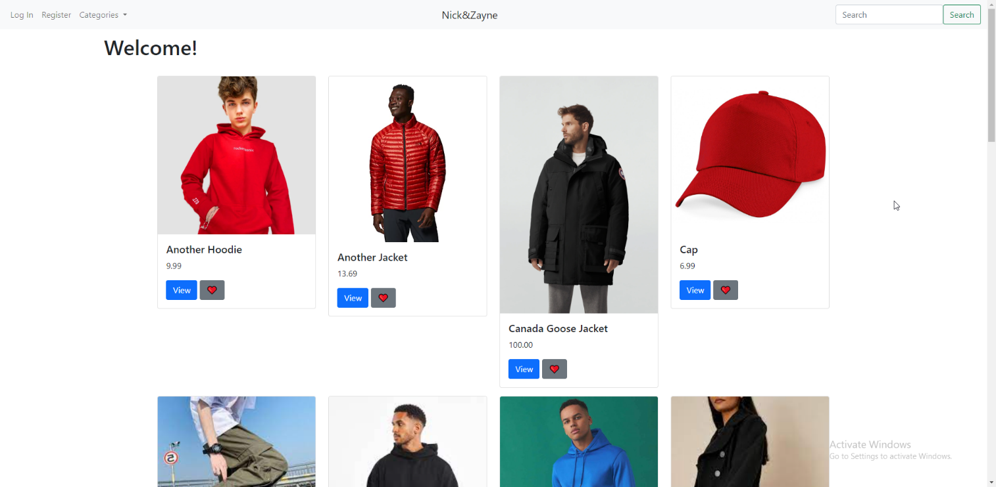

## Limitations

The solution that I created does have some limitations that arose due to the time constraints given. One of the most major setbacks is the removal of orders for the website. This was done as a compromise to finish the solution in time after constraints in timing resulted in a need to cut certain features from the scope of the NEA. This resulted in a revamp of the ordering system via the reservation system, which was a fair compromise that did not require payment processing, at the cost of being exploitable. If a customer reserves an item, there is no verification to check if they can even afford any given item.

Regarding the recommendation system, I only had two options at my disposal after the test where the hoodies were not recommended as expected. One was to attempt a reduction of the dataset. This however also might have taken a significant amount of time and maybe not even worked if the algorithm did not pick up on the inherent features of the items. The other was to attempt a different algorithm which could make recommendations at a reasonable speed. However, this would very likely result in inaccurate recommendations, as anything short of deep learning could not top SVD based techniques and simultaneously be light enough to compute within my time restrictions, including the time it would have taken to debug, test and iron it out until its predictions were accurate enough. Furthermore, building on the topic of accuracy, my dataset’s size would have made it very difficult to reach a reasonable state of accuracy since I wasn’t using any type of deep learning due to technical limitations of not having more powerful hardware to train a neural network on. Due to the time constraints that could have posed an inability to finish the solution in time, I decided that it was best to go forward, with the knowledge that the code was mostly written in the case of the recommendation system.

Lastly, the other important limitation to make notice of is that of the automatic task execution, such as deleting action tokens after 24 hours, or generating the featured items every Monday. This means that tokens will have to most likely be manually monitored until the system is patched, and it also means that a member of staff has to manually regenerate featured items each week. Although it is a tedious process, it is an easily done temporary workaround.

## Maintenance

The solution that I created was created with maintenance in mind, as websites tend to need to be rewriteable to meet any changing needs or developers. This shows through the use of many different conventions and standards I used throughout the development. One feature that makes my code easier to maintain is the use of a variable naming convention, which is camelCase. This can be seen in almost all my variables and functions, such as registerAccount, and the filename accountActions. The only time this convention was broken was out of necessity, due to the way that Django works. This is evident in the date_joined field. In the case of python classes, mostly used in model definitions, I used PascalCase, as is seen standard for class names. However, in the essence of the actual solution, object-oriented patterns are rarely used. One last thing to mention is the use of modularisation in my code, as the different functional components of the solution are split as different segments and files, which each hold some type of encapsulated abstraction away from the other files. These files all come together to form one complete program which works robustly.

On the topic of robustness, a significant amount of validation has been done throughout the whole solution. First of all, due to the way that I structured the views, non-logged in users will continuously get prompts to log in for tasks that they need to, such as attempting to add an item to the wishlist or the basket. This is also expressed in the log in forms themselves, as an inactive user won’t be able to log in. Throughout the iterative process of development, this is further shown. These validation points are all to the benefit of the stakeholders, as a robust solution is a secure one, and all of the forms have been protected from dirty input.

My code is also very well commented, which helped me multiple times when I took any form of hiatus from the code, as I was always able to recall and understand code that I wrote with the helpful notes that I left, and in the case of maintaining it in the further future, I am sure that I will be able to better understand my code because of this. This doesn’t only apply to me though. If more members were to join the development team for the solution, then they should also be able to understand the code written, as due to the previously mentioned conventions being followed, as well as the presence of comments.

However, with all of that said, there is a lot that could be worked on in the future of the website. A significant number of features was missing in the final solution. First and foremost, the reviews and recommendations system must be fixed to properly work in the case of the given context. This also is followed by the need to implement automated tasks into the final solution, as the clients are unlikely to wish to manually remove tokens and generate featured items every Monday at 12 am. The visualisation of statistics and logging of such information was also omitted as a result of time constraints. All the above are needed before a possible launch. And of course, the most important thing that I haven’t mentioned so far, the payment processing. Although I could argue that maybe the payment processing is beyond the scope of this project, the feature is a necessity if the business wishes to expand outside of their main chain and grow nationally.

## Conclusion

With all this reflection on my solution, I can now take a more holistic look upon the solution’s success. Overall, I would say that the solution that I have developed has been successful in a lot of areas and acts as a great foundation upon which my clients’ final website can be built. There are some missing features that will have to be added in the near future, but the solution works at face value.

## Final Code

### urls.py

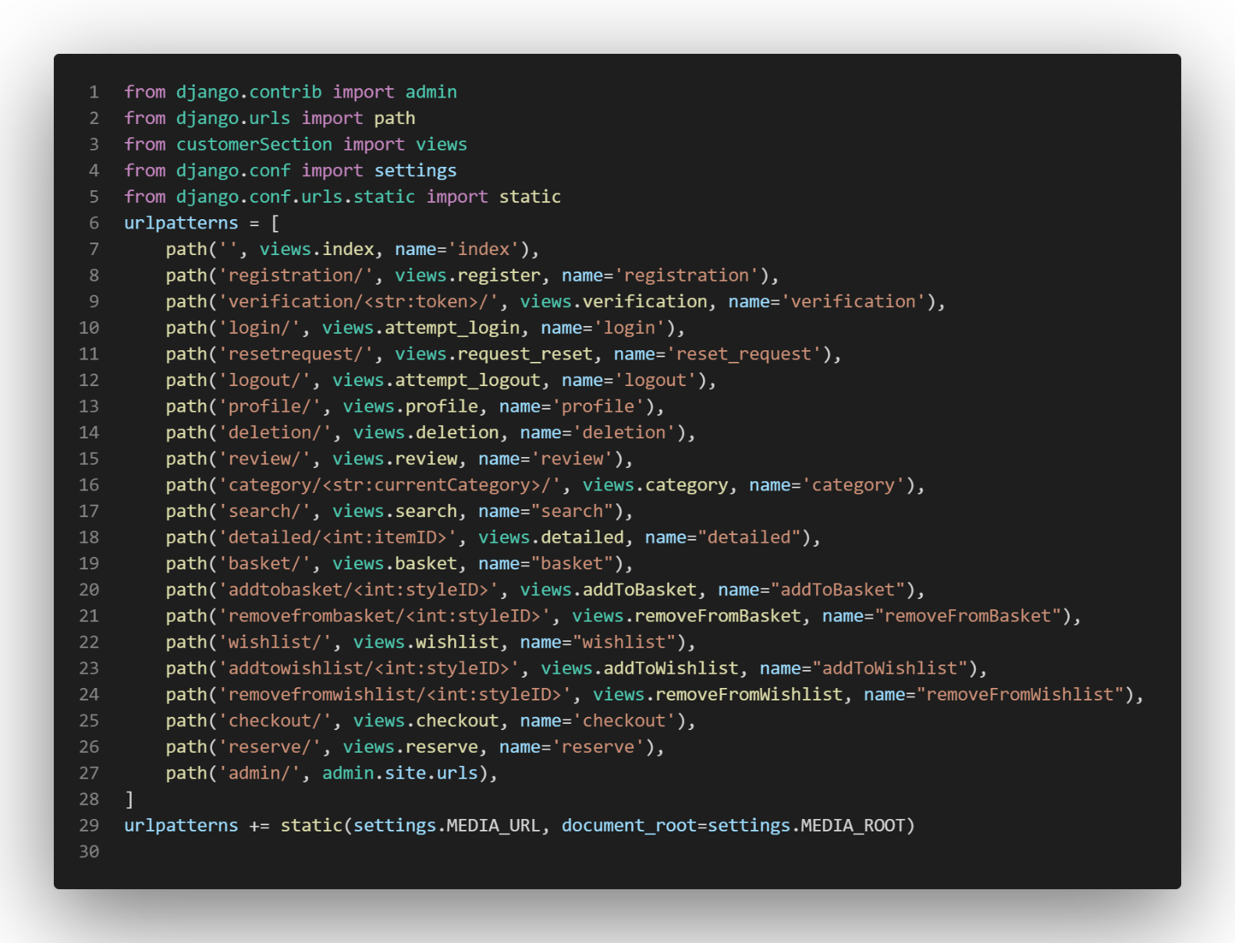

### models.py

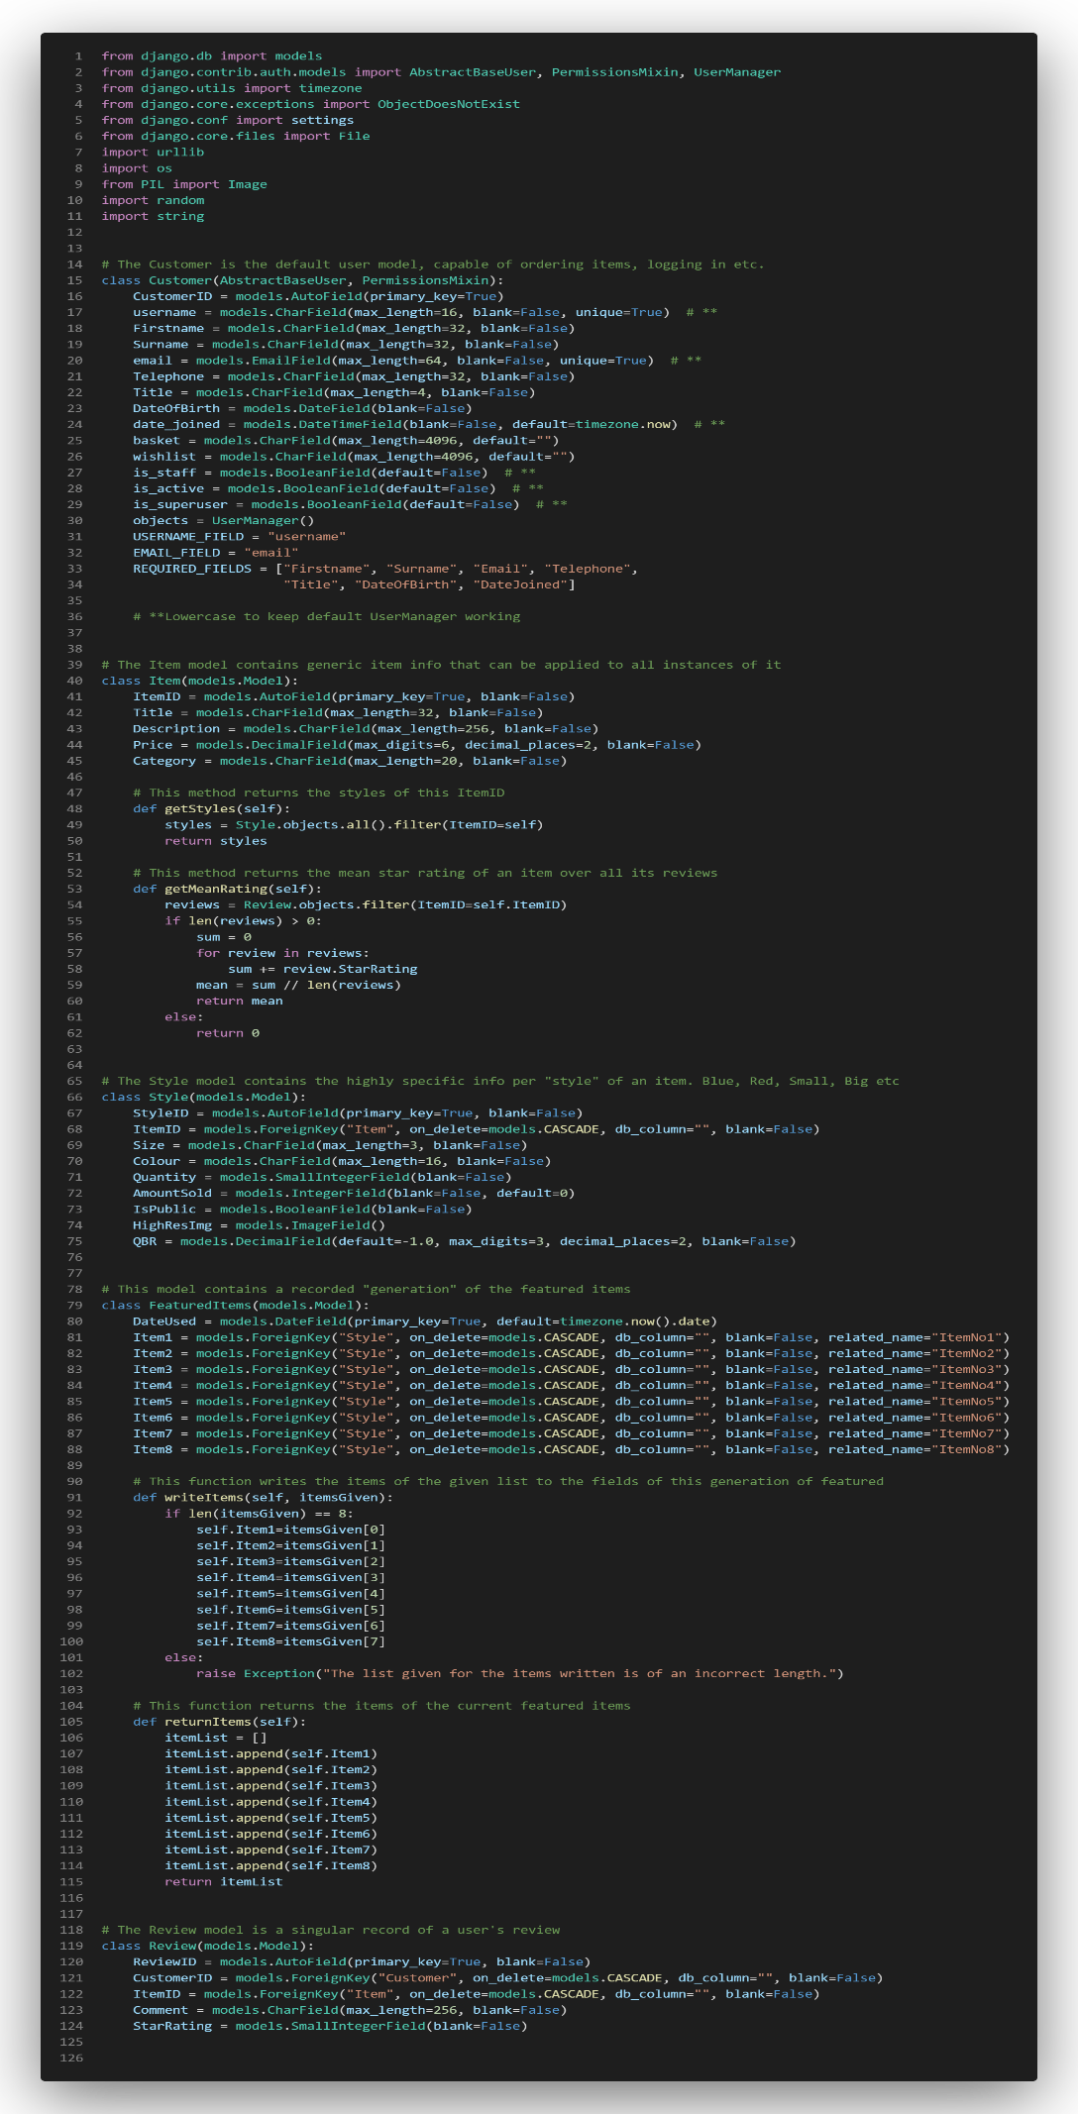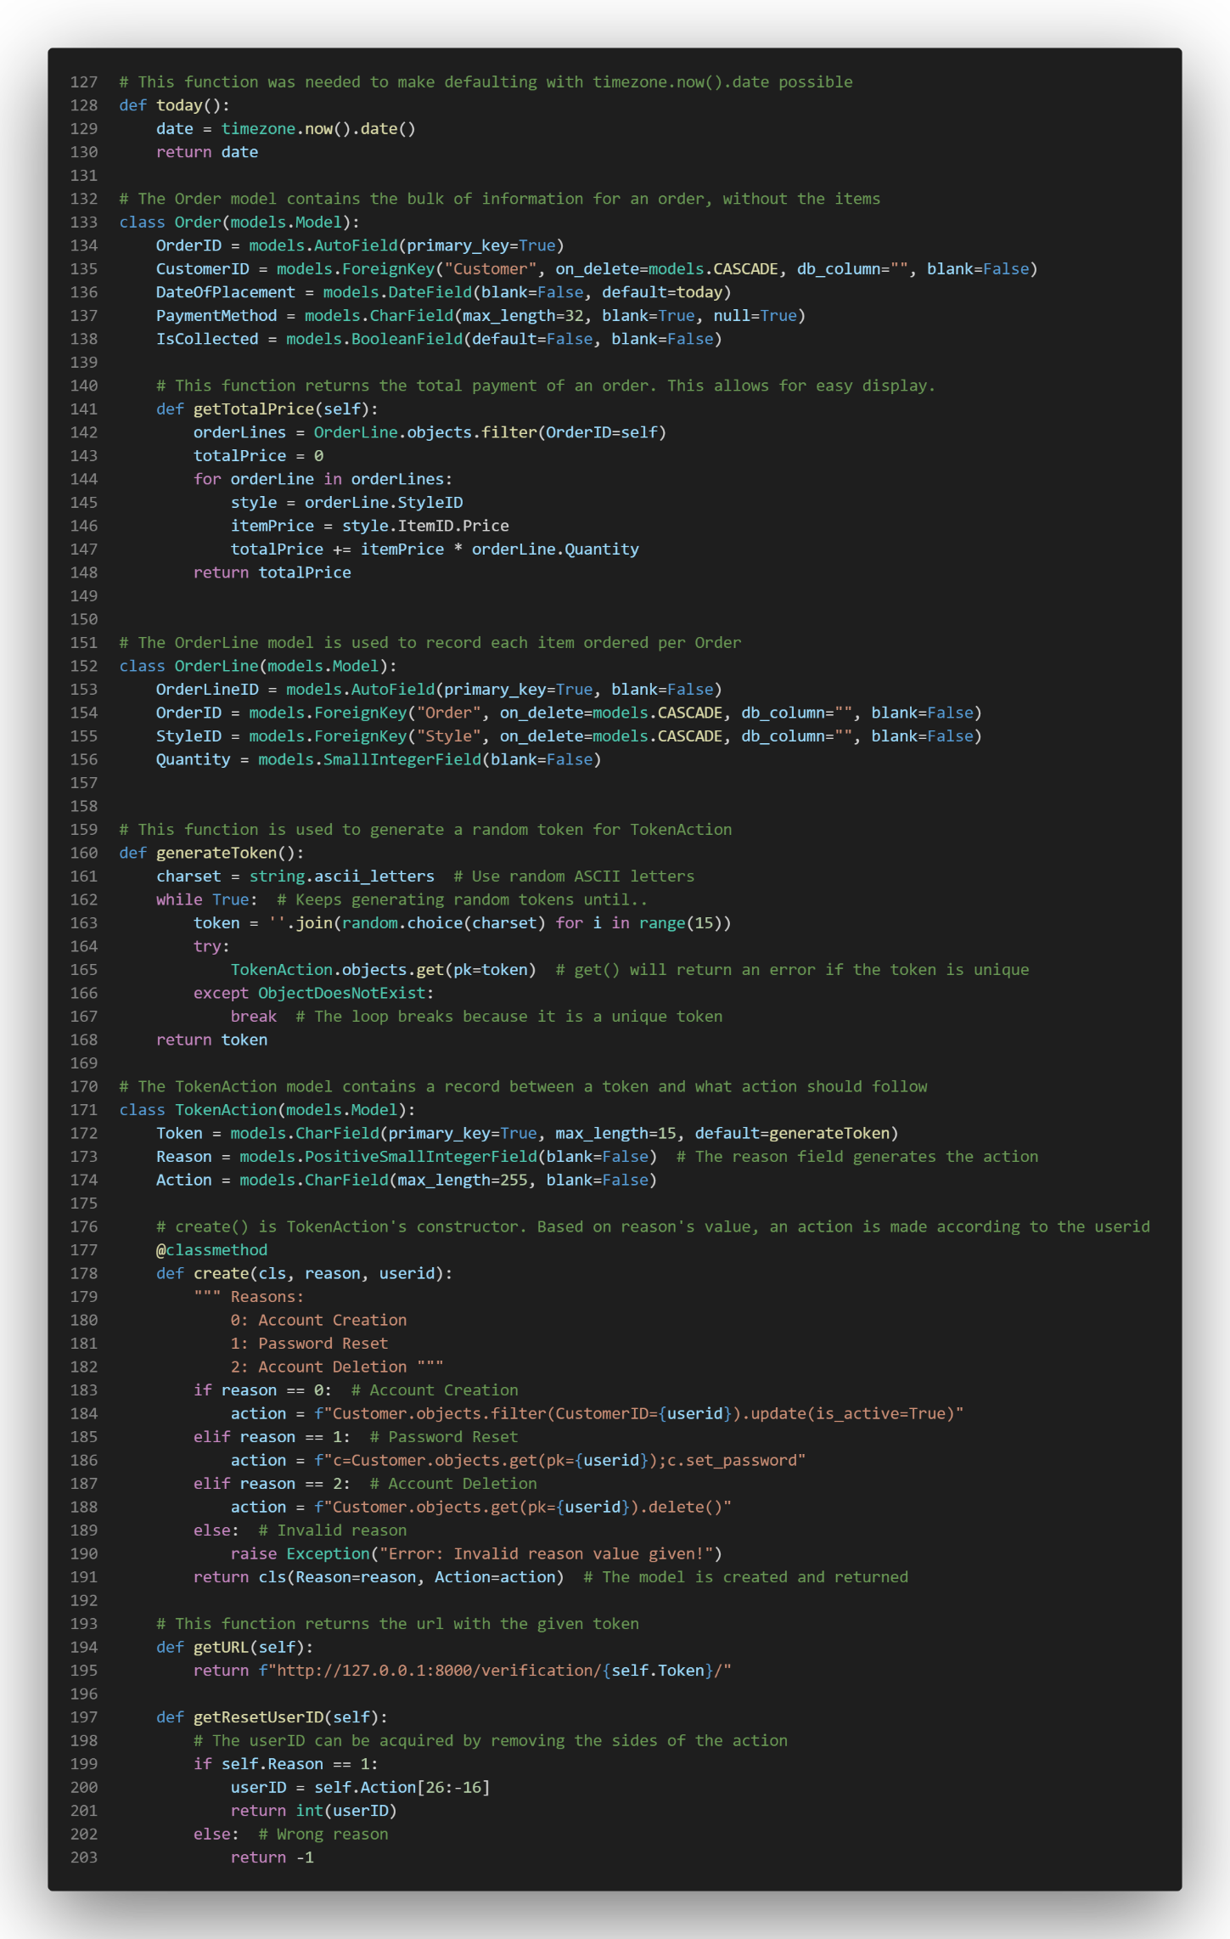

### forms.py

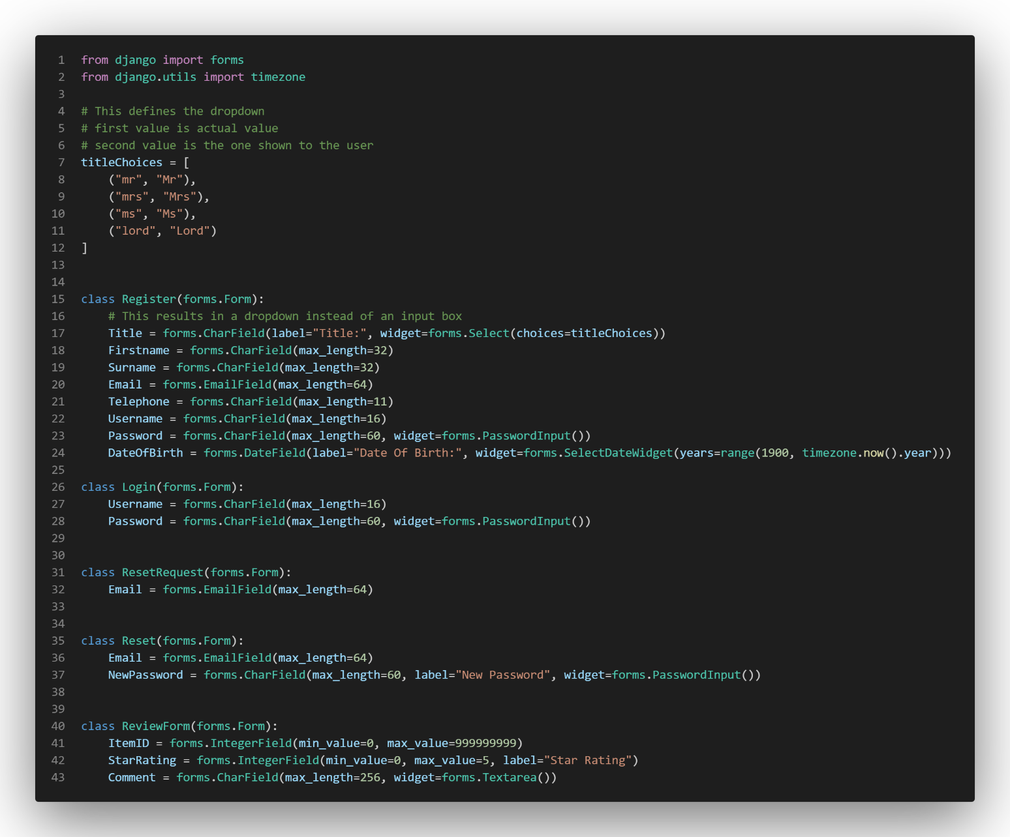

### views.py

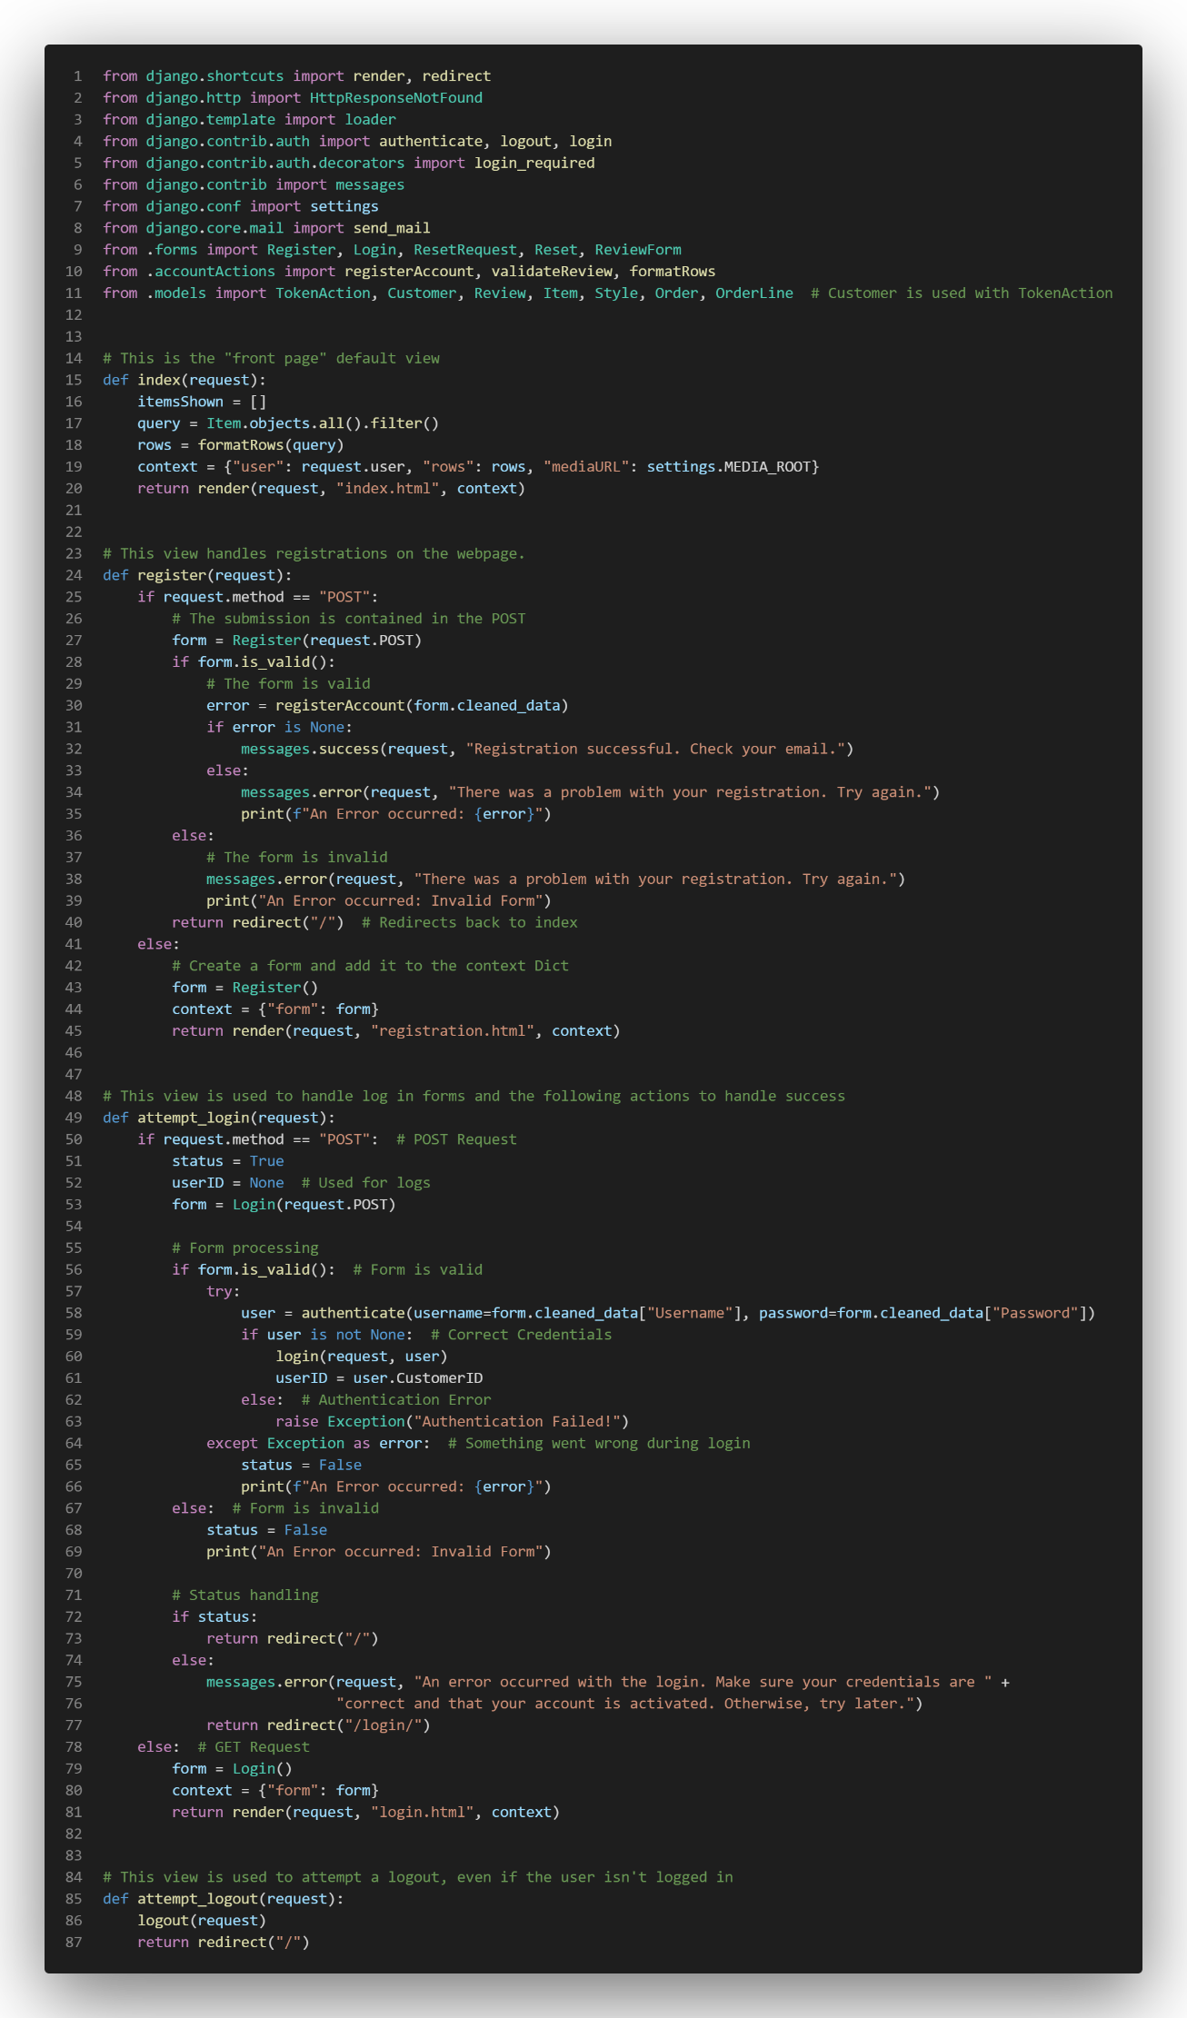

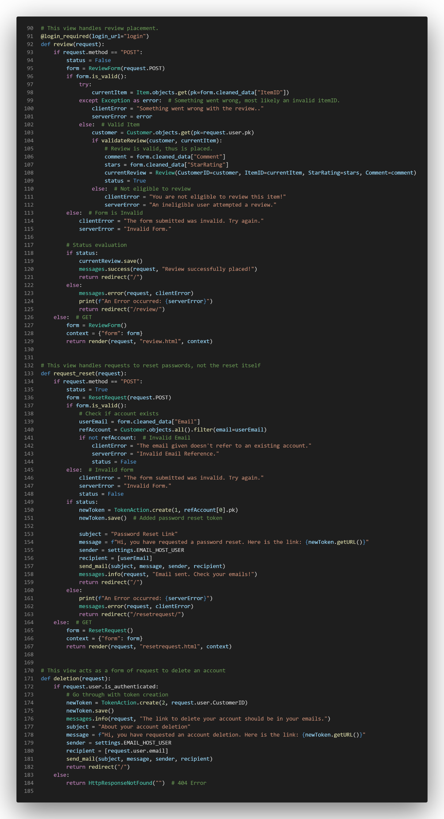

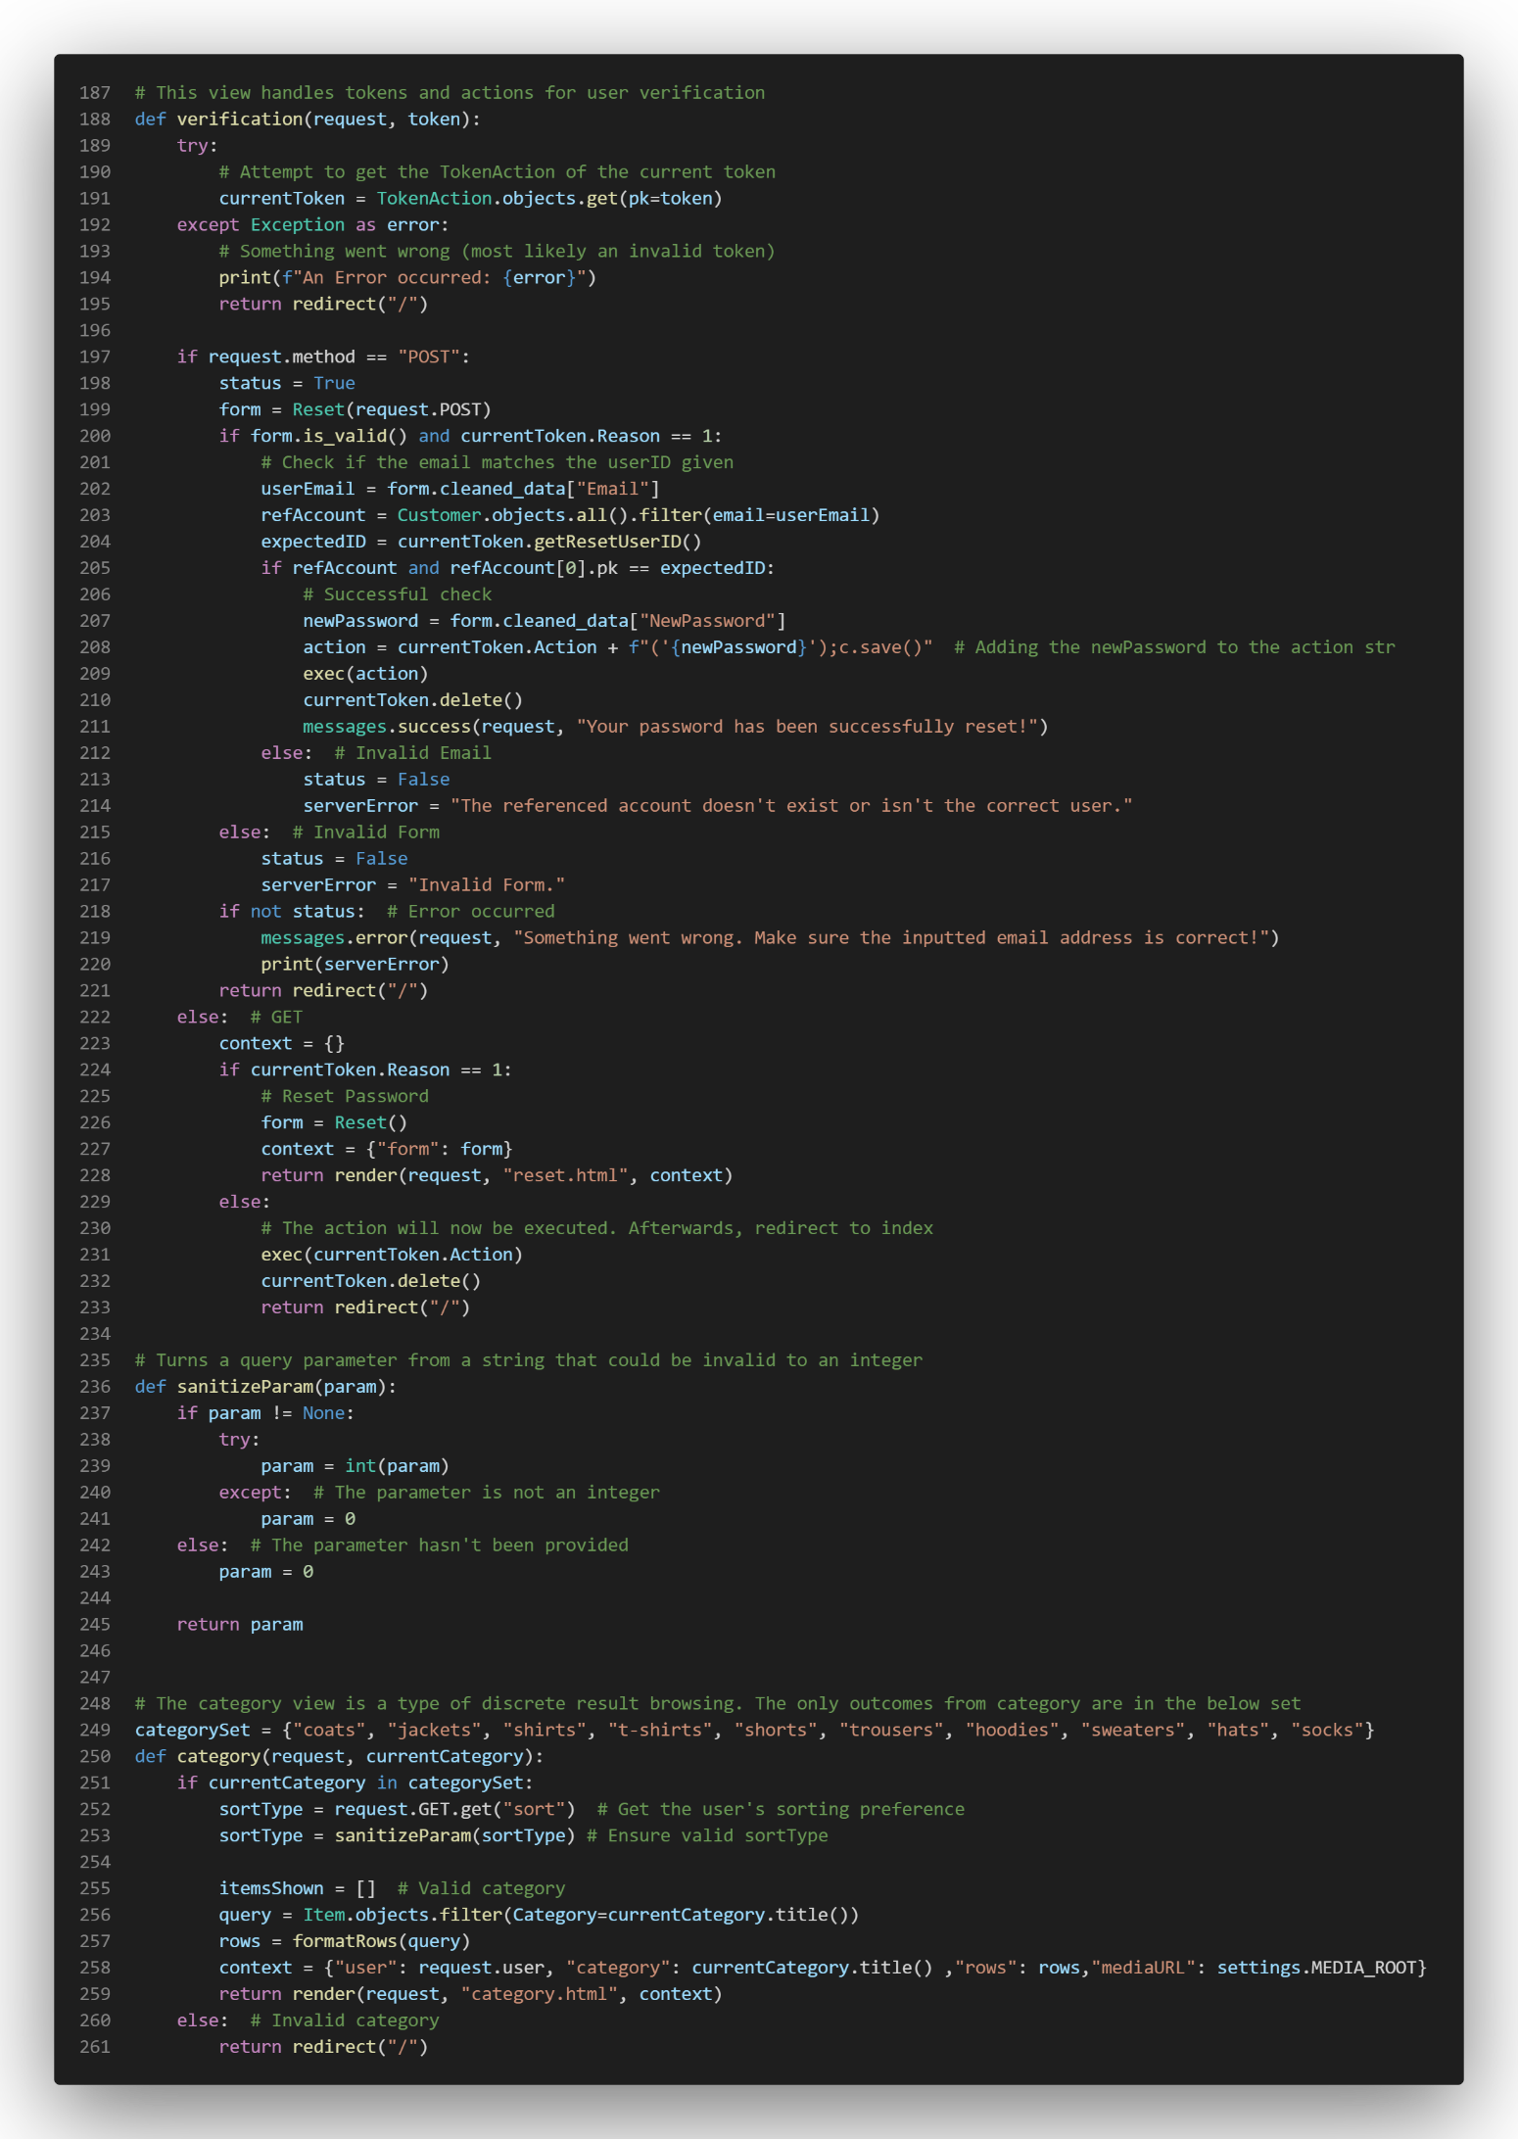

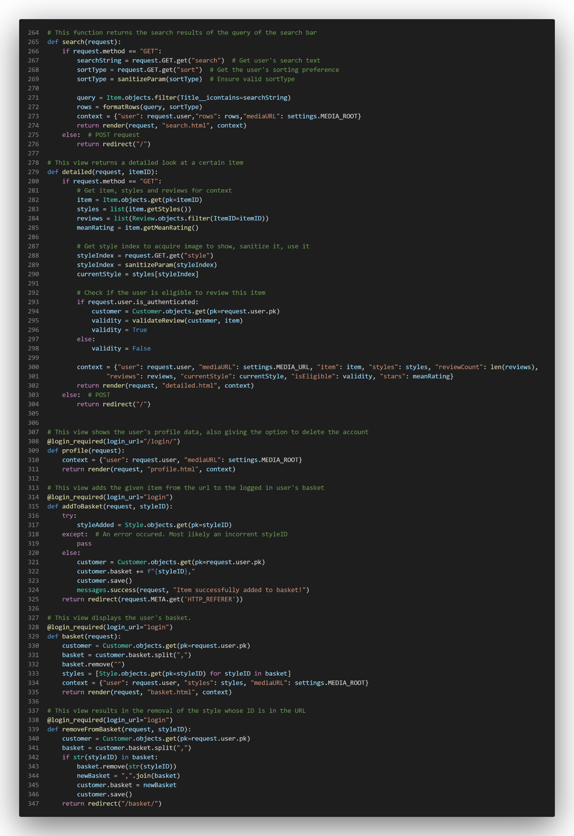

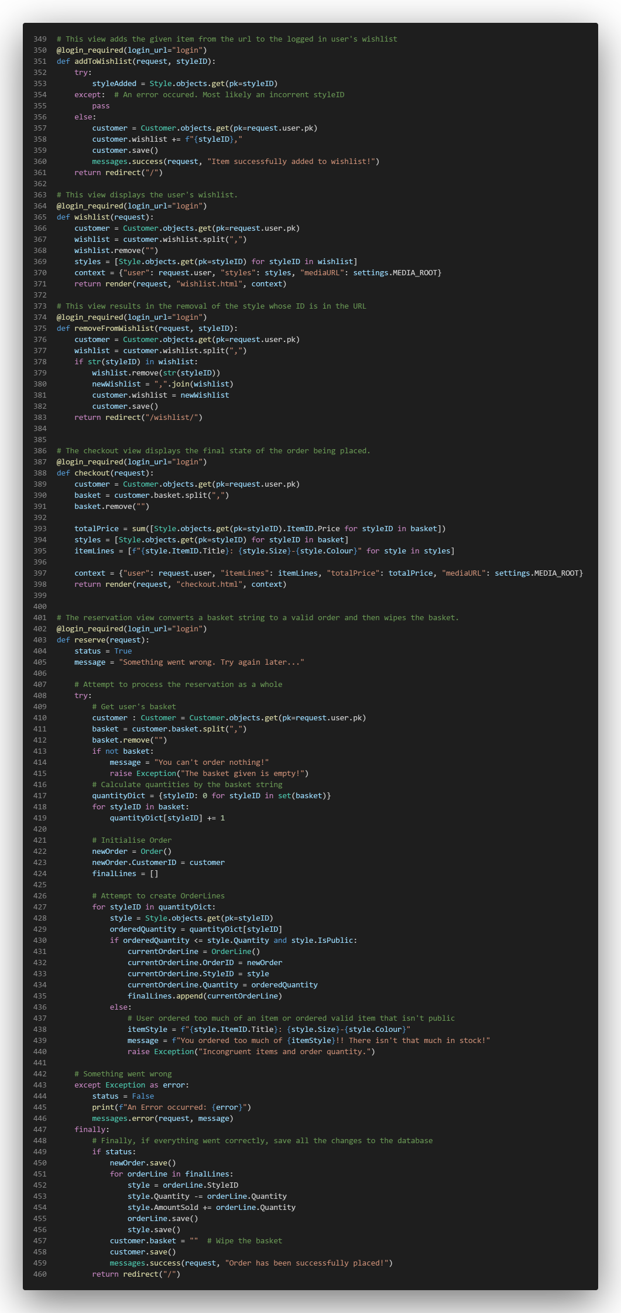

### accountActions.py

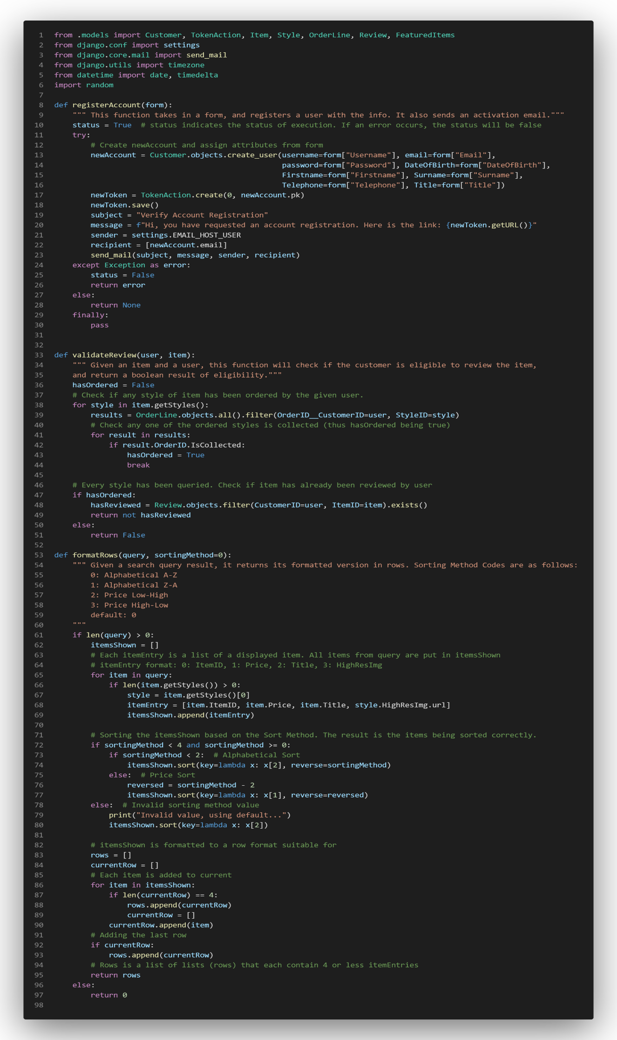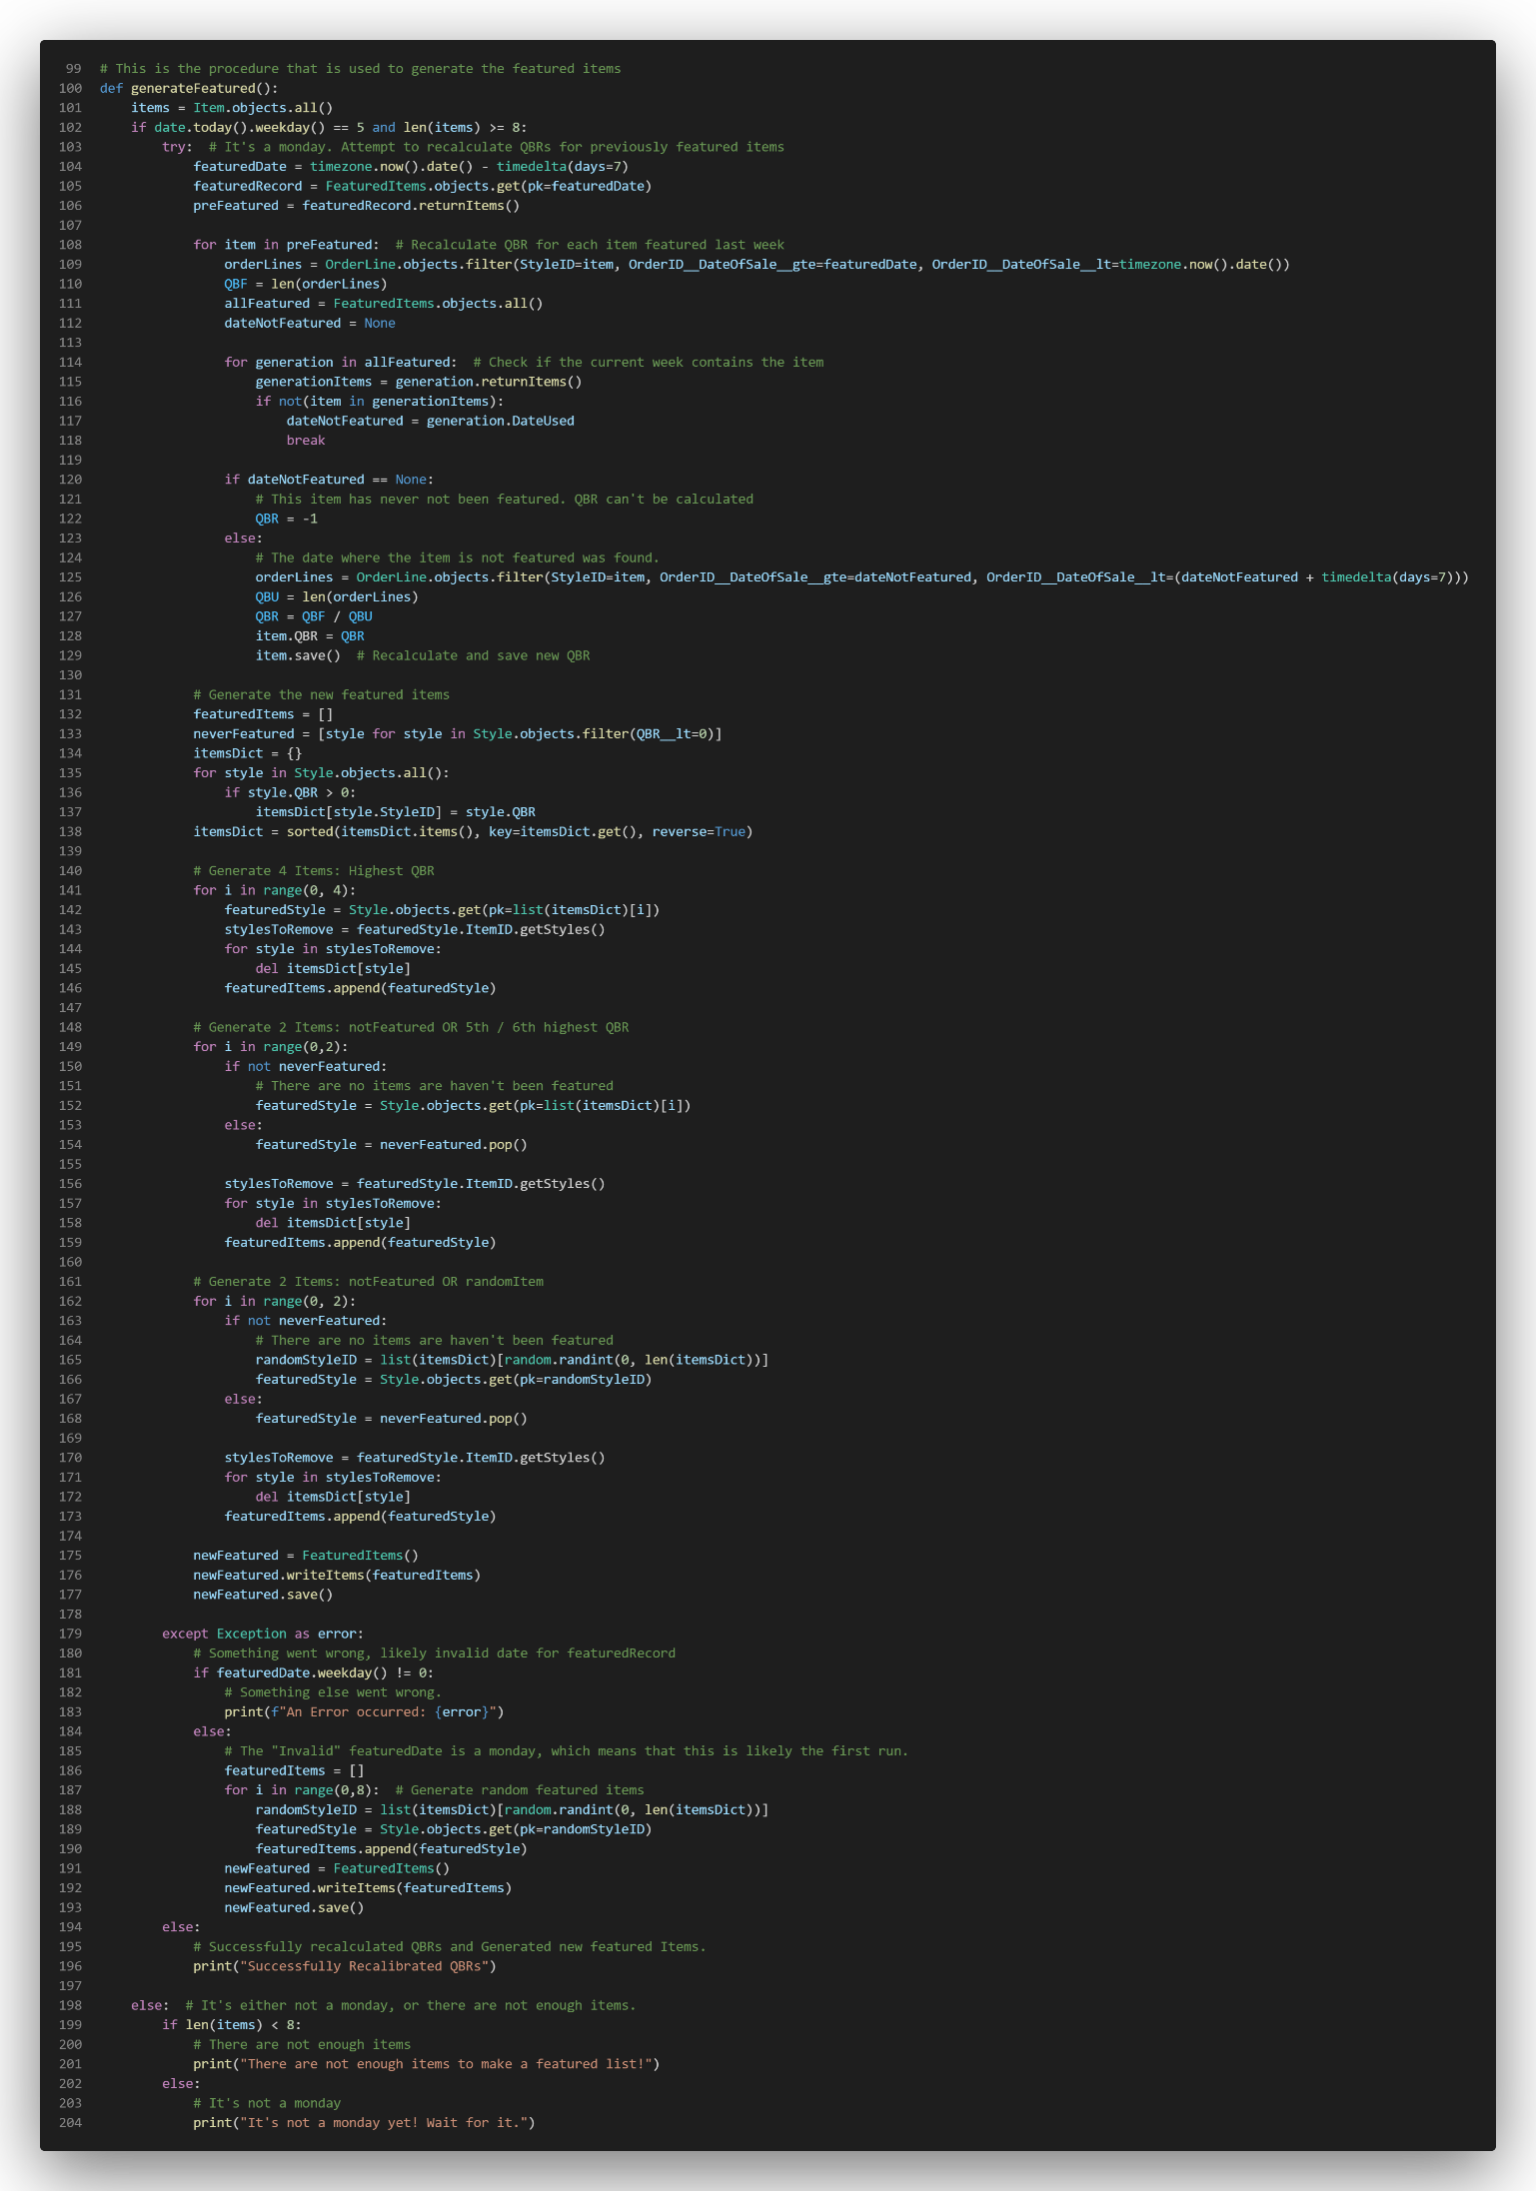

### admin.py

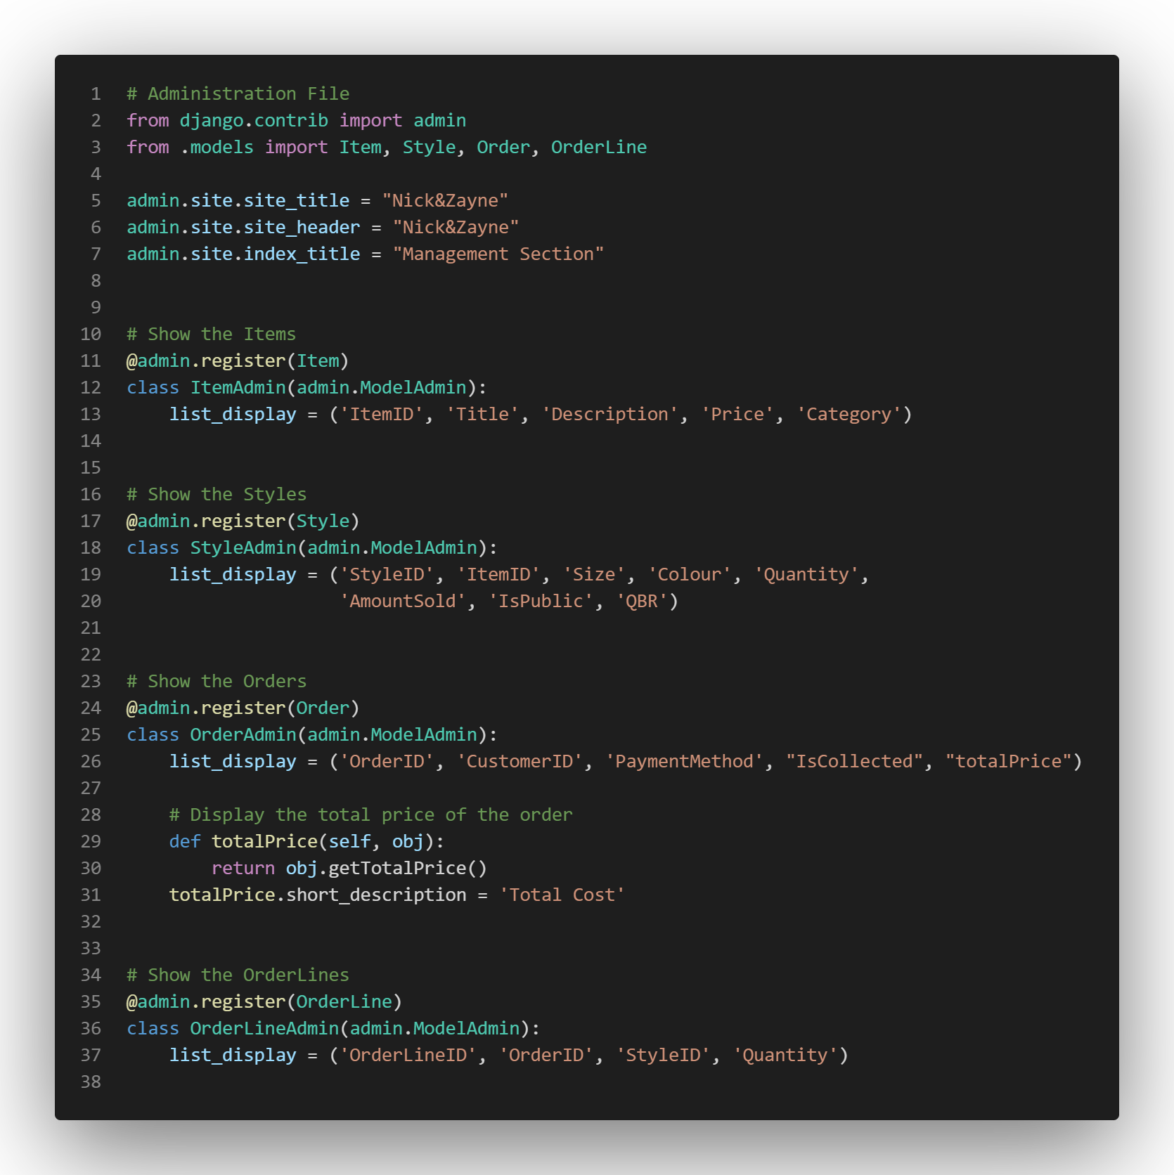

# Referencing

## References (Analysis)

Figure 1: Visualsoft (2022). Urban Male Clothing. URL: <http://urbanmaleclothing.com/>

Figure 2: ARNE (2022). Arne. URL: <http://arneclo.com/>

Figure 3: Bezos, J. (2022). Amazon. URL: <http://amazon.co.uk/>

## References (Design)

Flowcharts: Lucid Software Inc. (2022). Lucidchart. URL: <https://lucidchart.com/>

## References (Development)

Collaborative Filtering Diagram: Google. URL: https://developers.google.com/machine-learning/recommendation/collaborative/basics